Contents

Outline: 1

Organised Outline 2

Interesting Quotes and ideas from automation papers. 3

Things to add 3

Artificial Curiosity: A Search for Novel Chemistry and Chemical Understanding. 5

1.0 Introduction 5

1.1 Problem Introduction 6

1.2 Current Solutions 6

1.3 Project Solutions 7

1.4 Workflow Choice 8

1.4 Chemistry Choice 8

2.0 Workflow Overview 11

3.0 Defining Chemistry 11

3.1 Reagent Selection 12

3.2 Combination Space Generation 13

3.3 Chemical Space Generation 13

4.0 Dataset Generation 13

4.1.1 Feature Selection 13

4.1.2 Feature Generation 15

4.2.1.1 Set Up Robotic Workflow 17

4.2.1.2 Synthesis and Analysis of the Selected Space 21

4.2.2 Set Up Decision Maker 23

4.2.3 Label Acquired Reactions 25

5.0 Dataset Exploration 26

References 26

Supplementary Information 28

# Outline:

* Hypothesis: it is possible to learn new chemistry from a robotic ML platform.
* Definition of chemistry and how it defines the search space.
* Removal of bias from sampling all combination reactions.
* Bias of decision maker for single, discrete, diamagnetic supramolecular structures.
* Add reagents used for generation of sample space.
* The choice of reagents were based on: bite angle, rigidity, aromaticity, chirality, sterics, metal valency, and metal size.
* Strength of using ML systems: analysis of huge amounts of data and come to unintuitive decisions.
* Supramolecular chemistry is chosen due to its combinatorics, complexity, easy reaction conidiations to automate, reactions being in equilibrium make single discrete species making it easier to be analysed by NMR.
* The advantage of automation comes with its organisation, (and a bit of saving human effort). Humans get tired and bored and will therefore mess up making up tens of different reactions. Robotic platforms do not have this issue and follow steps to the dot.
* The choice of features for model.
* What is SHAPS and how can it be used for inference (if smiles representations are used, SHAPS will highlight what part of the molecule has the greatest say in prediction).
* The physical setup of the platform.
* How the workflow operates.
* Discovery of Novel structures via a more reasoning approach. If this proof of concept works, the paper would not only have provided insights into the chemistry, but to the fact that ML can infact learn chemical rules. The ML can then be trained on a subset of the combination space, and then predict chemical structures for the remainder. This allows for the discovery of novel compounds without neccasrly having to carry out reactions.
* Robotic platforms allow for the standardisation of reactions, helping bridge the information gap present in todays research1.

# Organised Outline

1) Introduction:

* Hypothesis: it is possible to learn new chemistry from a robotic ML platform.
* Removal of bias from sampling all combination reactions.
* Strength of using ML systems: analysis of huge amounts of data and come to unintuitive decisions.
* Supramolecular chemistry is chosen due to its combinatorics, complexity, easy reaction conidiations to automate, reactions being in equilibrium make single discrete species making it easier to be analysed by NMR.
* The advantage of automation comes with its organisation, (and a bit of saving human effort). Humans get tired and bored and will therefore mess up making up tens of different reactions. Robotic platforms do not have this issue and follow steps to the dot.
* Discovery of Novel structures via a more reasoning approach. If this proof of concept works, the paper would not only have provided insights into the chemistry, but to the fact that ML can infact learn chemical rules. The ML can then be trained on a subset of the combination space, and then predict chemical structures for the remainder. This allows for the discovery of novel compounds without neccasrly having to carry out reactions.

2) Results and discussion:

* Definition of chemistry and how it defines the search space.
* Bias of decision maker for single, discrete, diamagnetic supramolecular structures.
* Add reagents used for generation of sample space.
* The choice of reagents were based on: bite angle, rigidity, aromaticity, chirality, sterics, metal valency, and metal size.
* The choice of features for model.
* What is SHAPS and how can it be used for inference (if smiles representations are used, SHAPS will highlight what part of the molecule has the greatest say in prediction).
* The physical setup of the platform.
* How the workflow operates.
* Robotic platforms allow for the standardisation of reactions, helping bridge the information gap present in todays research1.

3) Conclusions:

# Interesting Quotes and ideas from automation papers.

# Things to add

Talk about the limitation and how the project could be expanded. Change the reaction space to new combinations, add X-ray crystallography workflow, vary temperatures (reaction conditions).

‘The adoption of the user-friendly reaction data format (SURF[41](https://www.nature.com/articles/s42004-023-01047-5#ref-CR41)), facilitated the collection of reaction data from literature sources and enabled standardized reporting of results from HTE and virtual reaction screening. Sharing reaction data in a standardized format plays a pivotal role in the effective utilization of machine learning models for predicting chemical reactivity[44](https://www.nature.com/articles/s42004-023-01047-5#ref-CR44),[45](https://www.nature.com/articles/s42004-023-01047-5#ref-CR45). By using SURF, the initi'al reaction data from three distinct sources (45 from literature, 207 from experiments, and 368 decoy reactions) became readily available for machine learning, obviating the need for manual data curation. Since both the experimental and, particularly, the literature data are predominantly comprised of positive results, incorporating decoy data from unsuccessful transformations played a crucial role in constructing a dependable prediction model.’2

Have a section describing the chemist time vs reaction time (i.e. robotic platform v human chemist time).

Talk about possible future work (this is required by UofG)

Make how parameters as acquired clearer.

Make how programme takes in chemist measured masses to calculate solvent volumes.

The majority of the chemists efforts and time went into setting up the workflow, and setting up runs.

Introduction of metal-organic supramolecular architectures.

Better link between paragraphs.

The imine constitutes as faces or edges of polyhedral structures, while metals act as glue and therefore are found at the vertices of these structures3. One can imaging such simplicity creates a diverse landscape of possible geometric structures. Fortunately, either the kinetic or thermodynamic product is favoured. These geometric structures are governed by chemical rules.

Reactivity and coordination geometry of the metal is a key component in determining structure topology4. Coordination preferences of metals results in vertices with well-defined linker directionality4.

‘In this study, we design and investigate a highly automated workflow that synergizes a high-throughput experimentation platform with a state-of-the-art active learning algorithm to significantly enhance the solubility of redox-active molecules in organic solvents.’5

‘With our automated HTE workflow, the total experimental time to finish the solubility measurement for 42 samples is ca. 27 h (~39 min/sample, less time per sample with running more samples). As shown in Fig. 2g, this is more than 13 times faster than processing samples one by one manually using the ‘excess solute’ approach, which requires approximately 525 min per sample (Supplementary Table S1). While the screening speed of our HTE workflow based on the ‘excess solute’ method is comparable to that of the automated platform proposed by Shiri et al. (20–80 min/sample)27, there are two important distinctions. First, we measured thermodynamic solubility, whereas Shiri and co-workers used the ‘excess solvent’ method for kinetic solubility measurements. Second, our workflow processes 42 or more samples at once, while Shiri et al.’s platform operates on one sample at a time.’5

Structures of coordination driven supramolecular chemistry can be simplified based on the number of binding sites on the metal, the orientation of these binding sites, the number of lewis-acid sites on the ligand, and the orientation between these sites6. These are some of the main features used to describe a supramolecular metal-organic structure, and are the same features which effect topology.

1. Importance of being able to filter reactions. Since space is huge method for exploring and cutting down space is required.
2. Is not a new idea (ML for seive) or HTS with ML for data processing and analysis, but what is missing is a complete automated end to process starting from the selection of chemistry to determining reaction outcome based on sample spectra.
3. Combination of ML and HTS is powerful for three main reason (reasons for the power of selecting HTS with ML):
   1. Ab initio calculations not so possible / Complexity of data ML can understand and process:
      1. Additionally, the use of robotic systems to physically explore the space allows for training on experimental data and outcompetes any ab initio explorations due to the latter’s associated computational costs7.
   2. Robots are better than humans:
      1. Thirdly, robots focus on the mundane tasks, allowing the chemist to focus on the intellectual challenges. Likewise, by improving reproductivity and accuracy of results, robotic platform reduces human error8.
   3. Interpretation of ML for improving ML decision reliability.
4. What is imine complex chemistry.
   1. This paper focuses on imine chemistry for several reasons: give list.
   2. The paradigm of self-assembly is perfect for use with ML for this project.
   3. The complexity of chemistry makes it hard for humans to act as sieves.
      1. Beyond the basic question of whether a given material is likely to absorb visible light, these factors are generally hard to predict. Also, the variables interact in complex ways:[11](https://pubs.rsc.org/en/content/articlelanding/2021/sc/d1sc02150h#cit11) for example, porosity might be desirable to increase the catalyst surface area, but it might also reduce charge carrier mobility. To deconvolute such multivariate relationships, we need algorithms to model multi-dimensional datasets. We also need a sufficient volume of data to create meaningful models. At present, most studies in the literature are focused on a handful of catalysts, making it difficult to probe general structure–activity relationships9.
   4. Experimental chemistry is very multifaceted so it is very hard to create a universal automated synthesis platform. Simple chemistry to perform via robots is therefore imperative. The current platform we are using is chemspeed which is pridominatly a liquid transfer robot, so we have to use this to our advantage.
   5. High symmetry makes it more simple to anaysle MS and NMR for reaction outcome.
      1. Give example of chemistry that is not good for THE (i.e. requires tags which might change the chemical properties of the system).
   6. Combinatorial space.
5. Overall the paper focuses selecting appropriate features for the sieve, synthesis of reactions in the chemical space, automated analysis of reactions for label generation via a heuristic thing, training and test of ML and lastly improving prediction reliability by making model decisions human interpretable.
6. Creating sieve requires a ML. A functional ML has to be trained and tested. This requires the generation of a dataset with features and labels.
7. These must be selected first.
8. The features we selected are.
   1. Talk about relevant chemistry
9. Due to the limited number of datapoints, for the masteres project we selected only 7
   1. List what 7
10. The label we chose is a binary classification where 0 and 1.

To populate the table 4 programmes were required.

1. Talk about programme for defining chemical space.
2. Talk about programme for finding out features
3. Talk about programme for synthesising and analysing chemical space.
4. Talk about decision maker and populating the table.

the ML can now be trained and tested. With trained model, SHAPs analysis was used to make it human interpretable.

1. Explain what SHAPs is.
2. Give conclusions which are made with SHAPs analysis.
3. Data interpretation section.

Future work

1. Platform for X-ray crystal growth
2. Testing out combination to study self sorting
3. Testing out sieve on new, slightly different dataset
4. Still lots of manual processes
   1. Using KUKA for sample transport.
   2. Better filtration method
5. Make it closed loop so more easy to expand on platform (currently first running all reaction and then using decision maker).

Conclusions

# Artificial Curiosity: A Search for Novel Chemistry and Chemical Understanding.

## Introduction

Serendipitous discoveries, such as Wittig olefination, play a major role in Chemistry, revolutionising different industries. Unfortunately, this makes finding new materials and compounds with useful properties both rare and unpredictable. If compound formation can be rationalised or alternatively, if the chemical space can be sieved through quickly and reliably, new materials can be found more consistently. Here, we present a workflow that generates a chemical dataset on imine-based metal organic complexes to understand their formation rational and to build a reactivity sieving tool. This workflow synthesises and analysis different combinations of diamine, monoaldehyde, and metals on a high through put platform and a heuristic decision maker determines if the combination is successful or not. The merging of HTE and automated spectra analysis generated a dataset of 376 different reactions. Afterwards, machine learning algorithms are used both as a sieve and for its ability to interpret complex relations in the space. The sieve is then used to further provide chemical insights and to improve its sieving reliability by making its decision-making processing human interpretable. Overall, the scope of the paper is to build a workflow that generates a dataset for developing chemical understanding and for sieve building and testing as both help locate areas in a chemical space containing valuable compounds without relying on conventional analogue-based approaches.

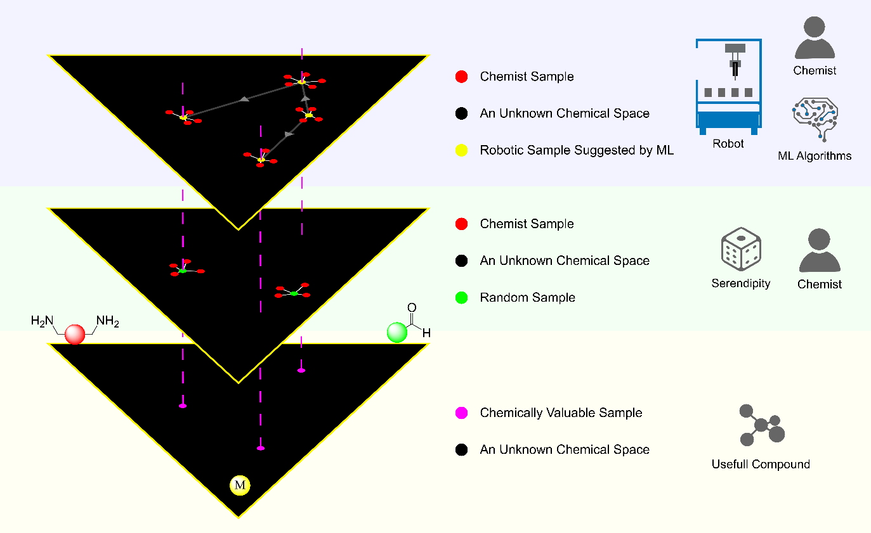

Figure : A chemical space of imine-based metal organic complexes replicated into 3 layers. The bottom layer shows the ground truth, the second is a random search along with chemist sampling, and the last layer shows a ML driven search conduct by both chemist and robot. A random search allowed for the identification of some chemically valuable samples. Based on chemical understanding, the chemist is able to produce samples which are in a similar region of the space as the random samples. A random search also allows for the identification of other samples, even though these lie outside the scope of the search (the identification of valuable samples). Using ML allows for a more systematic search of the space (shown by relations between searches represented by grey arrows), leading to the identification of all the chemically valuable samples. ML, like serendipity also identifies compounds outside the search scope. When combined with robotics, the search process is sped up, as demonstrated by the 4 robotic samples compared to the 2 random samples. All samples identified and chemistry learned by ML can then be used by the chemist to further sample the space.

### 1.1 Problem Introduction

The chemical space is huge. It is thought that the total space of organic small molecules (<500 daltons) is in the order of 1060 compounds10. Its massive!

Serendipity still plays a central role in sampling such a large space, that then lead to the discovery of novel compounds and chemistry. Such random molecular and material discoveries have aided in tacking challenges in healthcare, materials, energy storage, and sustainability. Just to name a few Nylon, ferrocene, fullerene, electrically conducting polymers, and Wittig olefination were all discovery by chance11. Cases where new materials were developed from theory12 are the exception rather than the norm, one must just look at the field of catalysis10. Therefore, a more systematic approach to sampling the chemical space is required.

When serendipity is not at play, the chemist relies on building new materials or compounds based on their research experience. The new material or compound is not novel, in the sense that it’s an amalgamation of previously known chemistries. This analogue-based design approach means that designed materials or compounds are still in a similar section of the chemical space as the materials it was modelled after. Therefore, if novel functionalities are to be required, the chemical space must be explored in a manner that departs from analogue-based approaches.

As Figure 1 seeks to explain, random exploration of a chemical space allows for the identification of some chemically valuable samples. Additionally, Figure 1 shows analogue based approaches, allows for the discovery of chemistry in the vicinity of its modelled materials. Hence, a solution seeks to combine random’s ability to explore valuable, distinct areas of a space, and the ability to rationalise novel compounds to reduce serendipity.

### 1.2 Current Solutions

Machine learning algorithms are capable of exploring spaces and chemical relations unthought of by the chemist as shown by Li et als. paper9. Robotics are used to generate and acquire data for model training, testing and space exploration. Compared to human chemists, robots are capable of acquiring more reactions on tighter time scales with more standardised reaction conditions as demonstrated by the mobile robotic chemist13. For these two reasons, the current literature focuses on implementing data driven approaches, where the chemist is replaced by both machine learning (ML) algorithms and robots allowing for a less bias, more reliable exploration of a chemical space.

There are two notable papers that highlight the importance of both ML and robotics for reliable, unbias space exploration and for developing understanding of a chemical space, they are: ‘*Sequential closed-loop Bayesian optimization as a guide for organic molecular metallophotocatalyst formulation discovery’* and *‘Combining machine learning and high-throughput experimentation to discover photocatalytically active organic molecules’*.

The first paper is a perfect example of the utilization of ML to dissect and understand complex relations in a chemical space. The paper sought to find candidates, out of a library of 560 organic photoredox catalysts, that achieve high target reaction yields and optimizing reaction conditions, via a double Bayesian optimization approach14. The paper used unsupervised learning techniques to explore the candidate space, surrogate models to identify top candidates, supervised learning to predict yields, and feature importance analysis to understand chemical features that affect catalytical activity. Bayesian optimisation was capable of finding the global optimum, or at least a good local optimum of the library of candidates, without reliance on serendipity. Moreover, the myriad of ML tools allowed the chemists to understand important molecular features that affect photocatalytic activity. With the acquired new knowledge and ML models, chemists now have a better method and understanding for designing and identifying organic photoredox catalysts. The paper therefore demonstrated the ability of ML to rationalise chemistry and systematically explore a space. Unfortunately, the paper fails to highlight the power of robotics for space exploration as synthesis were carried out by hand.

The second paper demonstrates the power of ML for exploration of unthought of areas of a space in combination with robotics. The paper sought to predict conjugated organic materials activity for photocatalytic hydrogen evolution9. Like the first paper, unsupervised learning was used to explore the candidate space and supervised models were used to understand feature importance and its relation to chemistry. However, unlike the first paper, supervised models were built to drive chemical space exploration, managing to identify several active catalysts including ID183 and ID2379. Both these catalysts were unreported in literature and their chemistries shown to be unexpected and unintuitive – highlighting the use of ML for unbiased space exploration. Furthermore, the paper showed an ML assisted space exploration outcompetes a random search when looking for candidates with catalytic activity. On the other hand, robotics was used in this paper to acquire data used to train these models via a high throughput platform. This allowed only 15 working days of chemist time and reactions to be standardised and reaction conditions kept constant.

Both papers show ML’s ability to reliably explore a space to identify useful materials, without the reliance on serendipity and conventional analogue-based approaches. Furthermore, the second paper shows the power of robotics for reliable and sturdy dataset generation. This is represented in Figure 1, where a more systematic exploration of a space with both robotics and chemists, result in the identification of more valuable compounds and other chemical samples, compared to a human driven random search. It is therefore, not surprising that the current literature uses a combination of both robotics and ML for unbiased chemical space exploration and for developing chemical understanding.

### 1.3 Project Solutions

The capabilities of ML and robotics for unbiased exploration and building rationals on the underlaying chemistry of a chemical space have been shown in both papers in section 1.2. Therefore, the master project uses approaches taken from both papers.

The first approach is to use ML to deviate from the analogue design approach, allowing for a reliable, unbiased exploration of a space. To do so, a space can be filtered based on reactions that work, using machine learning models as a sieve, trained on data produced on a high throughput platform5,9. Filtering a space based on compound synthesisability ensures suggested materials are realistic and attainable. Furthermore, building such a sieve makes candidate identification more frequent and less reliant on knowledge of the current literature9. This is the main approach taken from the second paper in section 1.2.

The second approach is to use these models to gain a better understanding of the chemistry in a space, such that compound development from theory is made less rare. This can be done via unsupervised models to cluster reactions or compounds based on relations the ML found. Supervised models can be used to build reactivity sieves, and feature importance on these models can be used to develop a better rational of the chemistry in a space. Both uses of ML will allow the chemist to suggest and develop better materials, due to refined understanding of the chemistry. This approach is taken from both papers in section 1.2.

The third approach is to use robotics to reduce human labour when exploring larger chemical spaces. This allows for a more standardised and methodological approach to space exploration. This approach is taken from the second paper in section 1.2.

To build on both previous work, the thesis project focuses on: building a more wholistic automated end to end process, starting from the selection of chemistry to data analysis; and a more in-depth analysis of the generated dataset to develop new chemical understanding. Furthermore, a better definition of a chemical space is defined, and along with an automated end to end process approach, allows this workflow to be used for other chemistries by more novice chemists.

### 1.4 Workflow Choice

To make a chemical space computer interpretable, it has to be well defined. The master project uses a combinatorial definition of a chemical space: combinations between reagents of different functional groups. This is the space in the bottom layer of Figure 2. By this definition, the space includes samples that are synthetically viable (i.e. the combined reagents react to form a product) or not. The search problem then becomes one of identifying products formed from reactive combinations – the synthesizable samples in Figure 2. Instead of relying on serendipity or analogue approaches to identify reactive combinations, a workflow similar to the second paper in section 1.2 will be followed. The idea behind the workflow is shown in Figure 2.

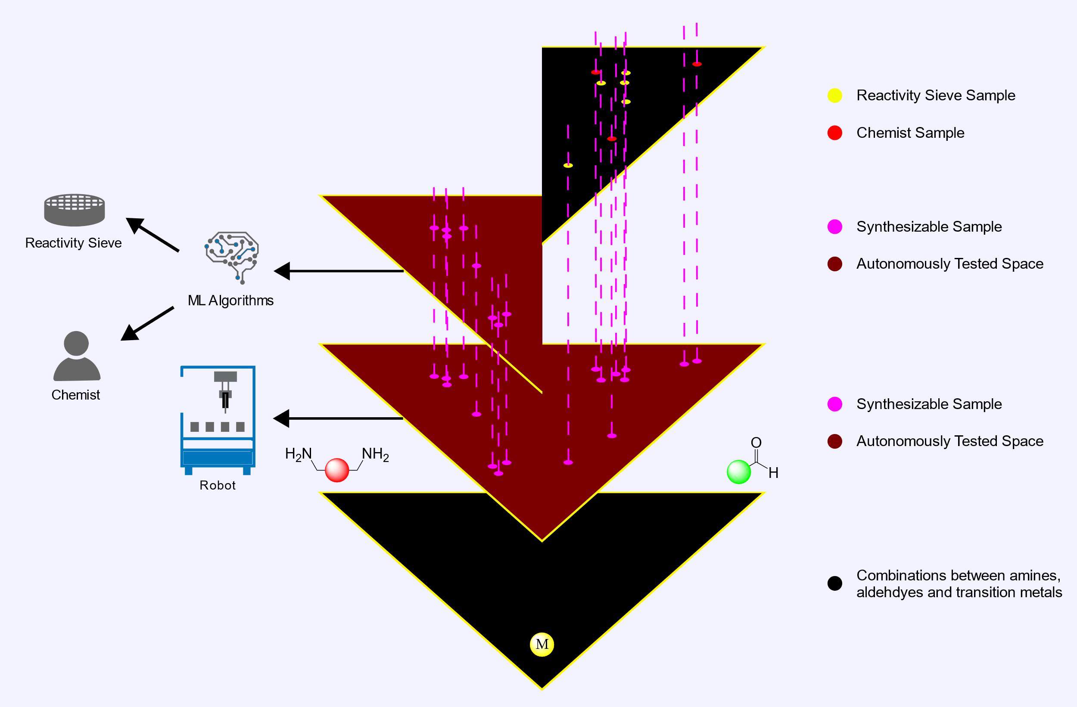

Figure : The idea behind the workflow. A chemical space is selected, in this case all combinations between amines aldehydes and metals. This space is then fully synthesised and analysed to find synthesisable samples via a high throughput platform. A portion of this analysed space is then used to train ML algorithms to build a reactivity sieve and to develop chemistry insights. The chemist then uses this new knowledge and sieve to identify synthesisable candidates in the other portion of the space. Having analysed the entire space, chemist and ML samples can be compared to ground truths.

With a well-defined space, all combinations in this space are firstly reacted and undergo NMR and Mass Spec via a high throughput platform to identify all synthetically viable candidates. Therefore, if a chemist or search method predicts any combination in the space to be reactive, this can be compared to the ground truth – the actual combinations reactivity. In other words, this allows the thesis to test the capabilities of any search methods.

The search method used in this workflow is a combination of both automated and chemist searches. A portion of the space explored by the HTE platform is used to preform an analysis of this space via ML algorithms. In part, these algorithms are used to build a reactivity sieve, capable of identifying combinations that react. Additionally, ML algorithms are also used to better inform the chemistry of the space to a chemist. This allows for both autonomous and chemist sampling on the remainder of the space not used for ML analysis (Figure 2). This search method was selected for three main reasons.

Firstly, screening manually or via Ab initio calculations is not feasible. The number of chemical parameters to consider simultaneously and their complex interplay makes it hard for a human to predict if reagents form a complex or not. Additionally, the use of robotic systems to physically capture the chemical space allows ML models to be trained on experimental data and outcompetes any ab initio explorations due to the latter’s associated computational costs7. Therefore, ML screening and analysis is a powerful option for chemical space exploration and understanding as its able to capture complex relations based on real world data.

Secondly, samples are gathered via a robotic platform. This ensures chemist experiment time is minimised, allowing them to focus on other work, especially with hundreds of reactions to carry out. Also, robotic platforms improve reproducibility, accurancy and standardisation of results, reducing human error and making datapoints analytically comparable and meaningful8. This is important as ML relay on creating relationships between data on acquired samples. Therefore, acquiring data with a robot improves sampling and experiment reliability.

Thirdly, if explainable ML are implemented, this improves decision making reliability while developing the chemists chemical understanding15. Explainable AI are ML algorithms that have the ability to make their decision-making process more understandable to the user. One method of gaining insights into the model’s logic is via SHAP analysis. Simply put, SHAP analysis allows the chemist to understand what parameters were the most relevant for a ML model to predict reactivity. Due to SHAP’s game theory approach, SHAP analysis lies in local explanations but may be used for global explanations. Local explanations would look at the chemistry of a single reaction, while global explanations would look at the general chemical trend - both provide powerful insights of the explored chemistry. It’s clear that ‘exlainabilty’ cements the chemists understanding of the explored space and their trust with the model’s extrapolative abilities. It therefore makes sieving more robust and trustworthy as it provides a rational of how and why the sample combinations was chosen (i.e. allows an expert to validate the model’s decision-making reasoning).

### 1.4 Chemistry Choice

While the workflow does come with several advantages for space exploration, it does not negate the fact that the whole chemical space is still massive. Therefore, to test such a workflow, the chemical space is cut down to imine-based metal organic complex chemistry. A smaller space allows for an exhaustive analysis of all reaction and products, to build and test chemical understanding and a reaction sieve. The created sieve and newly acquired chemical knowledge can then be transferred to a larger space to locate interesting synthetic areas.

As the name suggests, imine-based metal organic complexes, are formed on the basis of reacting amines and aldehydes to form imines which may then coordinate to metals. The formation of imines and metal coordination are dynamic equilibrium processes driven by molecular recognition16. The equilibrium processes allow for the formation of a single thermodynamic product from a landscape of possible products (Figure 2). The equilibria allow for error correction, therefore statistically unlikely products will be decomposed back to the single product. When diamines are involved, the formed imines behave as linkers between metal centres, creating complex topology. The topology of the formed supramolecular structures is programmed in the molecular codes of the building blocks, directing sorting and self-assembly17.

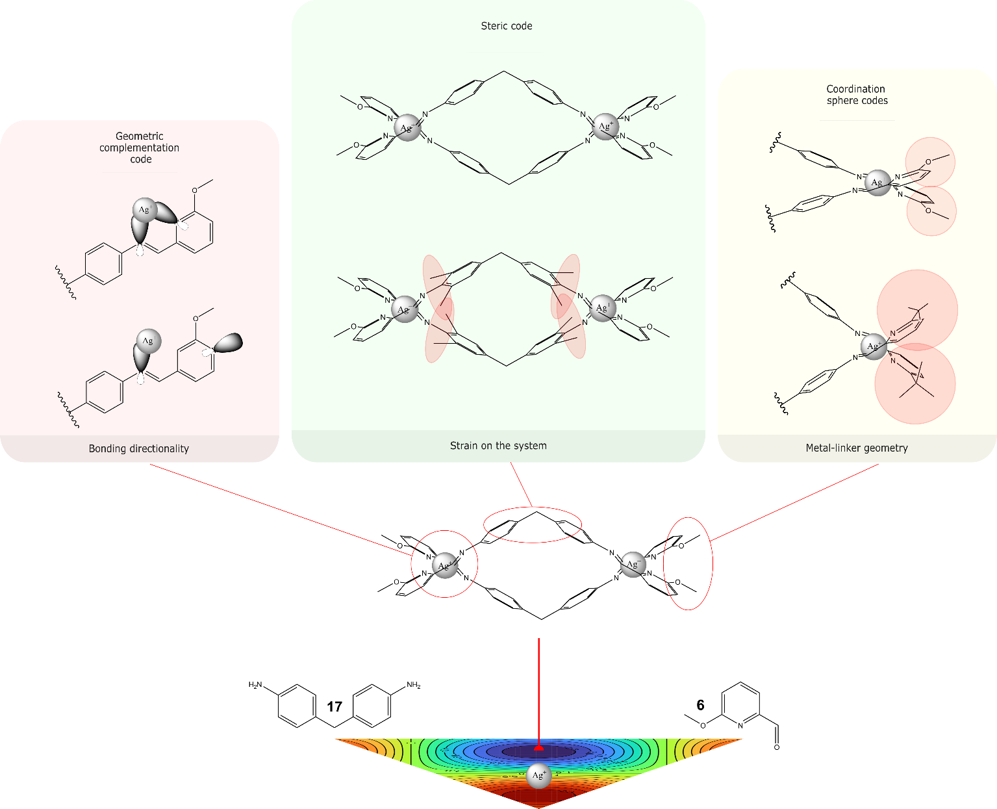

Figure : Example chemistry, where a single product is formed from the thermodynamic landscape. Single examples for each geometric complementation, steric, and coordination sphere codes are given for this compound. The example for the geometric complementation code, are different locations of nitrogen’s on the linker, which determines if a chelate can be formed. For steric codes, a bulky group are added to the linkers which causes steric strain. For coordination sphere codes, the bulky group in the coordination sphere is changed, causing a change in linker angles.

Some molecular codes found in imine-based metal organic complexes (Figure 2), include geometric complementation, sterics, and coordination sphere codes17. These are by no means an exhaustive list of codes.

Geometric complementation is at the heart of this self-assembly process. The interacting groups that form a directional bond (which drives the assembly process) require a geometrical fit first17. This fit comes in the form of size, shape, and rigidity of the linkers as well as the metal centres. An example is given in Figure 2, where the nitrogen lone pair para to the carbonyl do not overlap with the metal and hence does not chelate. Once geometry for bonding is satisfied, more nuanced codes come into play. Namely, steric and coordination sphere interactions.

Sterics affect the spatial arrangement of linkers, which in turn affect the topology of the complex. The steric code introduces strain to the geometric complementation, which may result in a change of topologies with the introduction of a different bulky group on the same linker scaffold. A toy example is shown in Figure 2, where instead methyl groups in the aromatic ring introduces further strain between the linkers, if such a group is massive, it could prevent coordination of two or more linkers to the same metal. It is important to note, the introduction of such a group could introduce new intra or intramolecular bonding which affects the original geometric complementation code. The same steric codes also affect coordination sphere codes.

Coordination sphere codes tend to dictate supramolecular topology and formation, as metals behave as vertices3,4. Coordination sphere codes capture the geometry of a vertex, its number of edges and the angles between these edges. The number of chelating imines on a vertex is affected by coordination number, while the vertex angles are governed by both metal geometry and steric codes. Metal geometries are distorted by steric codes as these may introduce strain in the coordination centre. For example, in Figure 2 the tertbutyl group introduces more strain in the coordination sphere, changing metal coordination geometry. This hierarchy and interrelations of molecular codes highlight the complexity and what chemistry might affect reaction outcome.

With this brief introduction of imine-complex chemistry, it is possible to show its compatibility with the paper’s workflow. The synergy between the chemistry and workflow is shown by the chemistry’s paradigm, the intricacies of molecular codes, the simplicity of supramolecular reactions, the chemistries high combinatorics, and supramolecular topology.

To be able to predict the outcome of a reaction without having to physically carry one out (i.e. the scope of the sieve), all the information of what makes a reaction successful must be encoded in the starting materials. As mentioned previously, the architecture of the complex is encoded in the metal-ligand building blocks4. Therefore, the machine learning tool has the ability to infer and predict the success of a reaction based on reagent information alone. This supramolecular paradigm makes the chemistry compatible with the project.

Moreover, the advantage of ML comes in its ability to explore complex and unintuitive data with speed and minimal computation18. As shown by the interdependence of steric, coordination and geometric molecular codes, predicting reactivity based on reagents is a challenging multivariable function. This unintuitive convolved chemistry, is a perfect test case for extracting chemical information with ML tools.

Experimental chemistry is a multifaceted problem and while making universal synthesis platforms have been attempted, they still lack real universality19,20. Additionally, the robot used in this study is a ChemSpeed liquid handling robot. Therefore, if reactions are to be taken reliably, the chemical space has to be limited to reactions which can be handled by the ChemSpeed. Since, imine formation and metal coordination are spontaneous at lower temperatures, the ChemSpeed does not need to be modified to resist and handle high temperature reactions21. Also, imine formation and metal coordination are orthogonal16, which allows for one pot reactions, reducing the number of base steps and reaction vials in the robotic workflow. Additionally, the solubility of many metals, amines, and aldehydes in acetonitrile and dichloromethane, allows for the ChemSpeed to handle reagents in the form of stock solutions with a standard solvent. Again, having a standard solvent reduces the number of base steps, limits the number of solvent peaks in an NMR spectrum for reliable analysis, and more importantly, plays the robots forte: liquid handling. Thus, the dynamic self-assembly of imine complex chemistry ensures the robotic platform is not a bottle neck of the project but rather a strength.

When it comes to automated spectra analysis, imine complex chemistry has advantages resulting from its reversibility and topological structure. The dynamic nature of imine and metal ligand bonds allows for the selection of the thermodynamic product22. The formation of a single species along with the high symmetry of its topology, simplifies the automated identification of a successful reaction due to a cleaner NMR spectra and splitting pattern. This is supported by previous research, where protons in a supramolecular complex exhibit a single chemical and magnetic environment, while ESI-MID elucidated the stoichiometries of building blocks of the architectures23. Unfortunately, both NMR and MS are not enough to fully characterise the architecture of a supramolecular structure but can be used in tandem to reliably determine reaction outcome. The formation of a high symmetry discrete species which can be identified in automation is another reason for the use of imine-based complexes in the work flow.

Lastly, imine coordination chemistry was chosen due to its combinatorics. Unlike in catalysis where HTE are limited by catalyst and ligand libraries10, the diversity of commercially available aldehydes and amines does not make reagent selection a limiting factor in this study21. Furthermore, the diversity of mono-aldehyde and diamines provide the ML the opportunity to learn the complex underlaying molecular codes. The combinatorial accessibility also lends to understanding self-sorting in future work based on exploring supramolecular structures with multiple metals, amine and aldehydes in a reaction. The combinatorics allows for a greater scope of the project, while ensuring a varied dataset can be generated.

Imine complex theory is convoluted and its chemistry is best suited for the robot used for HTE and automated spectra analysis. This makes it a perfect chemical space to test the work flows capabilities.

## 2.0 Workflow Overview

To recapitulate, the project focuses on being able to understand and filter a chemical space, to then locate areas of potentially useful chemistry to aid space exploration. The chemical space is reduced to imine-based metal organic complexes due to its compatibility with automation as well as to be able to exhaustively explore this smaller space for analysis. To do so, the work flow is divided into 3 main sections.

Firstly, the subset space is made explicit by selecting reagent libraries and populating the space with building block combinations. The combination space is then translated to the chemical space. Secondly, to train, sieve and explore the space with ML models, a table of features and labels need to be selected and populated. This requires chemically relevant features to be selected, and the creation of a robotic workflow that automates synthesis and reaction labelling. Once the features and labels have been generated, then analytical ML studies can be implemented. The process from defining chemistry to data analysis is shown in Figure 3 – an overview of the study.

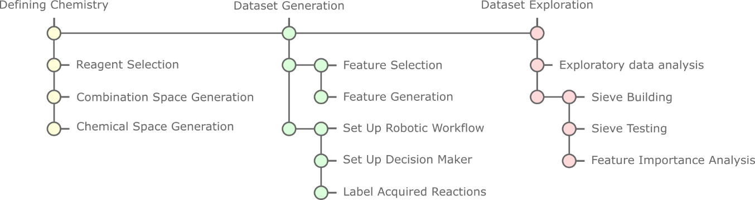

Figure : An overview of the study preformed in the paper, subdivided into three sections: defining chemistry, dataset generation and dataset exploration. The first section is responsible for defining the chemical space to explore and the generation of reactions to be carried as HTE. The second section is responsible for feature and label generation. The third section analyses the data of the chemical space, builds and test the sieve along with SHAPs analysis.

## 3.0 Defining Chemistry

The paper focuses on developing an end to end automated process. For this reason, all chemistry has to be unambiguously defined and represented digitally, as robots do not work well with ambiguity. Starting off with defining the chemical space. The chemical space are all the possible products of combinations of reagents of a reaction (i.e. all the possible combinations between amines, aldehydes and metals). To generate this space, the reagent library is first defined, where all the reagents of interest are listed under their functional group. Figure 4 shows the reagent libraries used in the paper along with an example reaction product.

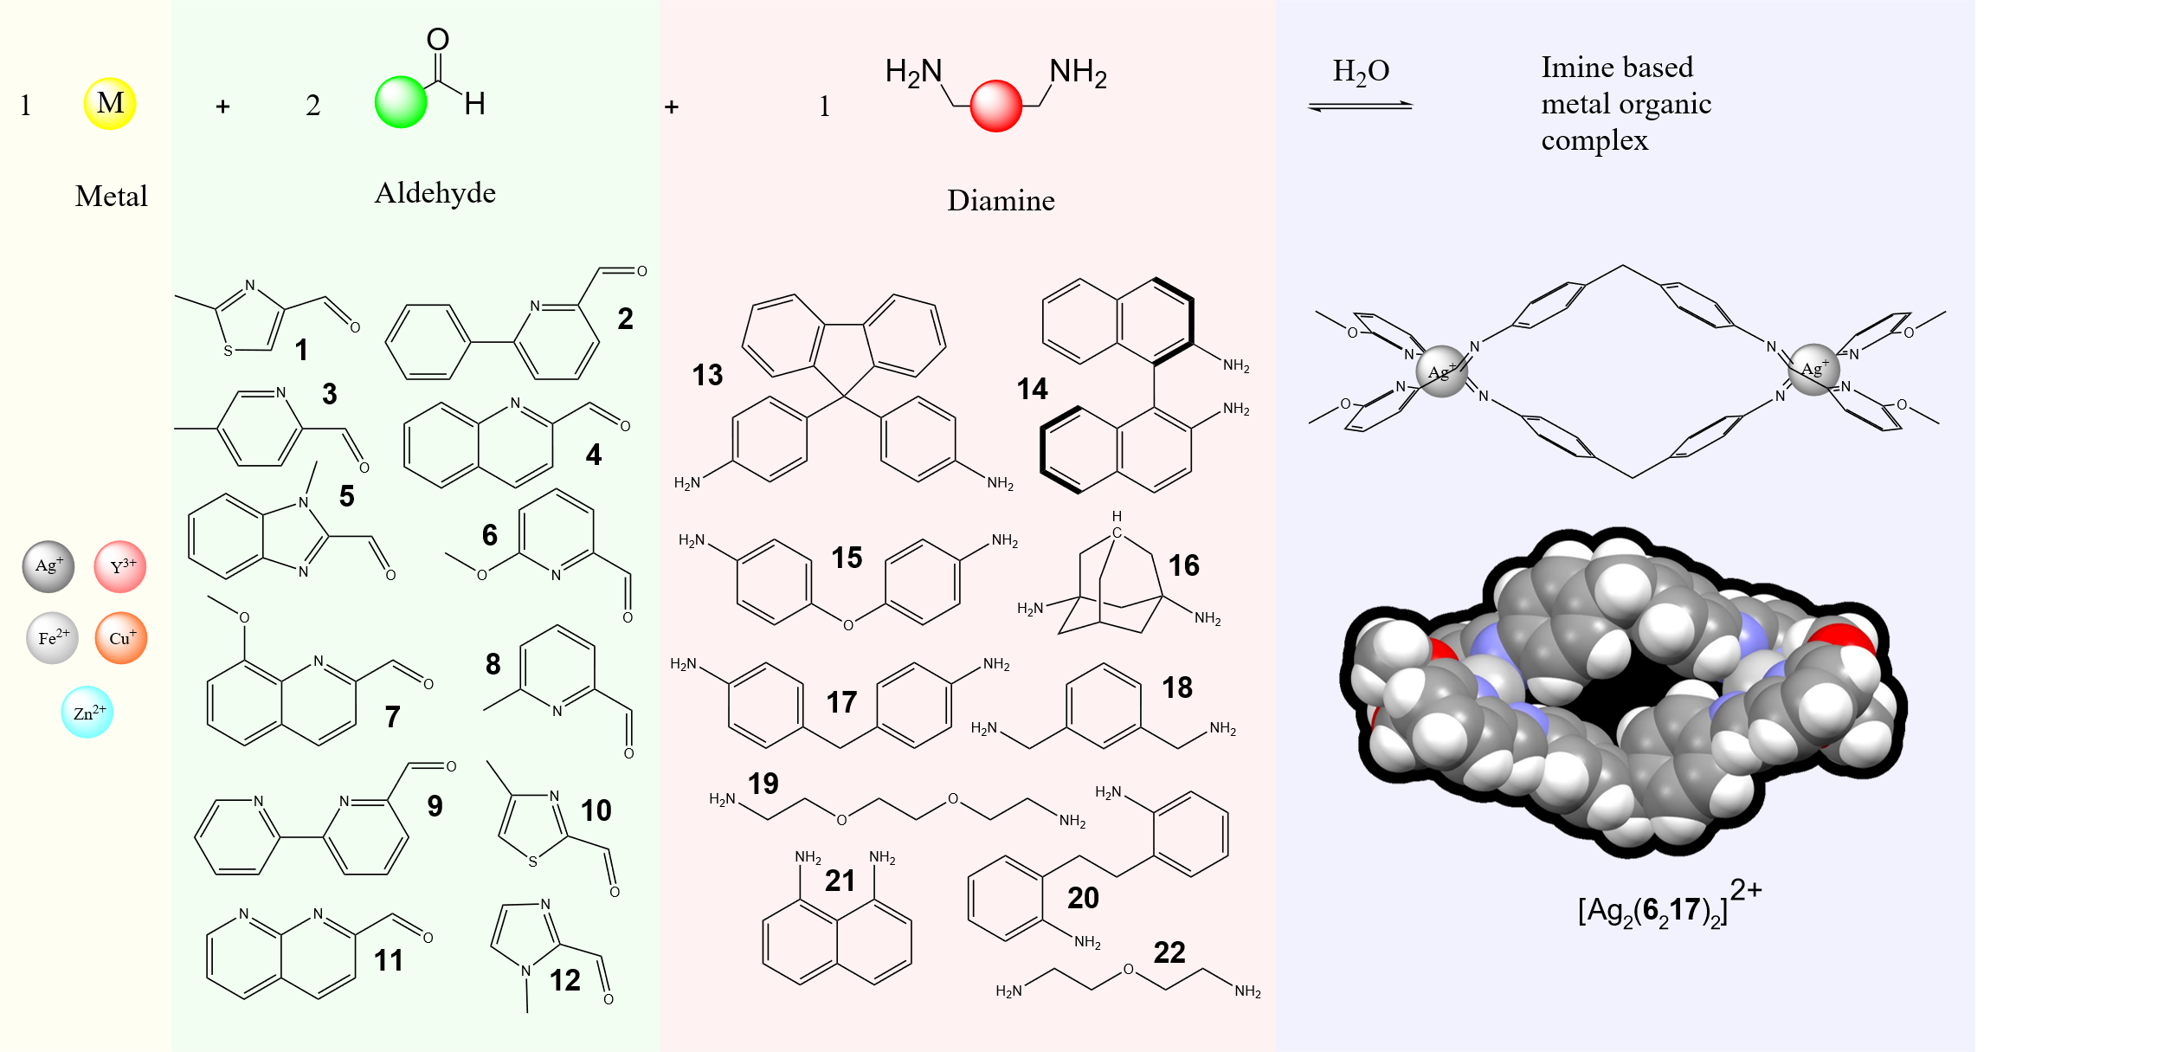

Figure : The reaction (shown above) explored in the study. Reagent libraries for metals, monoaldehydes and diamines are shown in yellow, green, and red areas respectively. An example supramolecular compound found in the study, and its 3D structure obtained from x-ray crystallography are also shown.

### 3.1 Reagent Selection

10 different diamines, 12 different monoaldehydes and 5 different transition metals were selected based on commercial availability, a nitrogen beta to the carbonyl group, the diamagnetism of the metals, the liabilities of the metals, and variation from the current literature.

A beta nitrogen forms a chelate after imine formation and a diamagnetic metal prevents uninterpretable paramagnetic NMR spectra. Furthermore, liable metals were chosen so that coordination is reversible allowing for the formation of the thermodynamic product.

If the sieve is to be used in a larger space (as for future work), and to get a broader understanding of the chemistry, reagents with varied chemistries must be selected. The variety of bite angles, rigidity, aromaticity, chirality, sterics, electronegativity, metal valency, and metal size of reagents in Figure 4 ensures different molecular codes are captivated in the chemical space. This variety develops a deeper understanding of the chemistry, and makes the ML sieve more generalisable and therefore sturdy against chemical reactions it has not seen before. For example, when exploring new spaces. Additionally, chemical variety not present in the in the current literature were selected, allowing the workflow to develop new meaningful chemical insights. A full list of reagents and their names are found in S 1.

### 3.2 Combination Space Generation

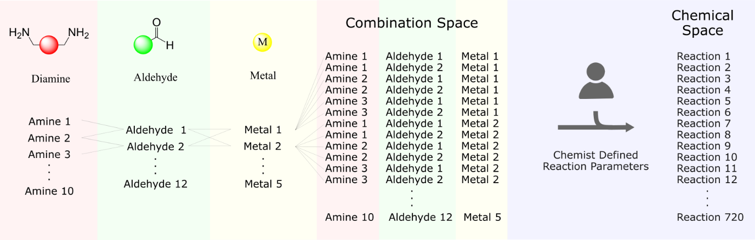

Figure : The generation of the combination space which is then translated to the chemical space, once combinations have translated to reactions via user defined reaction parameters.

Once the reagent library has been selected all possible combinations between reagents are taken, forming the combination space (Figure 5). This workflow includes silver to have coordination numbers of 4 and 6, generating 720 (6*10*12) combinations. S 3 shows the all combinations generated along with their reaction ID.

### 3.3 Chemical Space Generation

The combination space is chemically meaningless for the robotic workflow. Therefore, for the workflow to generate the chemical space, the chemist has to define reaction parameters to translate combinations to reactions (Figure 5). Parameters include: reagent concentrations, transfer volumes, reaction temperatures, reaction duration, and buffer volumes. This paper takes combinations of reagents in a 2:3:6 metal:diamine:mono-aldhdye ratio, heats them at 60oC for 40h to create reactions. While there are 720 reactions in the chemical space, due to time constrains, this master project was only able to synthesis and analyse 376 reactions.

The four steps of selecting reagent libraries, generating a combination space, taking in user defined parameters to generate the chemical space is handled via a programme written by the group. As mentioned before, having a computer representation allows for an automated end to end workflow. In fact, the chemical space generated by the programme is then used for Dataset Generation.

## 4.0 Dataset Generation

With the chemical space defined and with the intentions to analyse the space with ML, features and labels must be selected and generated.

### 4.1.1 Feature Selection

Feature selection was based on ideas from molecular coding and the supramolecular paradigm which have been outlined in the introduction. Features represent the most influential key areas of imine coordination based on expert opinion and translate these to computer language. More specifically, since reactions contain a metal, an aldehyde, and an amine, reaction features can be split based on its three reagents. Therefore, a supramolecular structure resulting from a reaction in the chemical space is represented by its building blocks (Figure 6). The building blocks, in turn, can be further represented with descriptors and features to encaptivate their chemistries.

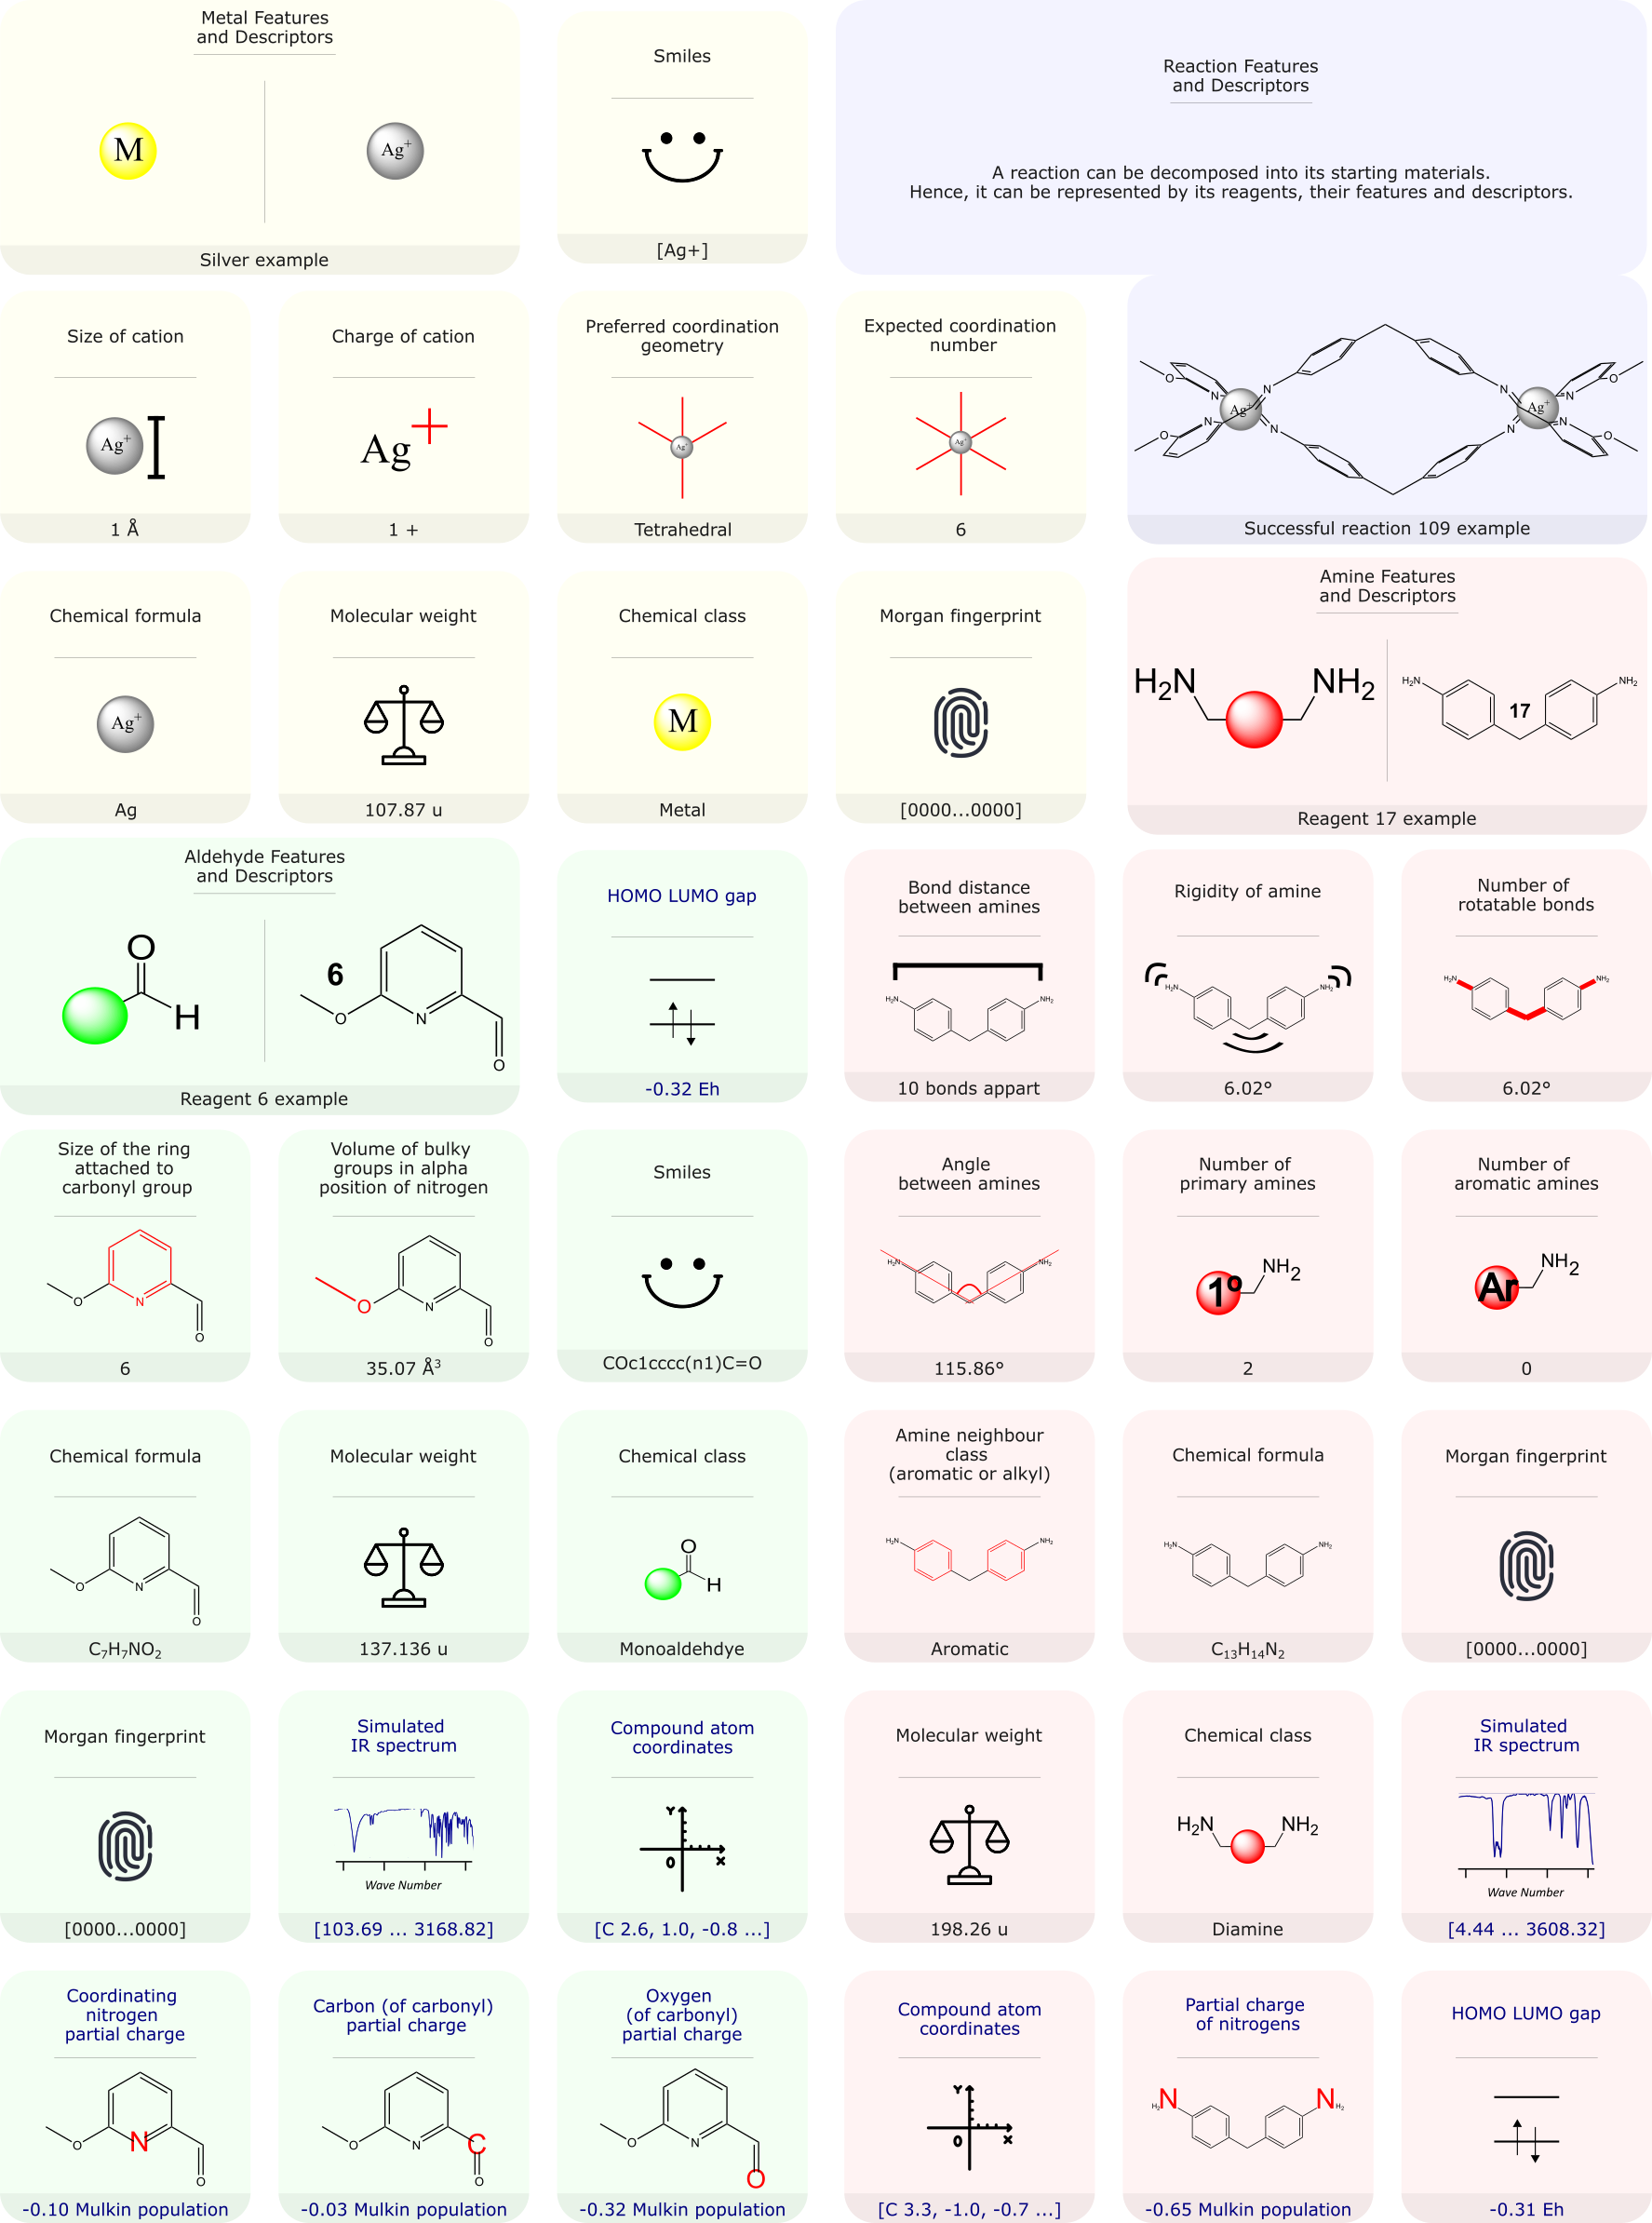

Figure : Decomposition of a reaction into reagents with their respective relevant features and descriptors used for data analysis. Example features and descriptors are given for reaction 109 (Silver + reagent 6 + reagent 17). Reaction 109 was successful and the formed supramolecular structure is shown. Features and descriptors in yellow, green, and red boxes belong to metals, aldehydes, and amines respectively. Features and descriptors written in blue are calculated via quantum mechanical means in orca. Features and descriptors written in black are extracted via cheminformatics toolkits.

Features that were select to embody the geometric complementation, sterics, and coordination sphere codes are: size of metal cation, charge of metal cation, preferred metal coordination geometry, expected coordination number, volume of bulky substituent in the coordination sphere, the partial charge of the coordinating nitrogen, bond distances between amines, rigidity of amines, number of rotatable bonds between amines, and the angle between amines.

Features that do not fit the outlined molecular codes are: the size of the ring attached to the carbonyl group, the partial charges of the carbonyl oxygen and carbon, the simulated IR spectra, HOMO-LUMO gaps, and if the amines are bonded to aromatic or aliphatic groups. These were selected to provide insight to imine reactivity.

Other information shown in Figure 6 are either ML interpretable molecular representations, descriptors, or additional information of the reagent.

As mentioned previously, for this master project the final dataset only contains 376 datapoints. Due to SHAP’s coalitions approach, the small dataset limits the number of features that may be used in a SHAPLY analysis. Therefore, only 7 of the relevant features in Figure 6 were selected for later use in dataset exploration. The choice for selecting these 7 features are outlined below.

For metals the cation size was chosen as this indirectly contains information of the charge (greater charges result in smaller radii), and possible geometries (smaller radii limit the number of ligands and covalency). Bennett et al. have highlighted the importance of cation radii in coordination to polypyridine ligands both in terms of chelation and preorganisation24. Cation sizes are expected to, therefore, affect topology and reactivity.

For aldehydes, the thesis focuses on the partial charge on the carbon of the aldehyde, the volume of bulky groups in coordination sphere, and the ring size attached to the carbonyl. The author expects the partial charge on the carbonyl carbon to dictate reactivity with amines, where lower electron populations results in a better electrophilic centre for an attack from the amine. Furthermore, it is thought that substituent volumes constrain imine metal coordination and metal geometry. For instance, a bulkier group may affect preorganisation of the imine for a specific metal, introduce steric strain between two coordinating imines and if exaggerated may prevent another imine from coordinating. This demonstrates volume of bulky group is a good representative of steric and coordination sphere codes. Lastly the authors think ring size provides further information on both supramolecular topology and imine reactivity. The size of the ring controls the number of double bonds conjugated to the imine and the carbonyl group, affecting their reactivities. A larger ring size also increases the steric presence of the imine, and its bite angle. Therefore, ring size is part of the steric and geometric complementation codes.

Lastly for amines, the selected features are: the nature of the amine (if its bonded to an aromatic group or not), the enforced angles between the two amines, and the number of rotatable bonds between amines. For similar reasons as the aldehydes, resonance of aromatics with amine groups affect the reactivity of both imines and amines. The dihedral angle between amines affects linker coordination direction, while the number of rotatable bonds provide information on the rigidity of the amine. The flexibility of the amine is important as rigidity constrains the possible geometries of the architectures. The authors expect the amine to behave as linkers, hence more features that encapsulate geometric complementation codes were chosen. These code in turn, affect topology and more importantly dictate if complexes are formed or not.

### 4.1.2 Feature Generation

Since the focus is on automating the entire workflow process (Figure 3), including feature selection and generation, a program was written to extract features outlined in the previous section. The general structure of the program is shown in Figure 7.

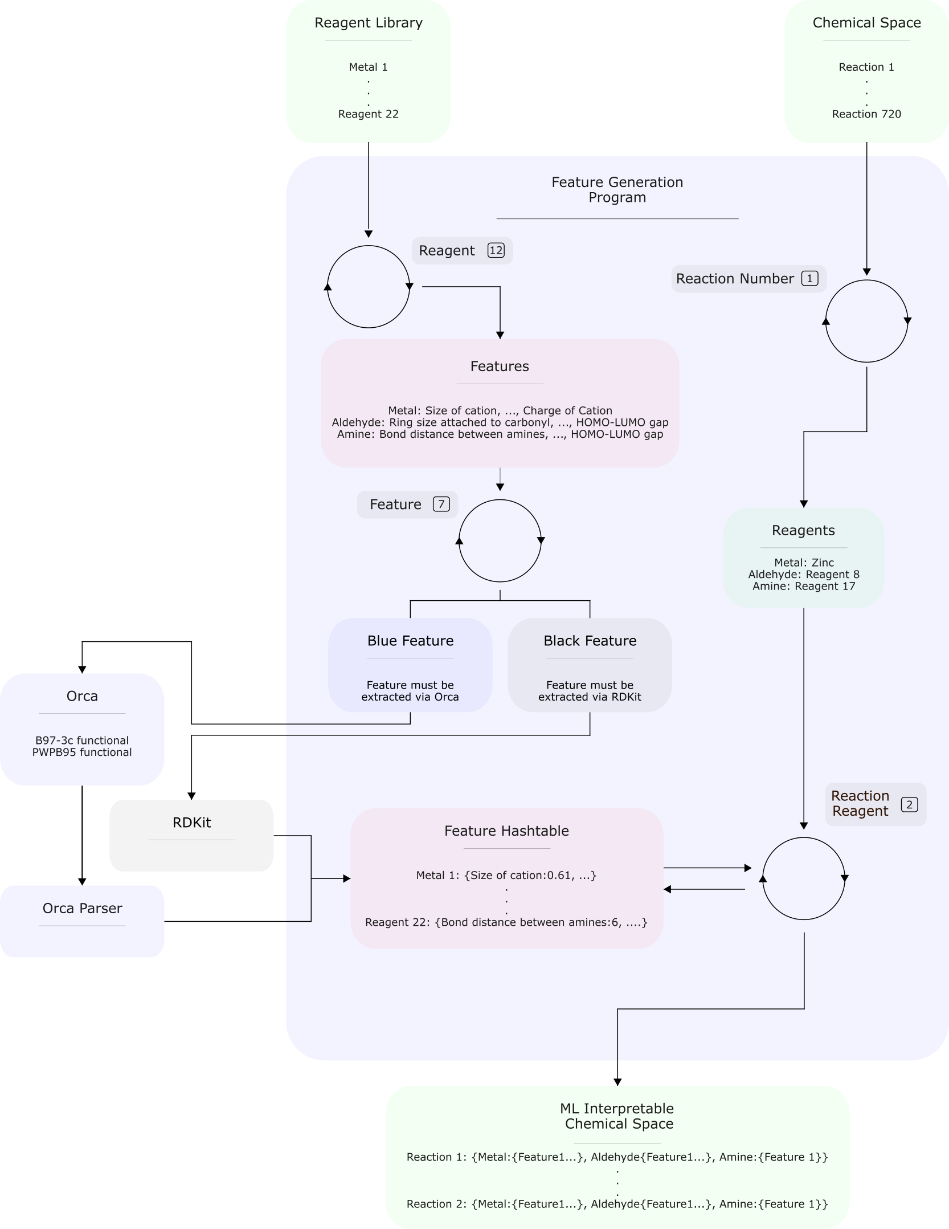

Figure : The programme responsible for the generation of features. A hash table is first populated with reagents, and its features extracted via either orca or RDkit. Reactions in the chemical space are then iterated through, and the reagents in the reactions are then iterated through mapped to the hash table to get an ML interpretable reaction. When the reaction number count hits 720 and the reaction reagent count hits 3, the generated chemical space is populated by all 720 ML interpretable reactions.

This programme takes in reagent libraries and the chemical space generated by the previous programme. Since reactions are represented by their reagents and there are a limited number of starting reagents, a hash table is first populated with reagents and features. Having a hash table reduces computational resources as features are not extracted on a reaction basis. Therefore, the programme first iterates through the reagent library. The features to extract are then iterated through and checked if they must be extracted via RDKit or Orca (see black and blue features in Figure 8). RDKit is cheminformatic toolkit and Orca is an app for quantum mechanical calculations25.

If Orca is required, the reagent first undergoes geometry optimization with B97-3c functionals, then energies are calculated with PWPB95 functionals. Both functionals were used as they are relatively not computationally expensive, and still provide accurate results. These functionals allows the programme to perform computations on a mid-range pc such as the one used in the workflow. Features are then extracted from calculations using a free parsing tool26.

Once features are extracted they are saved into the hash table. Once the hash table is fully populated with all starting reagents, reactions in the chemical space are iterated through and their reagents extracted. The reagents are then taken one at a time and mapped onto the hash table to retrieve their feature values (Figure 7). The final reaction is composed of the starting reagents and their features. The newly defined reaction populates a chemical space interpretable by ML. With the features collected, the ML interpretable space now requires labels.

### 4.2.1.1 Set Up Robotic Workflow

To generate labels, reactions in the chemical space need to be physically tested and analysed. To do so robotically, a few modifications to the synthesis platform needs to be done, reagent solubilities tested and a programme to schedule reactions and communicate between platforms needs to be written. These modifications and tests (Figure 8) were done to hasten workflow setup times and to improve robotic reliability.

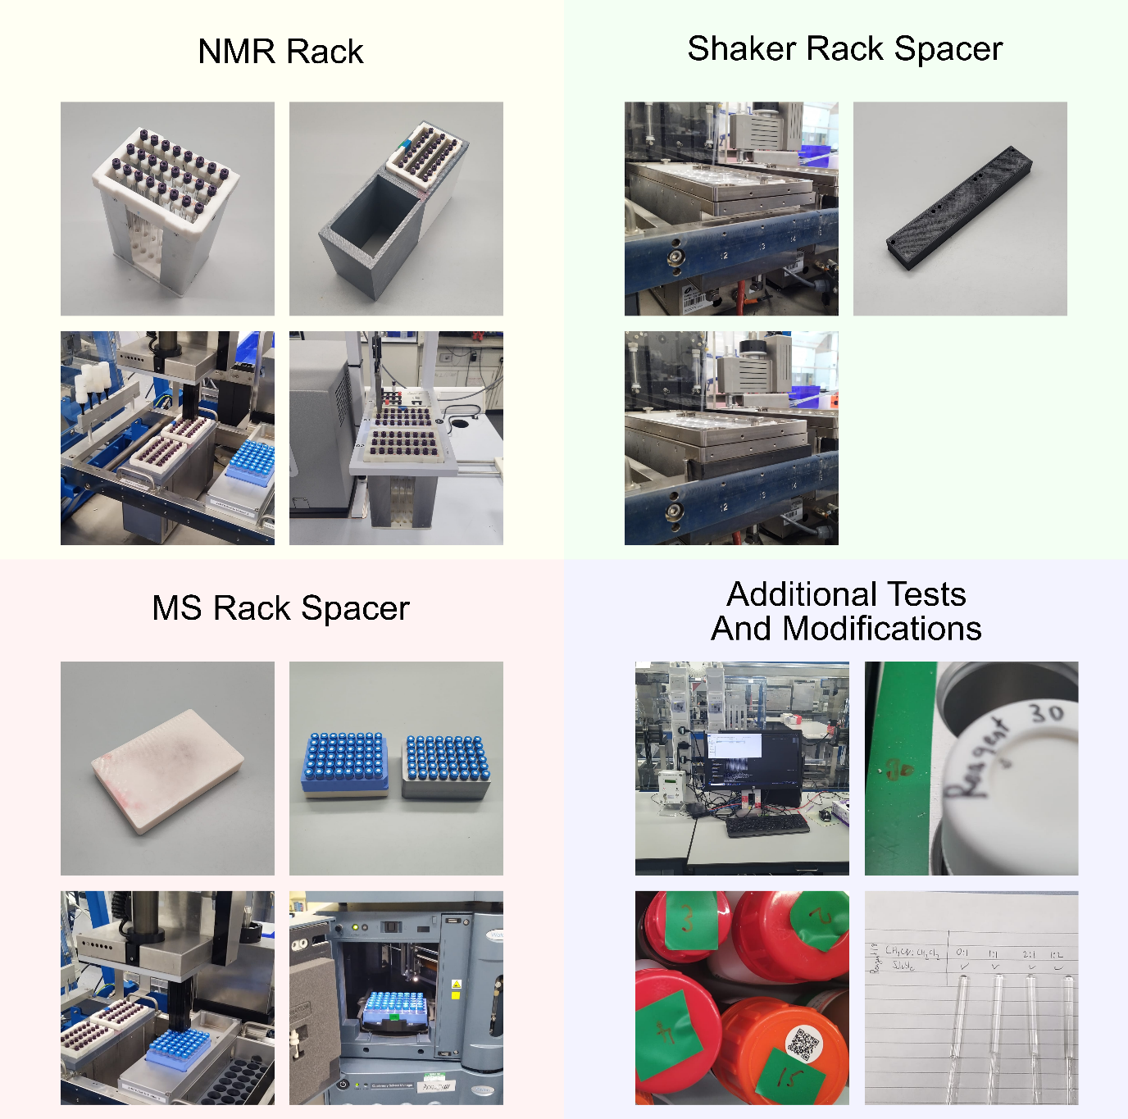

Figure : Modifications done to the platform along with required tests. These include developing a new NMR rack which is compatible in both ChemSpeed and NMR platforms, a spacer to ensure compatibility between ChemSpeed and shaker rack, an MS spacer so that LCMS racks can be used in the ChemSpeed platform, a computer with internet connection connected to the ChemSpeed, labelling of shaker rack areas to their corresponding reagents, and testing reagent solubilities in acetonitrile and / or dichloromethane. Pictures in yellow show: the inhouse developed and built NMR rack (top left); the 3D printed NMR rack adapter (top right); the NMR rack and adapter in the ChemSpeed platform (bottom left); and the NMR rack in the NMR machine (bottom right). Pictures in Green show the gap between the shaker rack and the ChemSpeed rack support (top left); the 3D printed spacer (top right); and the spacer wedged between shaker rack and support (bottom left). Pictures in red show: the LCMS spacer (top left); the LCMS rack stacked on the spacer next to the original ChemSpeed LCMS rack (top right); the spacer and LCMS rack in the ChemSpeed (bottom left); and the LCMS rack in the LCMS machine (bottom right). Pictures in blue show: the external pc connected to the ChemSpeed (top left); the labelled areas in the shaker rack (top right); some of the corresponding labelled reagents (bottom left); and some reagent solubility test (bottom right).

The ChemSpeed platform is controlled by an old computer running windows 7 with no internet connection. To be able to run the scheduling programme, an internet connection for cross platform communication along with an updated version of windows is required. This was fixed by adding an external pc, and creating a local network with the ChemSpeed pc.

NMR is used to analyse reactions. Therefore, an NMR sample rack which is compatible with both NMR and ChemSpeed platforms was developed and built from in house 3D printed parts, and in house cut aluminium sheets (Figure 8). Furthermore, samples will be dispensed via a hole in the NMR tubes via the ChemSpeed liquid handler syringe. This requires extremely tight tolerances for the workflow to be reliable. Hence, a new NMR rack adapter for the ChemSpeed was designed and 3D printed (Figure 8). This new design holds NMR racks from the top, much like the NMR machine, reducing the degrees of freedom between the ChemSpeed rack support and the NMR tube hole. Tests were done to ensure tight fit tolerances between ChemSpeed rack support, NMR rack adapter and NMR racks. These modifications allowed for the reliable automated dispensing of samples to NMR tubes.

To reduce setup times, an LCMS spacer was designed and 3D printed. The original ChemSpeed LCMS rack is incompatible with the LCMS machine, to mitigate this, a standard LCMS rack is used in conjunction with the designed spacer (Figure 8). Therefore, for a run, LCMS vials do not have to be transferred between racks and the standard rack can be directly taken from the ChemSpeed to the LCMS machine to run MS experiments.

Moreover, to fully dissolve reagents in solvents, two shaker racks were taken from another platform and added to the setup allowing for vial agitation. To make the racks ChemSpeed Swing compatible, spacers that fit between the shaker rack and the rack support were designed and 3D printed (Figure 8). Spacers keep the shaker racks held to the support rack removing the need to recalibrate shaker vial locations after reach run.

Since reagents have different solubilities, solubility tests with acetonitrile and dichloromethane were carried out at different ratios. Acetonitrile and dichloromethane were selected as solvents because the bench top NMR is capable of supressing their NMR peaks, and their peak positions have minimal overlap with reagent peaks. Different ratios were chosen to ensure maximal solubility and prevents any reagents from crashing out during robotic handling. Solubility testing, therefore, played an important role for robotic chemical handling and clean spectra acquisition.

Lastly the workflow was unable to automate solid dispensing as this is still an unsolved problem in chemistry. This requires the chemist to load charged vials into the platform. Often, 10 or more reagents must be loaded for reach run. Having a labelled zone to quickly identify where charged vials belong, cuts down set up times and reduces human error. Hence, the shaker racks were numerated based on reagent IDs (Figure 8).

With the tests and physical modifications in place, a programme that takes the chemical space, schedules reactions in batches and communicates between LCMS, NMR and synthesis platforms is needed. This programme was written in python and is run on the external pc (Figure 8) and its functionality is shown in Figure 9.

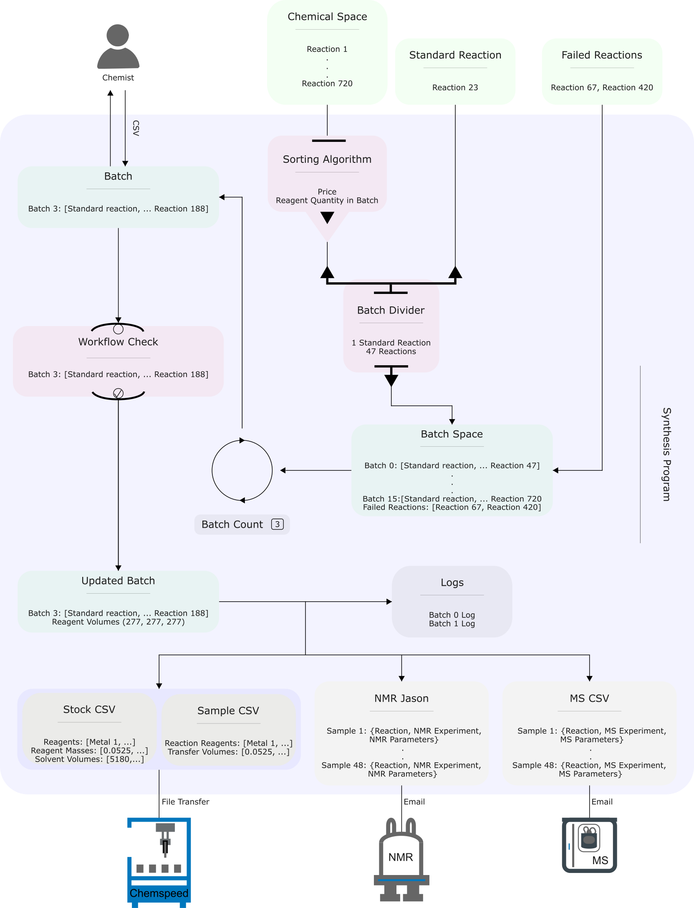

Figure : The logic and organisation of the synthesis program which is responsible for scheduling reactions for synthesis and analysis on ChemSpeed, NMR and MS platforms. The program takes in the chemical space, sorts it, divides it up into batches and adds a standard reaction for each batch to give, the batch space. Batches are then extracted from the batch space depending on batch count. The batch then generates a csv of all the reagent masses required to make up the reactions in the run. This csv is read and filled by a chemist and then, checked by the program to create updated batches. The updated batches are then stored in logs, generate Stock, Sample, MS CSVs and a NMR Json. The CSVs and Jason files are then sent to their respective platforms. It is possible to retake failed reactions, by re-writing them to the batch space.

The program initially takes in the chemical space generated previously, and sorts it based on reaction price and reagents. The workflow is plagued with errors once first set up. Hence the first few batches typically fail. When a batch or reaction fails, these can be easily retaken by the programme. The sorting algorithm is therefore responsible for selecting the cheapest reaction first, to minimise expenses. Additionally, the ChemSpeed platform is incapable of handling solids and is limited to handling 48 reactions at once. This requires the workflow to be broken down into 16 batches each of which requires the chemist to weigh out reagents. Therefore, the sorting algorithm also selects batch reactions to minimise the number of reagents the chemist has to weigh in a run. Consequently, sorting the chemical space reduces expenses and chemist physical efforts.

The sorted chemical space is then divided into batches of 47 along with an added standard reaction to generate the batch space. The standard reaction allows the chemist to quickly check if reaction parameters and machinery conditions were kept consistent between runs. The standard reaction is selected based on a successful reaction with a clean spectrum, allowing quick NMR interpretation for both the chemist and workflow. The standard reaction used was reaction 24 which is a combination of iron, reagent 3, and reagent 17. Therefore, standard reactions play the role of quality control.

Batches are then extracted by the batch space depending on the batch count. For example, a batch count of 3 extracts batch 3 from the batch space. Batch count starts at count 0 and ends at count 15. The count is updated by the program only once the Stock CSV, Batch CSV, MS CSV and NMR Jason have been generated.

As mentioned previously, the synthesis platform is incapable of solid dispensing. Hence, the extracted batch, generates a csv of reagent masses for the chemist to weigh. The chemist then adds the masses of the weighed reagents into the csv to be read by the program. The weighed masses and synthesis platform then undergo a series of checks before generating the updated batch (Figure 9). Checking chemist input catches errors where either no masses have been added or extreme cases. For example, where 20g of reagent were measured instead of 0.2g. The program also forces the chemist to check: if NMR vails, LCMS vials, charged reagent vials, reaction vials have been added; if solvents reservoirs are full; and if the waste reservoir is empty. The locations of the vials and reservoirs are shown in S 2. Therefore, the check ensures a complete setup before generating the updated batch, reducing failed runs.

The updated batch then is stored as logs and is used to generate a Stock CSV, a Sample CSV, a MS CSV, and a NMR Jason. CSVs were generated for the ChemSpeed as it’s the only input it takes. While Jsons and CSVs were generated for the NMR and LCMS machines as it’s the input type the autosampler takes in. Stock and Sample CSV are read by the ChemSpeed platform and provides information on how to make up the stock solutions (based on reagent solubilities tests determined before), and how to transfer stock solutions into reaction vials (to form reaction combinations in the batch). Both Stock and Sample CSV are transferred to the ChemSpeed via a shared folder on the local network. The MS CSV is sent to the LCMS autosampler via email and contains information on the aliquot volume, sample number, and several other MS parameters. For example, if samples need to pass through a column. The NMR Jason is sent to the NMR autosampler via email and contains information on the sample, and several NMR parameters. For example, the number of scans. These output files therefore dictate the behaviour of the platforms to create a batch its analysis.

These modifications allowed for a reliable synthesis and analysis workflow, where all 720 reactions can be acquired in the span of 6 weeks, where 15% of this time is spent setting up workflows, cleaning NMR tubes and cleaning used vials. Furthermore, the program is written in a way, that a non-expert coder is capable too of running experiments in automation. Lastly, both modifications and program reduce set up times while reducing as much human error as possible through each step of the process.

### 4.2.1.2 Synthesis and Analysis of the Selected Space

With all the platforms, modifications and programmes set up, reactions in the selected chemical space can be carried out and analysed in automation. This still requires the chemist to complete a few tasks for each batch run. The complete manual process of carrying out a run is shown in Figure 10 and the relevant locations in the synthesis platform are shown in S 2.

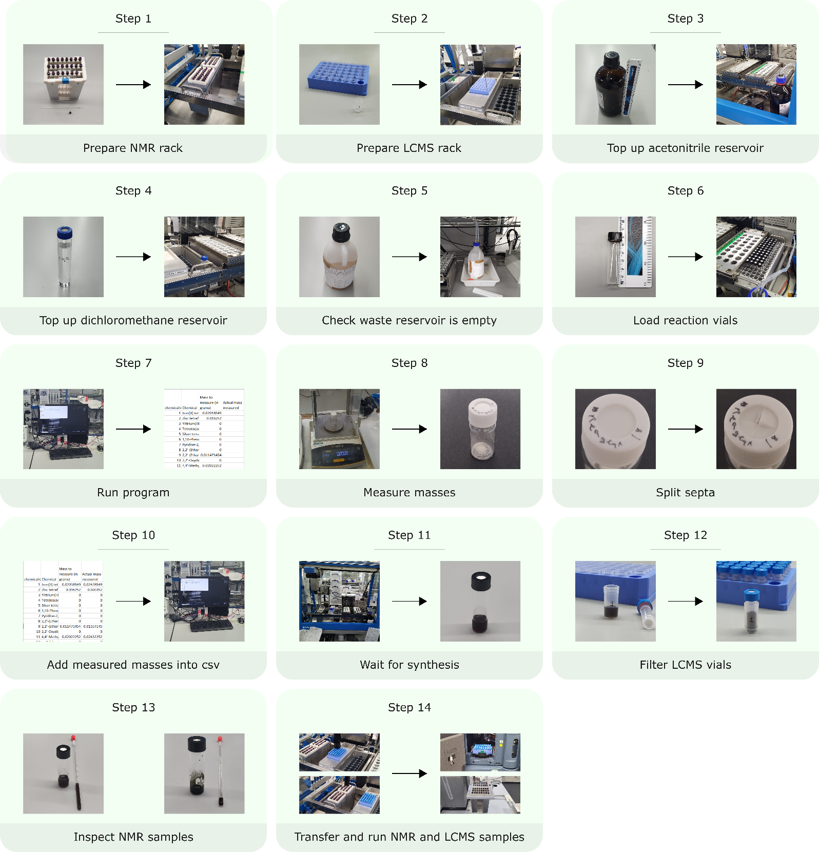

Figure : The physical steps a chemist needs to take to run a batch in the workflow. There are 14 overall steps that are required for post and pre-platform running.

As outlined in the section 3, the chemist first defines a chemical space into the program to generate a computer readable representation of the space.

With the space generated the workflow is now capable of taking batches for synthesis and analysis. However, the chemist must first setup the workflow before any batches can be run.

Firstly, clean nmr tubes are labelled and topped with an appropriate NMR lids, with holes drilled into them, are added onto the NMR rack. The hole in the lid allows the ChemSpeed to dispense samples into the NMR tube. The rack is then placed into the appropriate location on the ChemSpeed.

Secondly, LCMS vials are labelled and added onto their rack. In preliminary test, precipitates ended up clogging the mass spectrometer’s injection syringe. Hence, syringeless filter LCMS vials were used (Figure 10). The LCMS rack is then placed in the appropriate location on the ChemSpeed.

Since both acetonitrile and dichloromethane were used as solvents, these have to be topped up before each run. Since, acetonitrile was used as the main solvent, a whole Winchester bottle was used as a reservoir, while for dichloromethane, a 60mL vial was used.

The ChemSpeed only has 4 needles for liquid handling. Hence, to ensure reagent purity, these are washed by the platform autonomously after each transfer, creating solvent waste. Therefore, the chemist also has to ensure that the waste reservoir is not full before each run.

The platform carries out reactions in 8mL vials, where a vial belongs to a single reaction. 8 mL vials were chosen, so that enough sample can be easily prepared and handled by the platform for NMR and LCMS analysis. Additionally, a small reaction volume was chosen to avoid excess consumption of reagents. 48 of these empty 8mL vials need to be manually loaded into the ChemSpeed for each run.

With the above steps all set, the chemist can now run the program from section 4.2.1.1, spitting out a csv with reagents and masses to measure for each batch. The chemist measures the masses of each reagent into separate 20 mL vials, splits their septa and then loads them into appropriate locations in the ChemSpeed. 20 mL vials were chosen as they are capable of holding just the right volume of solvents to form stock solutions without requiring larger vials. The vial septa must be split as they are thick and do not allow pressure to equilibrate in the vial. If septa are not split, the platform does not dispense solvents reliably and accurately.

The chemist then adds the measured reagent masses into a csv for the program to read. The program then forces the chemist to double check the platform is set up correctly, and automatically checks for potential errors in the input masses. When these checks are confirmed, the platform starts synthesis and once done, the chemist needs to filter out the LCMS samples. This is made simple as the vials are purpose built to be filtered syringeless (Figure 10). Afterwards, the chemist visually checks that all NMR tubes contain samples with appropriate sample volumes for NMR spectra acquisition. A visual inspection for failed reactions is required, as often, seals in reaction vials are broken, causing the evaporative loss of reaction mixtures. Failed reactions can be re-feed into the programme to then be rerun.

The chemist then takes the NMR and mass spec samples to their appropriate machines to run analysis. The machines autosamplers should already have the relevant information of the batch and its samples, as these were sent by the main program via email.

This process of setting up and measuring reagents took 3-4 hours for each set up. Synthesis, and sample preparation took the synthesis platform 50 hours. Mass spec, and NMR analysis took 1.5 and 6 hours respectively. Each batch required 5 hours of rinsing and washing. For each batch an average of 5 reactions failed, caused by evaporative loss. Furthermore, when the workflow programs were refactored a bug was introduced, causing x of these reaction to run NMR spectra with 8 scans rather than 64. This only leave out X reactions for safe data analysis. Between runs, the NMR machine also had to be fixed. None the less, the setup of the workflow was designed to minimise human work effort.

### 4.2.2 Set Up Decision Maker

With the robotic set up fully in place, the reactions in the chemical space can be synthesised and their NMR and MS spectra taken. What is now required is the setup of the decision maker, which determines if a reaction is successful or not based on NMR and MS alone.

The heuristic decision maker was previously developed in the group, and has been adapted for this masters project. It aims to mimic the human decision-making process when analysing a spectrum for reactivity. Hence, it contains domain knowledge in its heuristics. The logic of the decision maker is shown Figure 11.

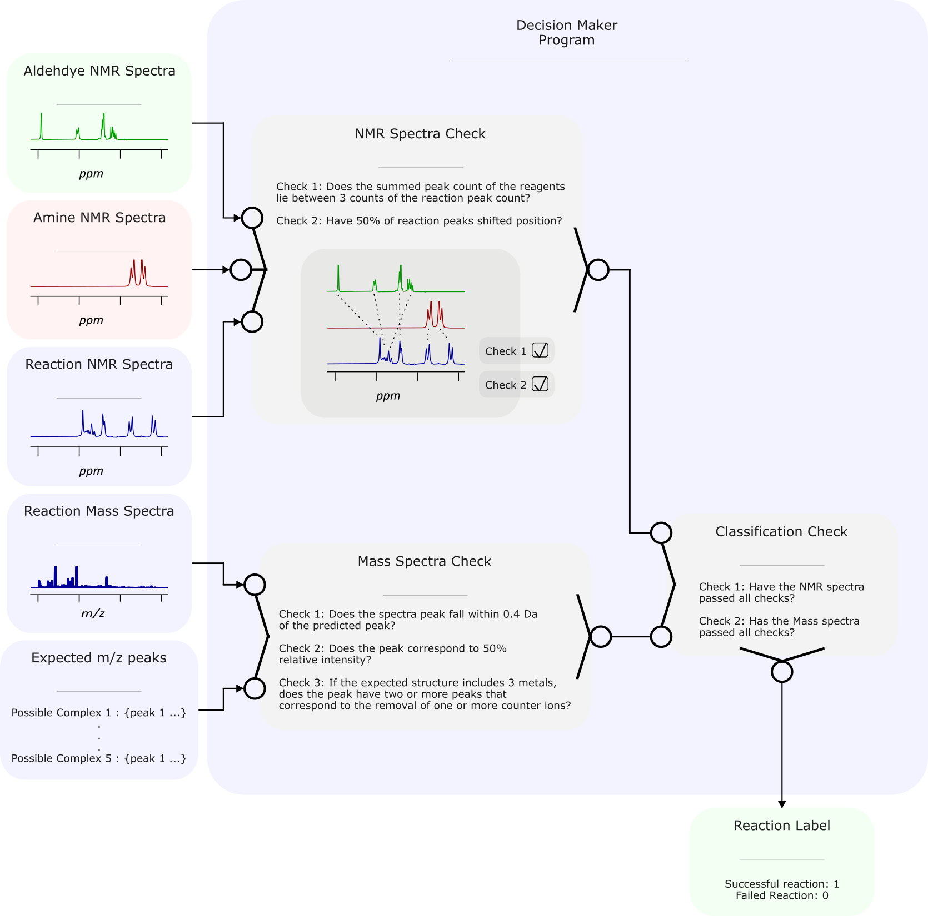

Figure : The decision maker. It takes in the starting material NMR spectra, the reaction NMR spectra, the reaction mass spectra and the expected peaks of the mass spectra. The reagent and reaction NMR spectra are then compared to chemist defined heuristics to determine if a reaction has occurred or not. The reaction mass spectra and predicted mass peaks are also compared by chemist defined heuristic to determine if a supramolecular complex has formed. If both mass and NMR spectra pass all heuristics, the reaction is labelled as successful.

The decision maker takes the starting material NMR spectra, the reaction NMR spectra, the reaction mass spectra, and the expected mass peaks. The expected peaks correspond to molecular ion peaks of possible formed complexes, each with different numbers of counter ions. NMR spectra indicates if a reaction has occurred while the mass spectra indicates if a supramolecular compound has formed. Therefore, both spectra are analysed to improve outcome robustness.

Decision maker compares reagent NMR spectra and reaction spectra based on peak count and chemical shift in two separate checks (Figure 11). If 50% of reagent peaks are shifted, the first check is passed. Since a low field NMR machine was used, these shifts may cause overlap or a change in multiplet shape. Hence, the second check ensures the sum of the number of peaks in reagent NMR fall within 3 counts of the number of peaks of the reaction NMR.

Decision maker compares the reaction mass spectra and expected mass peaks based on three checks. The first check ensures the reaction mass peak falls within 0.4 Da of the expected peak, and the second checks if this peak has a relative intensity of at least 50%. The third check ensures that if the predicted structure has to or more metals, two peaks that satisfy check 1 and check 2 have been found. This reduces the number of false positives caused by the shear amount of possible expected mass peaks.

The percentage of shifted NMR peaks, the range of NMR peak count, the range of mass peak hit, and the relative intensity of mass peak, are all parameters which can be varied. Hence, 94 reactions were labelled by an expert chemist and parameters optimized until decision maker and human labels best converged.

Once all checks for both spectra are passed, then the reaction is labelled as successful. Decision maker now allows the machine interpretable chemical space to be populated with labels.

There are a few things to set up before decision maker can be used. Firstly all spectra have to be processed, so that pick picking is functional. This includes, baseline corrections, fourier tranforms and phase corrections. This is done via the TopSpin API and spectra a checked manually. Sometimes the automated phase correction fails dramatically, and must be fixed by human (efp causes a formation of a wave, sometimes apk makes phase 180 out of phase). Secondly, all NMR spectra is classified as successful or not by a chemist. Preliminary experiments demonstrate 4 types of spectra: clean, oligomers, paramagnetic, SM. This data is then used to optimize decision maker. Decision maker is only capable of determining if a discrete structure is formed or not.

A manual classification also ensure quality of NMR data, and comparison between human and automated labelling.

### 4.2.3 Label Acquired Reactions

With the robotic platforms and decision maker all setup, the reactions and their spectra taken, labels for each reaction can be generated. This is handled by the program in Figure 12, the simplest so far.

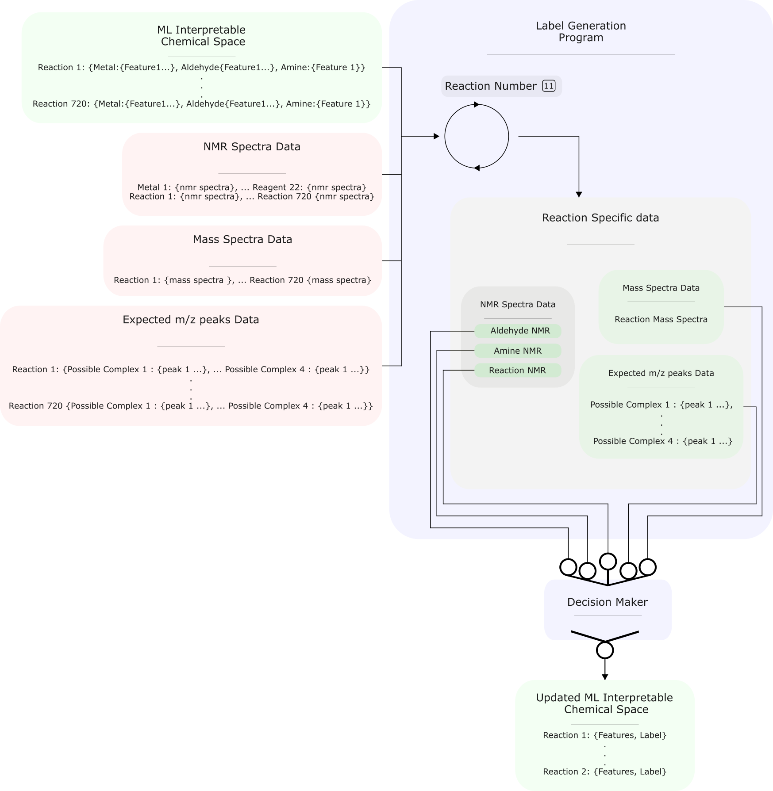

Figure : The logic behind the programme that takes in all spectra data, feeds it to decision maker to generate a chemical space filled by reactions with both features and labels. This program is a simple loop.

While simple, the programme plays a fundamental role in tying together features, spectra, and labels. The program is a loop that iterates through each reaction, and with it its features, and feeds decision maker with its NMR and mass spectra along with its reagent NMR spectra and expected mass peaks (Figure 12). This then generates a label for the reaction. The final output of the program is a chemical space with reactions, features and labels. This is the dataset to be analysed and used with machine learning models.

## 5.0 Dataset Exploration

The robotic platform, along with decision maker, allows data to be collected on a whole chemical space. What is now required, is sieve building and an in-depth analysis to gain chemical insight.

## References

(1) Schrader, M. L.; Schäfer, F. R.; Schäfers, F.; Glorius, F. Bridging the Information Gap in Organic Chemical Reactions. *Nat. Chem.* **2024**, *16* (4), 491–498. https://doi.org/10.1038/s41557-024-01470-8.

(2) Nippa, D. F.; Atz, K.; Müller, A. T.; Wolfard, J.; Isert, C.; Binder, M.; Scheidegger, O.; Konrad, D. B.; Grether, U.; Martin, R. E.; Schneider, G. Identifying Opportunities for Late-Stage C-H Alkylation with High-Throughput Experimentation and in Silico Reaction Screening. *Commun. Chem.* **2023**, *6* (1), 1–11. https://doi.org/10.1038/s42004-023-01047-5.

(3) Zhang, D.; Ronson, T. K.; Nitschke, J. R. Functional Capsules via Subcomponent Self-Assembly. *Acc. Chem. Res.* **2018**, *51* (10), 2423–2436. https://doi.org/10.1021/acs.accounts.8b00303.

(4) Chakrabarty, R.; Mukherjee, P. S.; Stang, P. J. Supramolecular Coordination: Self-Assembly of Finite Two- and Three-Dimensional Ensembles. *Chem. Rev.* **2011**, *111* (11), 6810–6918. https://doi.org/10.1021/cr200077m.

(5) Noh, J.; Doan, H. A.; Job, H.; Robertson, L. A.; Zhang, L.; Assary, R. S.; Mueller, K.; Murugesan, V.; Liang, Y. An Integrated High-Throughput Robotic Platform and Active Learning Approach for Accelerated Discovery of Optimal Electrolyte Formulations. *Nat. Commun.* **2024**, *15* (1), 2757. https://doi.org/10.1038/s41467-024-47070-5.

(6) Cook, T. R.; Zheng, Y.-R.; Stang, P. J. Metal–Organic Frameworks and Self-Assembled Supramolecular Coordination Complexes: Comparing and Contrasting the Design, Synthesis, and Functionality of Metal–Organic Materials. *Chem. Rev.* **2013**, *113* (1), 734–777. https://doi.org/10.1021/cr3002824.

(7) Caramelli, D.; Granda, J. M.; Mehr, S. H. M.; Cambié, D.; Henson, A. B.; Cronin, L. Discovering New Chemistry with an Autonomous Robotic Platform Driven by a Reactivity-Seeking Neural Network. *ACS Cent. Sci.* **2021**, *7* (11), 1821–1830. https://doi.org/10.1021/acscentsci.1c00435.

(8) Abolhasani, M.; Kumacheva, E. The Rise of Self-Driving Labs in Chemical and Materials Sciences. *Nat. Synth.* **2023**, *2* (6), 483–492. https://doi.org/10.1038/s44160-022-00231-0.

(9) Li, X.; Maffettone, P. M.; Che, Y.; Liu, T.; Chen, L.; Cooper, A. I. Combining Machine Learning and High-Throughput Experimentation to Discover Photocatalytically Active Organic Molecules. *Chem. Sci.* **2021**, *12* (32), 10742–10754. https://doi.org/10.1039/D1SC02150H.

(10) Renom-Carrasco, M.; Lefort, L. Ligand Libraries for High Throughput Screening of Homogeneous Catalysts. *Chem. Soc. Rev.* **2018**, *47* (13), 5038–5060. https://doi.org/10.1039/C7CS00844A.

(11) Rulev, A. Y. Serendipity or the Art of Making Discoveries. *New J. Chem.* **2017**, *41* (11), 4262–4268. https://doi.org/10.1039/C7NJ00182G.

(12) O’Shaughnessy, M.; Glover, J.; Hafizi, R.; Barhi, M.; Clowes, R.; Chong, S. Y.; Argent, S. P.; Day, G. M.; Cooper, A. I. Porous Isoreticular Non-Metal Organic Frameworks. *Nature* **2024**, *630* (8015), 102–108. https://doi.org/10.1038/s41586-024-07353-9.

(13) Burger, B.; Maffettone, P. M.; Gusev, V. V.; Aitchison, C. M.; Bai, Y.; Wang, X.; Li, X.; Alston, B. M.; Li, B.; Clowes, R.; Rankin, N.; Harris, B.; Sprick, R. S.; Cooper, A. I. A Mobile Robotic Chemist. *Nature* **2020**, *583* (7815), 237–241. https://doi.org/10.1038/s41586-020-2442-2.

(14) Li, X.; Che, Y.; Chen, L.; Liu, T.; Wang, K.; Liu, L.; Yang, H.; Pyzer-Knapp, E. O.; Cooper, A. I. Sequential Closed-Loop Bayesian Optimization as a Guide for Organic Molecular Metallophotocatalyst Formulation Discovery. *Nat. Chem.* **2024**, 1–9. https://doi.org/10.1038/s41557-024-01546-5.

(15) Rodríguez-Pérez, R.; Bajorath, J. Interpretation of Compound Activity Predictions from Complex Machine Learning Models Using Local Approximations and Shapley Values. *J. Med. Chem.* **2020**, *63* (16), 8761–8777. https://doi.org/10.1021/acs.jmedchem.9b01101.

(16) Goral, V.; Nelen, M. I.; Eliseev, A. V.; Lehn, J.-M. Double-Level “Orthogonal” Dynamic Combinatorial Libraries on Transition Metal Template. *Proc. Natl. Acad. Sci.* **2001**, *98* (4), 1347–1352. https://doi.org/10.1073/pnas.98.4.1347.

(17) Safont-Sempere, M. M.; Fernández, G.; Würthner, F. Self-Sorting Phenomena in Complex Supramolecular Systems. *Chem. Rev.* **2011**, *111* (9), 5784–5814. https://doi.org/10.1021/cr100357h.

(18) *Supramolecular chemistry and self-assembly*. https://doi.org/10.1073/pnas.062524299.

(19) Collins, N.; Stout, D.; Lim, J.-P.; Malerich, J. P.; White, J. D.; Madrid, P. B.; Latendresse, M.; Krieger, D.; Szeto, J.; Vu, V.-A.; Rucker, K.; Deleo, M.; Gorfu, Y.; Krummenacker, M.; Hokama, L. A.; Karp, P.; Mallya, S. Fully Automated Chemical Synthesis: Toward the Universal Synthesizer. *Org. Process Res. Dev.* **2020**, *24* (10), 2064–2077. https://doi.org/10.1021/acs.oprd.0c00143.

(20) Manzano, J. S.; Hou, W.; Zalesskiy, S. S.; Frei, P.; Wang, H.; Kitson, P. J.; Cronin, L. An Autonomous Portable Platform for Universal Chemical Synthesis. *Nat. Chem.* **2022**, *14* (11), 1311–1318. https://doi.org/10.1038/s41557-022-01016-w.

(21) van Dam, A.; van Schendel, R.; Gangarapu, S.; Zuilhof, H.; Smulders, M. M. J. DFT Study of Imine-Exchange Reactions in Iron(II)-Coordinated Pincers. *Chem. – Eur. J.* **2023**, *29* (61), e202301795. https://doi.org/10.1002/chem.202301795.

(22) Ayme, J.-F.; Beves, J. E.; Campbell, C. J.; Leigh, D. A. Probing the Dynamics of the Imine-Based Pentafoil Knot and Pentameric Circular Helicate Assembly. *J. Am. Chem. Soc.* **2019**, *141* (8), 3605–3612. https://doi.org/10.1021/jacs.8b12800.

(23) Ayme, J.-F.; Lehn, J.-M.; Bailly, C.; Karmazin, L. Simultaneous Generation of a [2 × 2] Grid-Like Complex and a Linear Double Helicate: A Three-Level Self-Sorting Process. *J. Am. Chem. Soc.* **2020**, *142* (12), 5819–5824. https://doi.org/10.1021/jacs.0c00896.

(24) Bennett, K. J.; Bates, A. L.; Carolan, A. N.; Jones, S. B.; Lee, H.-S.; Hancock, R. D. Complexation of Lanthanide(III) and Yttrium(III) Cations with Terpyridyl, Dipyridoacridine, and 1,10-Phenanthroline in Aqueous Solution. Importance of Covalence in Metal–Ligand Bonding in Complexes of Lanthanides with Nitrogen Donor Ligands. *Inorganica Chim. Acta* **2023**, *557*, 121669. https://doi.org/10.1016/j.ica.2023.121669.

(25) Neese, F. (2012) The ORCA Program System, Wiley Interdiscip.

(26) Alexander T. (2024) Orca-Parser 0.2.4.

# Supplementary Information

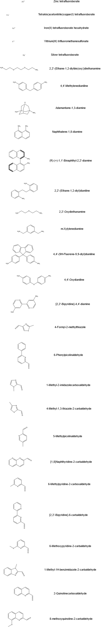

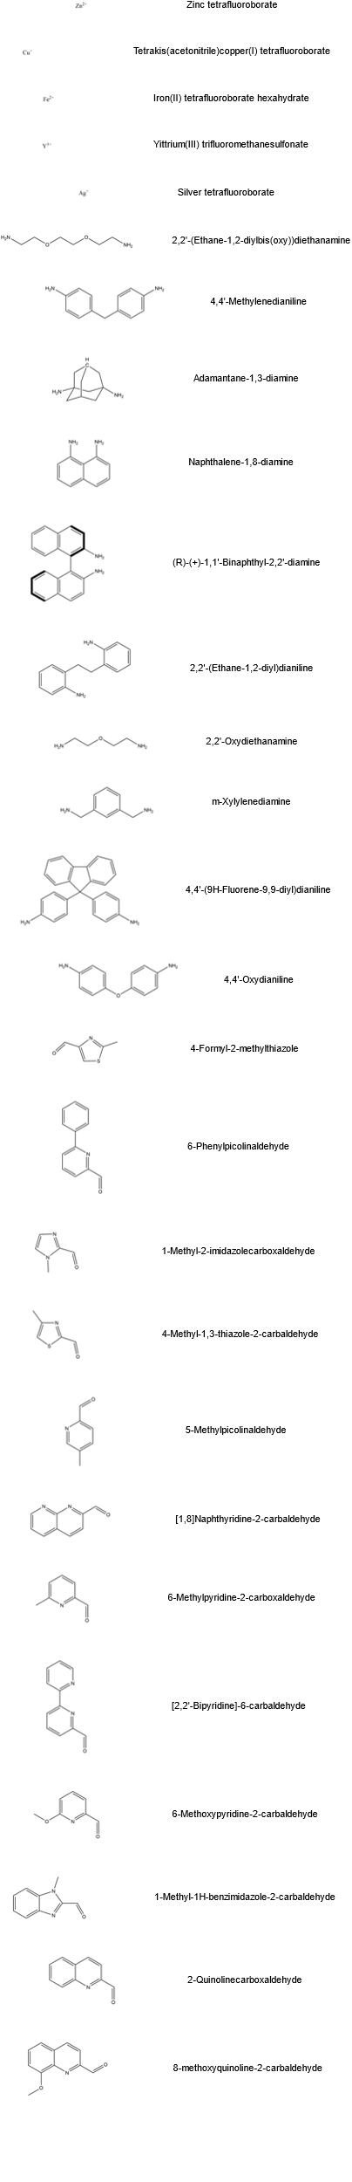

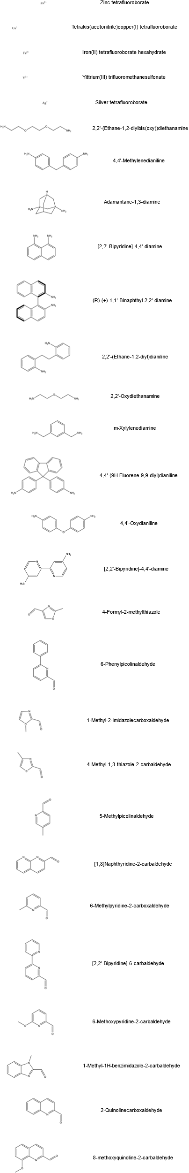

S : A table of reagent names and structures used in the study.

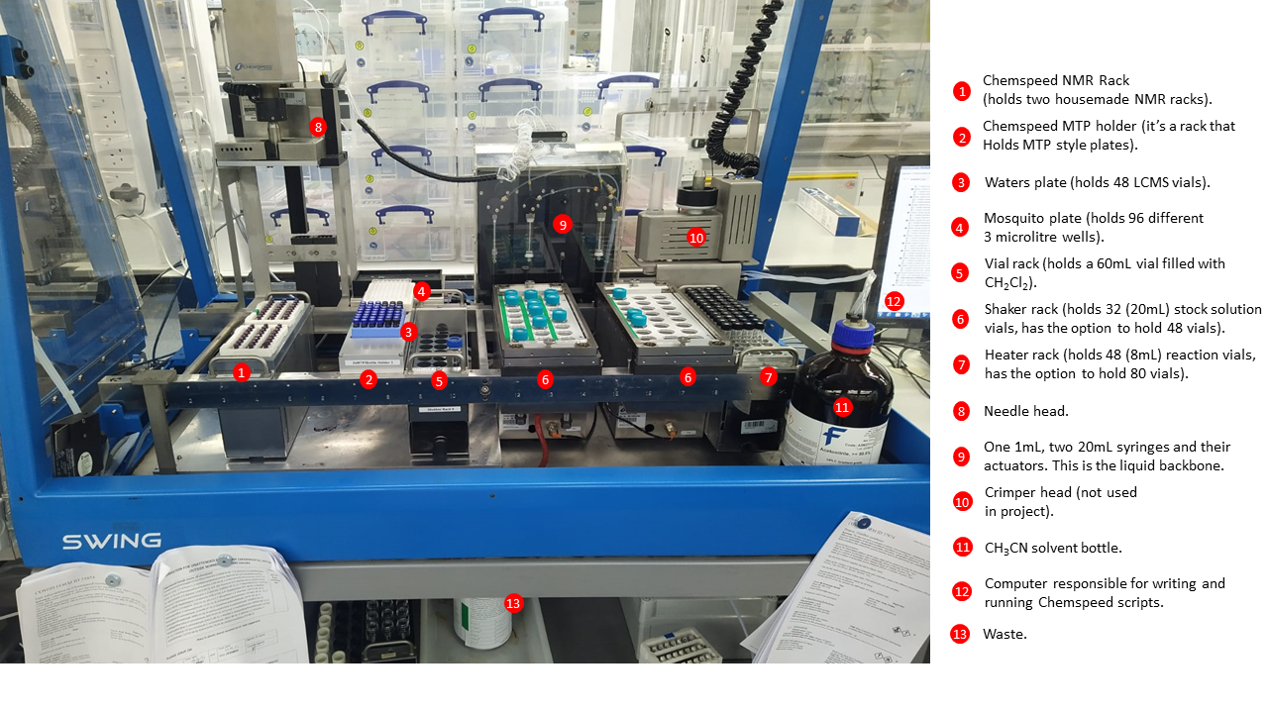

S : The physical setup of the synthesis (ChemSpeed Swing) platform. The relevant areas are marked via an index. The above shows the platform ready for a run.

|  |  |
| --- | --- |
| Unique Identifier | Reaction |
| 1 | [6-Methylpyridine-2-carboxaldehyde, Zinc tetrafluoroborate, 4,4'-Methylenedianiline] |
| 2 | [6-Methylpyridine-2-carboxaldehyde, Zinc tetrafluoroborate, 2,2'-(Ethane-1,2-diylbis(oxy))diethanamine] |
| 3 | [6-Methylpyridine-2-carboxaldehyde, Zinc tetrafluoroborate, 4,4'-Oxydianiline] |
| 4 | [Iron(II) tetrafluoroborate hexahydrate, 6-Methylpyridine-2-carboxaldehyde, 4,4'-Methylenedianiline] |
| 5 | [Iron(II) tetrafluoroborate hexahydrate, 6-Methylpyridine-2-carboxaldehyde, 2,2'-(Ethane-1,2-diylbis(oxy))diethanamine] |
| 6 | [Iron(II) tetrafluoroborate hexahydrate, 6-Methylpyridine-2-carboxaldehyde, 4,4'-Oxydianiline] |
| 7 | [6-Methoxypyridine-2-carbaldehyde, Zinc tetrafluoroborate, 4,4'-Methylenedianiline] |
| 8 | [6-Methoxypyridine-2-carbaldehyde, Zinc tetrafluoroborate, 2,2'-(Ethane-1,2-diylbis(oxy))diethanamine] |
| 9 | [6-Methoxypyridine-2-carbaldehyde, Zinc tetrafluoroborate, 4,4'-Oxydianiline] |
| 10 | [Naphthalene-1,8-diamine, 6-Methylpyridine-2-carboxaldehyde, Zinc tetrafluoroborate] |
| 11 | [4,4'-(9H-AdamantaeFlurene-9,9diyl)dianiline, 6-Methylpyridine-2-carboxaldehyde, Zinc tetrafluoroborate] |
| 12 | [6-Methoxypyridine-2-carbaldehyde, Iron(II) tetrafluoroborate hexahydrate, 4,4'-Methylenedianiline] |
| 13 | [6-Methoxypyridine-2-carbaldehyde, Iron(II) tetrafluoroborate hexahydrate, 2,2'-(Ethane-1,2-diylbis(oxy))diethanamine] |
| 14 | [6-Methoxypyridine-2-carbaldehyde, Iron(II) tetrafluoroborate hexahydrate, 4,4'-Oxydianiline] |
| 15 | [Naphthalene-1,8-diamine, Iron(II) tetrafluoroborate hexahydrate, 6-Methylpyridine-2-carboxaldehyde] |
| 16 | [4,4'-(9H-AdamantaeFlurene-9,9diyl)dianiline, Iron(II) tetrafluoroborate hexahydrate, 6-Methylpyridine-2-carboxaldehyde] |
| 17 | [Naphthalene-1,8-diamine, 6-Methoxypyridine-2-carbaldehyde, Zinc tetrafluoroborate] |
| 18 | [4,4'-(9H-AdamantaeFlurene-9,9diyl)dianiline, 6-Methoxypyridine-2-carbaldehyde, Zinc tetrafluoroborate] |
| 19 | [Naphthalene-1,8-diamine, 6-Methoxypyridine-2-carbaldehyde, Iron(II) tetrafluoroborate hexahydrate] |
| 20 | [4,4'-(9H-AdamantaeFlurene-9,9diyl)dianiline, 6-Methoxypyridine-2-carbaldehyde, Iron(II) tetrafluoroborate hexahydrate] |
| 21 | [5-Methylpicolinaldehyde, Zinc tetrafluoroborate, 4,4'-Methylenedianiline] |
| 22 | [5-Methylpicolinaldehyde, Zinc tetrafluoroborate, 2,2'-(Ethane-1,2-diylbis(oxy))diethanamine] |
| 23 | [5-Methylpicolinaldehyde, Zinc tetrafluoroborate, 4,4'-Oxydianiline] |
| 24 | [5-Methylpicolinaldehyde, Iron(II) tetrafluoroborate hexahydrate, 4,4'-Methylenedianiline] |
| 25 | [5-Methylpicolinaldehyde, Iron(II) tetrafluoroborate hexahydrate, 2,2'-(Ethane-1,2-diylbis(oxy))diethanamine] |
| 26 | [5-Methylpicolinaldehyde, Iron(II) tetrafluoroborate hexahydrate, 4,4'-Oxydianiline] |
| 27 | [5-Methylpicolinaldehyde, Naphthalene-1,8-diamine, Zinc tetrafluoroborate] |
| 28 | [5-Methylpicolinaldehyde, 4,4'-(9H-AdamantaeFlurene-9,9diyl)dianiline, Zinc tetrafluoroborate] |
| 29 | [5-Methylpicolinaldehyde, Naphthalene-1,8-diamine, Iron(II) tetrafluoroborate hexahydrate] |
| 30 | [5-Methylpicolinaldehyde, 4,4'-(9H-AdamantaeFlurene-9,9diyl)dianiline, Iron(II) tetrafluoroborate hexahydrate] |
| 31 | [m-Xylylenediamine, 6-Methylpyridine-2-carboxaldehyde, Zinc tetrafluoroborate] |
| 32 | [m-Xylylenediamine, Iron(II) tetrafluoroborate hexahydrate, 6-Methylpyridine-2-carboxaldehyde] |
| 33 | [m-Xylylenediamine, 6-Methoxypyridine-2-carbaldehyde, Zinc tetrafluoroborate] |
| 34 | [m-Xylylenediamine, 6-Methoxypyridine-2-carbaldehyde, Iron(II) tetrafluoroborate hexahydrate] |
| 35 | [m-Xylylenediamine, 5-Methylpicolinaldehyde, Zinc tetrafluoroborate] |
| 36 | [m-Xylylenediamine, 5-Methylpicolinaldehyde, Iron(II) tetrafluoroborate hexahydrate] |
| 37 | [1-Methyl-2-imidazolecarboxaldehyde, Zinc tetrafluoroborate, 4,4'-Methylenedianiline] |
| 38 | [1-Methyl-2-imidazolecarboxaldehyde, Zinc tetrafluoroborate, 2,2'-(Ethane-1,2-diylbis(oxy))diethanamine] |
| 39 | [1-Methyl-2-imidazolecarboxaldehyde, Zinc tetrafluoroborate, 4,4'-Oxydianiline] |
| 40 | [2,2'-(Ethane-1,2-diyl)dianiline, 6-Methylpyridine-2-carboxaldehyde, Zinc tetrafluoroborate] |
| 41 | [1-Methyl-2-imidazolecarboxaldehyde, Iron(II) tetrafluoroborate hexahydrate, 4,4'-Methylenedianiline] |
| 42 | [1-Methyl-2-imidazolecarboxaldehyde, Iron(II) tetrafluoroborate hexahydrate, 2,2'-(Ethane-1,2-diylbis(oxy))diethanamine] |
| 43 | [1-Methyl-2-imidazolecarboxaldehyde, Iron(II) tetrafluoroborate hexahydrate, 4,4'-Oxydianiline] |
| 44 | [2,2'-(Ethane-1,2-diyl)dianiline, Iron(II) tetrafluoroborate hexahydrate, 6-Methylpyridine-2-carboxaldehyde] |
| 45 | [1-Methyl-2-imidazolecarboxaldehyde, Naphthalene-1,8-diamine, Zinc tetrafluoroborate] |
| 46 | [1-Methyl-2-imidazolecarboxaldehyde, 4,4'-(9H-AdamantaeFlurene-9,9diyl)dianiline, Zinc tetrafluoroborate] |
| 47 | [2,2'-(Ethane-1,2-diyl)dianiline, 6-Methoxypyridine-2-carbaldehyde, Zinc tetrafluoroborate] |
| 48 | [1-Methyl-2-imidazolecarboxaldehyde, Naphthalene-1,8-diamine, Iron(II) tetrafluoroborate hexahydrate] |
| 49 | [1-Methyl-2-imidazolecarboxaldehyde, 4,4'-(9H-AdamantaeFlurene-9,9diyl)dianiline, Iron(II) tetrafluoroborate hexahydrate] |
| 50 | [2,2'-(Ethane-1,2-diyl)dianiline, 6-Methoxypyridine-2-carbaldehyde, Iron(II) tetrafluoroborate hexahydrate] |
| 51 | [2,2'-(Ethane-1,2-diyl)dianiline, 5-Methylpicolinaldehyde, Zinc tetrafluoroborate] |
| 52 | [2,2'-(Ethane-1,2-diyl)dianiline, 5-Methylpicolinaldehyde, Iron(II) tetrafluoroborate hexahydrate] |
| 53 | [1-Methyl-2-imidazolecarboxaldehyde, m-Xylylenediamine, Zinc tetrafluoroborate] |
| 54 | [1-Methyl-2-imidazolecarboxaldehyde, m-Xylylenediamine, Iron(II) tetrafluoroborate hexahydrate] |
| 55 | [2,2'-(Ethane-1,2-diyl)dianiline, 1-Methyl-2-imidazolecarboxaldehyde, Zinc tetrafluoroborate] |
| 56 | [2,2'-(Ethane-1,2-diyl)dianiline, 1-Methyl-2-imidazolecarboxaldehyde, Iron(II) tetrafluoroborate hexahydrate] |
| 57 | [Yittrium(III) trifluoromethanesulfonate, 6-Methylpyridine-2-carboxaldehyde, 4,4'-Methylenedianiline] |
| 58 | [Yittrium(III) trifluoromethanesulfonate, 6-Methylpyridine-2-carboxaldehyde, 2,2'-(Ethane-1,2-diylbis(oxy))diethanamine] |
| 59 | [Yittrium(III) trifluoromethanesulfonate, 6-Methylpyridine-2-carboxaldehyde, 4,4'-Oxydianiline] |
| 60 | [Yittrium(III) trifluoromethanesulfonate, 6-Methoxypyridine-2-carbaldehyde, 4,4'-Methylenedianiline] |
| 61 | [Yittrium(III) trifluoromethanesulfonate, 6-Methoxypyridine-2-carbaldehyde, 2,2'-(Ethane-1,2-diylbis(oxy))diethanamine] |
| 62 | [Yittrium(III) trifluoromethanesulfonate, 6-Methoxypyridine-2-carbaldehyde, 4,4'-Oxydianiline] |
| 63 | [Yittrium(III) trifluoromethanesulfonate, Naphthalene-1,8-diamine, 6-Methylpyridine-2-carboxaldehyde] |
| 64 | [Yittrium(III) trifluoromethanesulfonate, 4,4'-(9H-AdamantaeFlurene-9,9diyl)dianiline, 6-Methylpyridine-2-carboxaldehyde] |
| 65 | [Yittrium(III) trifluoromethanesulfonate, Naphthalene-1,8-diamine, 6-Methoxypyridine-2-carbaldehyde] |
| 66 | [Yittrium(III) trifluoromethanesulfonate, 4,4'-(9H-AdamantaeFlurene-9,9diyl)dianiline, 6-Methoxypyridine-2-carbaldehyde] |
| 67 | [Yittrium(III) trifluoromethanesulfonate, 5-Methylpicolinaldehyde, 4,4'-Methylenedianiline] |
| 68 | [Yittrium(III) trifluoromethanesulfonate, 5-Methylpicolinaldehyde, 2,2'-(Ethane-1,2-diylbis(oxy))diethanamine] |
| 69 | [Yittrium(III) trifluoromethanesulfonate, 5-Methylpicolinaldehyde, 4,4'-Oxydianiline] |
| 70 | [Yittrium(III) trifluoromethanesulfonate, 5-Methylpicolinaldehyde, Naphthalene-1,8-diamine] |
| 71 | [Yittrium(III) trifluoromethanesulfonate, 5-Methylpicolinaldehyde, 4,4'-(9H-AdamantaeFlurene-9,9diyl)dianiline] |
| 72 | [Yittrium(III) trifluoromethanesulfonate, m-Xylylenediamine, 6-Methylpyridine-2-carboxaldehyde] |
| 73 | [Yittrium(III) trifluoromethanesulfonate, m-Xylylenediamine, 6-Methoxypyridine-2-carbaldehyde] |
| 74 | [Yittrium(III) trifluoromethanesulfonate, m-Xylylenediamine, 5-Methylpicolinaldehyde] |
| 75 | [Yittrium(III) trifluoromethanesulfonate, 1-Methyl-2-imidazolecarboxaldehyde, 4,4'-Methylenedianiline] |
| 76 | [Yittrium(III) trifluoromethanesulfonate, 1-Methyl-2-imidazolecarboxaldehyde, 2,2'-(Ethane-1,2-diylbis(oxy))diethanamine] |
| 77 | [Yittrium(III) trifluoromethanesulfonate, 1-Methyl-2-imidazolecarboxaldehyde, 4,4'-Oxydianiline] |
| 78 | [Yittrium(III) trifluoromethanesulfonate, 2,2'-(Ethane-1,2-diyl)dianiline, 6-Methylpyridine-2-carboxaldehyde] |
| 79 | [Yittrium(III) trifluoromethanesulfonate, 1-Methyl-2-imidazolecarboxaldehyde, Naphthalene-1,8-diamine] |
| 80 | [Yittrium(III) trifluoromethanesulfonate, 1-Methyl-2-imidazolecarboxaldehyde, 4,4'-(9H-AdamantaeFlurene-9,9diyl)dianiline] |
| 81 | [Yittrium(III) trifluoromethanesulfonate, 2,2'-(Ethane-1,2-diyl)dianiline, 6-Methoxypyridine-2-carbaldehyde] |
| 82 | [Yittrium(III) trifluoromethanesulfonate, 2,2'-(Ethane-1,2-diyl)dianiline, 5-Methylpicolinaldehyde] |
| 83 | [Yittrium(III) trifluoromethanesulfonate, 1-Methyl-2-imidazolecarboxaldehyde, m-Xylylenediamine] |
| 84 | [Yittrium(III) trifluoromethanesulfonate, 2,2'-(Ethane-1,2-diyl)dianiline, 1-Methyl-2-imidazolecarboxaldehyde] |
| 85 | [4-Formyl-2-methylthiazole, Zinc tetrafluoroborate, 4,4'-Methylenedianiline] |
| 86 | [4-Formyl-2-methylthiazole, Zinc tetrafluoroborate, 2,2'-(Ethane-1,2-diylbis(oxy))diethanamine] |
| 87 | [4-Formyl-2-methylthiazole, Zinc tetrafluoroborate, 4,4'-Oxydianiline] |
| 88 | [4-Formyl-2-methylthiazole, Iron(II) tetrafluoroborate hexahydrate, 4,4'-Methylenedianiline] |
| 89 | [4-Formyl-2-methylthiazole, Iron(II) tetrafluoroborate hexahydrate, 2,2'-(Ethane-1,2-diylbis(oxy))diethanamine] |
| 90 | [4-Formyl-2-methylthiazole, Iron(II) tetrafluoroborate hexahydrate, 4,4'-Oxydianiline] |
| 91 | [4-Formyl-2-methylthiazole, Naphthalene-1,8-diamine, Zinc tetrafluoroborate] |
| 92 | [4-Formyl-2-methylthiazole, 4,4'-(9H-AdamantaeFlurene-9,9diyl)dianiline, Zinc tetrafluoroborate] |
| 93 | [4-Formyl-2-methylthiazole, Naphthalene-1,8-diamine, Iron(II) tetrafluoroborate hexahydrate] |
| 94 | [4-Formyl-2-methylthiazole, 4,4'-(9H-AdamantaeFlurene-9,9diyl)dianiline, Iron(II) tetrafluoroborate hexahydrate] |
| 95 | [4-Formyl-2-methylthiazole, m-Xylylenediamine, Zinc tetrafluoroborate] |
| 96 | [4-Formyl-2-methylthiazole, m-Xylylenediamine, Iron(II) tetrafluoroborate hexahydrate] |
| 97 | [4-Formyl-2-methylthiazole, 2,2'-(Ethane-1,2-diyl)dianiline, Zinc tetrafluoroborate] |
| 98 | [4-Formyl-2-methylthiazole, 2,2'-(Ethane-1,2-diyl)dianiline, Iron(II) tetrafluoroborate hexahydrate] |
| 99 | [4-Formyl-2-methylthiazole, Yittrium(III) trifluoromethanesulfonate, 4,4'-Methylenedianiline] |
| 100 | [4-Formyl-2-methylthiazole, Yittrium(III) trifluoromethanesulfonate, 2,2'-(Ethane-1,2-diylbis(oxy))diethanamine] |
| 101 | [4-Formyl-2-methylthiazole, Yittrium(III) trifluoromethanesulfonate, 4,4'-Oxydianiline] |
| 102 | [4-Formyl-2-methylthiazole, Yittrium(III) trifluoromethanesulfonate, Naphthalene-1,8-diamine] |
| 103 | [4-Formyl-2-methylthiazole, Yittrium(III) trifluoromethanesulfonate, 4,4'-(9H-AdamantaeFlurene-9,9diyl)dianiline] |
| 104 | [4-Formyl-2-methylthiazole, Yittrium(III) trifluoromethanesulfonate, m-Xylylenediamine] |
| 105 | [4-Formyl-2-methylthiazole, Yittrium(III) trifluoromethanesulfonate, 2,2'-(Ethane-1,2-diyl)dianiline] |
| 106 | [Silver tetrafluoroborate, 6-Methylpyridine-2-carboxaldehyde, 4,4'-Methylenedianiline] |
| 107 | [Silver tetrafluoroborate, 6-Methylpyridine-2-carboxaldehyde, 2,2'-(Ethane-1,2-diylbis(oxy))diethanamine] |
| 108 | [Silver tetrafluoroborate, 6-Methylpyridine-2-carboxaldehyde, 4,4'-Oxydianiline] |
| 109 | [Silver tetrafluoroborate, 6-Methoxypyridine-2-carbaldehyde, 4,4'-Methylenedianiline] |
| 110 | [Silver tetrafluoroborate, 6-Methoxypyridine-2-carbaldehyde, 2,2'-(Ethane-1,2-diylbis(oxy))diethanamine] |
| 111 | [Silver tetrafluoroborate, 6-Methoxypyridine-2-carbaldehyde, 4,4'-Oxydianiline] |
| 112 | [Silver tetrafluoroborate, Naphthalene-1,8-diamine, 6-Methylpyridine-2-carboxaldehyde] |
| 113 | [Silver tetrafluoroborate, 4,4'-(9H-AdamantaeFlurene-9,9diyl)dianiline, 6-Methylpyridine-2-carboxaldehyde] |
| 114 | [Silver tetrafluoroborate, Naphthalene-1,8-diamine, 6-Methoxypyridine-2-carbaldehyde] |
| 115 | [Silver tetrafluoroborate, 4,4'-(9H-AdamantaeFlurene-9,9diyl)dianiline, 6-Methoxypyridine-2-carbaldehyde] |
| 116 | [Silver tetrafluoroborate, 5-Methylpicolinaldehyde, 4,4'-Methylenedianiline] |
| 117 | [Silver tetrafluoroborate, 5-Methylpicolinaldehyde, 2,2'-(Ethane-1,2-diylbis(oxy))diethanamine] |
| 118 | [Silver tetrafluoroborate, 5-Methylpicolinaldehyde, 4,4'-Oxydianiline] |
| 119 | [Silver tetrafluoroborate, 5-Methylpicolinaldehyde, Naphthalene-1,8-diamine] |
| 120 | [Silver tetrafluoroborate, 5-Methylpicolinaldehyde, 4,4'-(9H-AdamantaeFlurene-9,9diyl)dianiline] |
| 121 | [Silver tetrafluoroborate, m-Xylylenediamine, 6-Methylpyridine-2-carboxaldehyde] |
| 122 | [Silver tetrafluoroborate, m-Xylylenediamine, 6-Methoxypyridine-2-carbaldehyde] |
| 123 | [Silver tetrafluoroborate, m-Xylylenediamine, 5-Methylpicolinaldehyde] |
| 124 | [Silver tetrafluoroborate, 1-Methyl-2-imidazolecarboxaldehyde, 4,4'-Methylenedianiline] |
| 125 | [Silver tetrafluoroborate, 1-Methyl-2-imidazolecarboxaldehyde, 2,2'-(Ethane-1,2-diylbis(oxy))diethanamine] |
| 126 | [Silver tetrafluoroborate, 1-Methyl-2-imidazolecarboxaldehyde, 4,4'-Oxydianiline] |
| 127 | [Silver tetrafluoroborate, 2,2'-(Ethane-1,2-diyl)dianiline, 6-Methylpyridine-2-carboxaldehyde] |
| 128 | [Silver tetrafluoroborate, 1-Methyl-2-imidazolecarboxaldehyde, Naphthalene-1,8-diamine] |
| 129 | [Silver tetrafluoroborate, 1-Methyl-2-imidazolecarboxaldehyde, 4,4'-(9H-AdamantaeFlurene-9,9diyl)dianiline] |
| 130 | [Silver tetrafluoroborate, 2,2'-(Ethane-1,2-diyl)dianiline, 6-Methoxypyridine-2-carbaldehyde] |
| 131 | [Silver tetrafluoroborate, 2,2'-(Ethane-1,2-diyl)dianiline, 5-Methylpicolinaldehyde] |
| 132 | [Silver tetrafluoroborate, 1-Methyl-2-imidazolecarboxaldehyde, m-Xylylenediamine] |
| 133 | [Silver tetrafluoroborate, 2,2'-(Ethane-1,2-diyl)dianiline, 1-Methyl-2-imidazolecarboxaldehyde] |
| 134 | [Silver tetrafluoroborate, 4-Formyl-2-methylthiazole, 4,4'-Methylenedianiline] |
| 135 | [Silver tetrafluoroborate, 4-Formyl-2-methylthiazole, 2,2'-(Ethane-1,2-diylbis(oxy))diethanamine] |
| 136 | [Silver tetrafluoroborate, 4-Formyl-2-methylthiazole, 4,4'-Oxydianiline] |
| 137 | [Silver tetrafluoroborate, 4-Formyl-2-methylthiazole, Naphthalene-1,8-diamine] |
| 138 | [Silver tetrafluoroborate, 4-Formyl-2-methylthiazole, 4,4'-(9H-AdamantaeFlurene-9,9diyl)dianiline] |
| 139 | [Silver tetrafluoroborate, 4-Formyl-2-methylthiazole, m-Xylylenediamine] |
| 140 | [Silver tetrafluoroborate, 4-Formyl-2-methylthiazole, 2,2'-(Ethane-1,2-diyl)dianiline] |
| 141 | [2-Quinolinecarboxaldehyde, Zinc tetrafluoroborate, 4,4'-Methylenedianiline] |
| 142 | [2-Quinolinecarboxaldehyde, Zinc tetrafluoroborate, 2,2'-(Ethane-1,2-diylbis(oxy))diethanamine] |
| 143 | [2-Quinolinecarboxaldehyde, Zinc tetrafluoroborate, 4,4'-Oxydianiline] |
| 144 | [2-Quinolinecarboxaldehyde, Iron(II) tetrafluoroborate hexahydrate, 4,4'-Methylenedianiline] |
| 145 | [2-Quinolinecarboxaldehyde, Iron(II) tetrafluoroborate hexahydrate, 2,2'-(Ethane-1,2-diylbis(oxy))diethanamine] |
| 146 | [2-Quinolinecarboxaldehyde, Iron(II) tetrafluoroborate hexahydrate, 4,4'-Oxydianiline] |
| 147 | [2-Quinolinecarboxaldehyde, Naphthalene-1,8-diamine, Zinc tetrafluoroborate] |
| 148 | [2-Quinolinecarboxaldehyde, 4,4'-(9H-AdamantaeFlurene-9,9diyl)dianiline, Zinc tetrafluoroborate] |
| 149 | [2-Quinolinecarboxaldehyde, Naphthalene-1,8-diamine, Iron(II) tetrafluoroborate hexahydrate] |
| 150 | [2-Quinolinecarboxaldehyde, 4,4'-(9H-AdamantaeFlurene-9,9diyl)dianiline, Iron(II) tetrafluoroborate hexahydrate] |
| 151 | [2-Quinolinecarboxaldehyde, m-Xylylenediamine, Zinc tetrafluoroborate] |
| 152 | [2-Quinolinecarboxaldehyde, m-Xylylenediamine, Iron(II) tetrafluoroborate hexahydrate] |
| 153 | [2-Quinolinecarboxaldehyde, 2,2'-(Ethane-1,2-diyl)dianiline, Zinc tetrafluoroborate] |
| 154 | [2-Quinolinecarboxaldehyde, 2,2'-(Ethane-1,2-diyl)dianiline, Iron(II) tetrafluoroborate hexahydrate] |
| 155 | [2-Quinolinecarboxaldehyde, Yittrium(III) trifluoromethanesulfonate, 4,4'-Methylenedianiline] |
| 156 | [2-Quinolinecarboxaldehyde, Yittrium(III) trifluoromethanesulfonate, 2,2'-(Ethane-1,2-diylbis(oxy))diethanamine] |
| 157 | [2-Quinolinecarboxaldehyde, Yittrium(III) trifluoromethanesulfonate, 4,4'-Oxydianiline] |
| 158 | [2-Quinolinecarboxaldehyde, Yittrium(III) trifluoromethanesulfonate, Naphthalene-1,8-diamine] |
| 159 | [2-Quinolinecarboxaldehyde, Yittrium(III) trifluoromethanesulfonate, 4,4'-(9H-AdamantaeFlurene-9,9diyl)dianiline] |
| 160 | [2-Quinolinecarboxaldehyde, Yittrium(III) trifluoromethanesulfonate, m-Xylylenediamine] |
| 161 | [2-Quinolinecarboxaldehyde, Yittrium(III) trifluoromethanesulfonate, 2,2'-(Ethane-1,2-diyl)dianiline] |
| 162 | [2-Quinolinecarboxaldehyde, Silver tetrafluoroborate, 4,4'-Methylenedianiline] |
| 163 | [2-Quinolinecarboxaldehyde, Silver tetrafluoroborate, 2,2'-(Ethane-1,2-diylbis(oxy))diethanamine] |
| 164 | [2-Quinolinecarboxaldehyde, Silver tetrafluoroborate, 4,4'-Oxydianiline] |
| 165 | [2-Quinolinecarboxaldehyde, Silver tetrafluoroborate, Naphthalene-1,8-diamine] |
| 166 | [2-Quinolinecarboxaldehyde, Silver tetrafluoroborate, 4,4'-(9H-AdamantaeFlurene-9,9diyl)dianiline] |
| 167 | [2-Quinolinecarboxaldehyde, Silver tetrafluoroborate, m-Xylylenediamine] |
| 168 | [2-Quinolinecarboxaldehyde, Silver tetrafluoroborate, 2,2'-(Ethane-1,2-diyl)dianiline] |
| 169 | [2-Quinolinecarboxaldehyde, Silver tetrafluoroborate, 4,4'-Methylenedianiline] |
| 170 | [2-Quinolinecarboxaldehyde, Silver tetrafluoroborate, 2,2'-(Ethane-1,2-diylbis(oxy))diethanamine] |
| 171 | [2-Quinolinecarboxaldehyde, Silver tetrafluoroborate, 4,4'-Oxydianiline] |
| 172 | [2-Quinolinecarboxaldehyde, Silver tetrafluoroborate, Naphthalene-1,8-diamine] |
| 173 | [2-Quinolinecarboxaldehyde, Silver tetrafluoroborate, 4,4'-(9H-AdamantaeFlurene-9,9diyl)dianiline] |
| 174 | [2-Quinolinecarboxaldehyde, Silver tetrafluoroborate, m-Xylylenediamine] |
| 175 | [2-Quinolinecarboxaldehyde, Silver tetrafluoroborate, 2,2'-(Ethane-1,2-diyl)dianiline] |
| 176 | [2,2'-Oxydiethanamine, 6-Methylpyridine-2-carboxaldehyde, Zinc tetrafluoroborate] |
| 177 | [2,2'-Oxydiethanamine, Iron(II) tetrafluoroborate hexahydrate, 6-Methylpyridine-2-carboxaldehyde] |
| 178 | [2,2'-Oxydiethanamine, 6-Methoxypyridine-2-carbaldehyde, Zinc tetrafluoroborate] |
| 179 | [2,2'-Oxydiethanamine, 6-Methoxypyridine-2-carbaldehyde, Iron(II) tetrafluoroborate hexahydrate] |
| 180 | [2,2'-Oxydiethanamine, 5-Methylpicolinaldehyde, Zinc tetrafluoroborate] |
| 181 | [2,2'-Oxydiethanamine, 5-Methylpicolinaldehyde, Iron(II) tetrafluoroborate hexahydrate] |
| 182 | [2,2'-Oxydiethanamine, 1-Methyl-2-imidazolecarboxaldehyde, Zinc tetrafluoroborate] |
| 183 | [2,2'-Oxydiethanamine, 1-Methyl-2-imidazolecarboxaldehyde, Iron(II) tetrafluoroborate hexahydrate] |
| 184 | [2,2'-Oxydiethanamine, Yittrium(III) trifluoromethanesulfonate, 6-Methylpyridine-2-carboxaldehyde] |
| 185 | [2,2'-Oxydiethanamine, Yittrium(III) trifluoromethanesulfonate, 6-Methoxypyridine-2-carbaldehyde] |
| 186 | [2,2'-Oxydiethanamine, Yittrium(III) trifluoromethanesulfonate, 5-Methylpicolinaldehyde] |
| 187 | [2,2'-Oxydiethanamine, Yittrium(III) trifluoromethanesulfonate, 1-Methyl-2-imidazolecarboxaldehyde] |
| 188 | [2,2'-Oxydiethanamine, 4-Formyl-2-methylthiazole, Zinc tetrafluoroborate] |
| 189 | [2,2'-Oxydiethanamine, 4-Formyl-2-methylthiazole, Iron(II) tetrafluoroborate hexahydrate] |
| 190 | [2,2'-Oxydiethanamine, 4-Formyl-2-methylthiazole, Yittrium(III) trifluoromethanesulfonate] |
| 191 | [2,2'-Oxydiethanamine, Silver tetrafluoroborate, 6-Methylpyridine-2-carboxaldehyde] |
| 192 | [2,2'-Oxydiethanamine, Silver tetrafluoroborate, 6-Methoxypyridine-2-carbaldehyde] |
| 193 | [2,2'-Oxydiethanamine, Silver tetrafluoroborate, 5-Methylpicolinaldehyde] |
| 194 | [2,2'-Oxydiethanamine, Silver tetrafluoroborate, 1-Methyl-2-imidazolecarboxaldehyde] |
| 195 | [2,2'-Oxydiethanamine, Silver tetrafluoroborate, 4-Formyl-2-methylthiazole] |
| 196 | [2,2'-Oxydiethanamine, 2-Quinolinecarboxaldehyde, Zinc tetrafluoroborate] |
| 197 | [2,2'-Oxydiethanamine, 2-Quinolinecarboxaldehyde, Iron(II) tetrafluoroborate hexahydrate] |
| 198 | [2,2'-Oxydiethanamine, 2-Quinolinecarboxaldehyde, Yittrium(III) trifluoromethanesulfonate] |
| 199 | [2,2'-Oxydiethanamine, 2-Quinolinecarboxaldehyde, Silver tetrafluoroborate] |
| 200 | [2,2'-Oxydiethanamine, 2-Quinolinecarboxaldehyde, Silver tetrafluoroborate] |
| 201 | [2,2'-Oxydiethanamine, Silver tetrafluoroborate, 6-Methylpyridine-2-carboxaldehyde] |
| 202 | [2,2'-Oxydiethanamine, Silver tetrafluoroborate, 6-Methoxypyridine-2-carbaldehyde] |
| 203 | [2,2'-Oxydiethanamine, Silver tetrafluoroborate, 5-Methylpicolinaldehyde] |
| 204 | [2,2'-Oxydiethanamine, Silver tetrafluoroborate, 1-Methyl-2-imidazolecarboxaldehyde] |
| 205 | [2,2'-Oxydiethanamine, Silver tetrafluoroborate, 4-Formyl-2-methylthiazole] |
| 206 | [2,2'-Oxydiethanamine, Tetrakis(acetonitrile)copper(I) tetrafluoroborate, 6-Methylpyridine-2-carboxaldehyde] |
| 207 | [2,2'-Oxydiethanamine, Tetrakis(acetonitrile)copper(I) tetrafluoroborate, 6-Methoxypyridine-2-carbaldehyde] |
| 208 | [2,2'-Oxydiethanamine, Tetrakis(acetonitrile)copper(I) tetrafluoroborate, 5-Methylpicolinaldehyde] |
| 209 | [2,2'-Oxydiethanamine, Tetrakis(acetonitrile)copper(I) tetrafluoroborate, 1-Methyl-2-imidazolecarboxaldehyde] |
| 210 | [2,2'-Oxydiethanamine, Tetrakis(acetonitrile)copper(I) tetrafluoroborate, 4-Formyl-2-methylthiazole] |
| 211 | [2,2'-Oxydiethanamine, Tetrakis(acetonitrile)copper(I) tetrafluoroborate, 2-Quinolinecarboxaldehyde] |
| 212 | [Silver tetrafluoroborate, 6-Methylpyridine-2-carboxaldehyde, 4,4'-Methylenedianiline] |
| 213 | [Silver tetrafluoroborate, 6-Methylpyridine-2-carboxaldehyde, 2,2'-(Ethane-1,2-diylbis(oxy))diethanamine] |
| 214 | [Silver tetrafluoroborate, 6-Methylpyridine-2-carboxaldehyde, 4,4'-Oxydianiline] |
| 215 | [Silver tetrafluoroborate, 6-Methoxypyridine-2-carbaldehyde, 4,4'-Methylenedianiline] |
| 216 | [Silver tetrafluoroborate, 6-Methoxypyridine-2-carbaldehyde, 2,2'-(Ethane-1,2-diylbis(oxy))diethanamine] |
| 217 | [Silver tetrafluoroborate, 6-Methoxypyridine-2-carbaldehyde, 4,4'-Oxydianiline] |
| 218 | [Silver tetrafluoroborate, Naphthalene-1,8-diamine, 6-Methylpyridine-2-carboxaldehyde] |
| 219 | [Silver tetrafluoroborate, 4,4'-(9H-AdamantaeFlurene-9,9diyl)dianiline, 6-Methylpyridine-2-carboxaldehyde] |
| 220 | [Silver tetrafluoroborate, Naphthalene-1,8-diamine, 6-Methoxypyridine-2-carbaldehyde] |
| 221 | [Silver tetrafluoroborate, 4,4'-(9H-AdamantaeFlurene-9,9diyl)dianiline, 6-Methoxypyridine-2-carbaldehyde] |
| 222 | [Silver tetrafluoroborate, 5-Methylpicolinaldehyde, 4,4'-Methylenedianiline] |
| 223 | [Silver tetrafluoroborate, 5-Methylpicolinaldehyde, 2,2'-(Ethane-1,2-diylbis(oxy))diethanamine] |
| 224 | [Silver tetrafluoroborate, 5-Methylpicolinaldehyde, 4,4'-Oxydianiline] |
| 225 | [Silver tetrafluoroborate, 5-Methylpicolinaldehyde, Naphthalene-1,8-diamine] |
| 226 | [Silver tetrafluoroborate, 5-Methylpicolinaldehyde, 4,4'-(9H-AdamantaeFlurene-9,9diyl)dianiline] |
| 227 | [Silver tetrafluoroborate, m-Xylylenediamine, 6-Methylpyridine-2-carboxaldehyde] |
| 228 | [Silver tetrafluoroborate, m-Xylylenediamine, 6-Methoxypyridine-2-carbaldehyde] |
| 229 | [Silver tetrafluoroborate, m-Xylylenediamine, 5-Methylpicolinaldehyde] |
| 230 | [Silver tetrafluoroborate, 1-Methyl-2-imidazolecarboxaldehyde, 4,4'-Methylenedianiline] |
| 231 | [Silver tetrafluoroborate, 1-Methyl-2-imidazolecarboxaldehyde, 2,2'-(Ethane-1,2-diylbis(oxy))diethanamine] |
| 232 | [Silver tetrafluoroborate, 1-Methyl-2-imidazolecarboxaldehyde, 4,4'-Oxydianiline] |
| 233 | [Silver tetrafluoroborate, 2,2'-(Ethane-1,2-diyl)dianiline, 6-Methylpyridine-2-carboxaldehyde] |
| 234 | [Silver tetrafluoroborate, 1-Methyl-2-imidazolecarboxaldehyde, Naphthalene-1,8-diamine] |
| 235 | [Silver tetrafluoroborate, 1-Methyl-2-imidazolecarboxaldehyde, 4,4'-(9H-AdamantaeFlurene-9,9diyl)dianiline] |
| 236 | [Silver tetrafluoroborate, 2,2'-(Ethane-1,2-diyl)dianiline, 6-Methoxypyridine-2-carbaldehyde] |
| 237 | [Silver tetrafluoroborate, 2,2'-(Ethane-1,2-diyl)dianiline, 5-Methylpicolinaldehyde] |
| 238 | [Silver tetrafluoroborate, 1-Methyl-2-imidazolecarboxaldehyde, m-Xylylenediamine] |
| 239 | [Silver tetrafluoroborate, 2,2'-(Ethane-1,2-diyl)dianiline, 1-Methyl-2-imidazolecarboxaldehyde] |
| 240 | [Silver tetrafluoroborate, 4-Formyl-2-methylthiazole, 4,4'-Methylenedianiline] |
| 241 | [Silver tetrafluoroborate, 4-Formyl-2-methylthiazole, 2,2'-(Ethane-1,2-diylbis(oxy))diethanamine] |
| 242 | [Silver tetrafluoroborate, 4-Formyl-2-methylthiazole, 4,4'-Oxydianiline] |
| 243 | [Silver tetrafluoroborate, 4-Formyl-2-methylthiazole, Naphthalene-1,8-diamine] |
| 244 | [Silver tetrafluoroborate, 4-Formyl-2-methylthiazole, 4,4'-(9H-AdamantaeFlurene-9,9diyl)dianiline] |
| 245 | [Silver tetrafluoroborate, 4-Formyl-2-methylthiazole, m-Xylylenediamine] |
| 246 | [Silver tetrafluoroborate, 4-Formyl-2-methylthiazole, 2,2'-(Ethane-1,2-diyl)dianiline] |
| 247 | [Tetrakis(acetonitrile)copper(I) tetrafluoroborate, 6-Methylpyridine-2-carboxaldehyde, 4,4'-Methylenedianiline] |
| 248 | [Tetrakis(acetonitrile)copper(I) tetrafluoroborate, 6-Methylpyridine-2-carboxaldehyde, 2,2'-(Ethane-1,2-diylbis(oxy))diethanamine] |
| 249 | [Tetrakis(acetonitrile)copper(I) tetrafluoroborate, 6-Methylpyridine-2-carboxaldehyde, 4,4'-Oxydianiline] |
| 250 | [Tetrakis(acetonitrile)copper(I) tetrafluoroborate, 6-Methoxypyridine-2-carbaldehyde, 4,4'-Methylenedianiline] |
| 251 | [Tetrakis(acetonitrile)copper(I) tetrafluoroborate, 6-Methoxypyridine-2-carbaldehyde, 2,2'-(Ethane-1,2-diylbis(oxy))diethanamine] |
| 252 | [Tetrakis(acetonitrile)copper(I) tetrafluoroborate, 6-Methoxypyridine-2-carbaldehyde, 4,4'-Oxydianiline] |
| 253 | [Tetrakis(acetonitrile)copper(I) tetrafluoroborate, Naphthalene-1,8-diamine, 6-Methylpyridine-2-carboxaldehyde] |
| 254 | [Tetrakis(acetonitrile)copper(I) tetrafluoroborate, 4,4'-(9H-AdamantaeFlurene-9,9diyl)dianiline, 6-Methylpyridine-2-carboxaldehyde] |
| 255 | [Tetrakis(acetonitrile)copper(I) tetrafluoroborate, Naphthalene-1,8-diamine, 6-Methoxypyridine-2-carbaldehyde] |
| 256 | [Tetrakis(acetonitrile)copper(I) tetrafluoroborate, 4,4'-(9H-AdamantaeFlurene-9,9diyl)dianiline, 6-Methoxypyridine-2-carbaldehyde] |
| 257 | [Tetrakis(acetonitrile)copper(I) tetrafluoroborate, 5-Methylpicolinaldehyde, 4,4'-Methylenedianiline] |
| 258 | [Tetrakis(acetonitrile)copper(I) tetrafluoroborate, 5-Methylpicolinaldehyde, 2,2'-(Ethane-1,2-diylbis(oxy))diethanamine] |
| 259 | [Tetrakis(acetonitrile)copper(I) tetrafluoroborate, 5-Methylpicolinaldehyde, 4,4'-Oxydianiline] |
| 260 | [Tetrakis(acetonitrile)copper(I) tetrafluoroborate, 5-Methylpicolinaldehyde, Naphthalene-1,8-diamine] |
| 261 | [Tetrakis(acetonitrile)copper(I) tetrafluoroborate, 5-Methylpicolinaldehyde, 4,4'-(9H-AdamantaeFlurene-9,9diyl)dianiline] |
| 262 | [Tetrakis(acetonitrile)copper(I) tetrafluoroborate, m-Xylylenediamine, 6-Methylpyridine-2-carboxaldehyde] |
| 263 | [Tetrakis(acetonitrile)copper(I) tetrafluoroborate, m-Xylylenediamine, 6-Methoxypyridine-2-carbaldehyde] |
| 264 | [Tetrakis(acetonitrile)copper(I) tetrafluoroborate, m-Xylylenediamine, 5-Methylpicolinaldehyde] |
| 265 | [Tetrakis(acetonitrile)copper(I) tetrafluoroborate, 1-Methyl-2-imidazolecarboxaldehyde, 4,4'-Methylenedianiline] |
| 266 | [Tetrakis(acetonitrile)copper(I) tetrafluoroborate, 1-Methyl-2-imidazolecarboxaldehyde, 2,2'-(Ethane-1,2-diylbis(oxy))diethanamine] |
| 267 | [Tetrakis(acetonitrile)copper(I) tetrafluoroborate, 1-Methyl-2-imidazolecarboxaldehyde, 4,4'-Oxydianiline] |
| 268 | [Tetrakis(acetonitrile)copper(I) tetrafluoroborate, 2,2'-(Ethane-1,2-diyl)dianiline, 6-Methylpyridine-2-carboxaldehyde] |
| 269 | [Tetrakis(acetonitrile)copper(I) tetrafluoroborate, 1-Methyl-2-imidazolecarboxaldehyde, Naphthalene-1,8-diamine] |
| 270 | [Tetrakis(acetonitrile)copper(I) tetrafluoroborate, 1-Methyl-2-imidazolecarboxaldehyde, 4,4'-(9H-AdamantaeFlurene-9,9diyl)dianiline] |
| 271 | [Tetrakis(acetonitrile)copper(I) tetrafluoroborate, 2,2'-(Ethane-1,2-diyl)dianiline, 6-Methoxypyridine-2-carbaldehyde] |
| 272 | [Tetrakis(acetonitrile)copper(I) tetrafluoroborate, 2,2'-(Ethane-1,2-diyl)dianiline, 5-Methylpicolinaldehyde] |
| 273 | [Tetrakis(acetonitrile)copper(I) tetrafluoroborate, 1-Methyl-2-imidazolecarboxaldehyde, m-Xylylenediamine] |
| 274 | [Tetrakis(acetonitrile)copper(I) tetrafluoroborate, 2,2'-(Ethane-1,2-diyl)dianiline, 1-Methyl-2-imidazolecarboxaldehyde] |
| 275 | [Tetrakis(acetonitrile)copper(I) tetrafluoroborate, 4-Formyl-2-methylthiazole, 4,4'-Methylenedianiline] |
| 276 | [Tetrakis(acetonitrile)copper(I) tetrafluoroborate, 4-Formyl-2-methylthiazole, 2,2'-(Ethane-1,2-diylbis(oxy))diethanamine] |
| 277 | [Tetrakis(acetonitrile)copper(I) tetrafluoroborate, 4-Formyl-2-methylthiazole, 4,4'-Oxydianiline] |
| 278 | [Tetrakis(acetonitrile)copper(I) tetrafluoroborate, 4-Formyl-2-methylthiazole, Naphthalene-1,8-diamine] |
| 279 | [Tetrakis(acetonitrile)copper(I) tetrafluoroborate, 4-Formyl-2-methylthiazole, 4,4'-(9H-AdamantaeFlurene-9,9diyl)dianiline] |
| 280 | [Tetrakis(acetonitrile)copper(I) tetrafluoroborate, 4-Formyl-2-methylthiazole, m-Xylylenediamine] |
| 281 | [Tetrakis(acetonitrile)copper(I) tetrafluoroborate, 4-Formyl-2-methylthiazole, 2,2'-(Ethane-1,2-diyl)dianiline] |
| 282 | [Tetrakis(acetonitrile)copper(I) tetrafluoroborate, 2-Quinolinecarboxaldehyde, 4,4'-Methylenedianiline] |
| 283 | [Tetrakis(acetonitrile)copper(I) tetrafluoroborate, 2-Quinolinecarboxaldehyde, 2,2'-(Ethane-1,2-diylbis(oxy))diethanamine] |
| 284 | [Tetrakis(acetonitrile)copper(I) tetrafluoroborate, 2-Quinolinecarboxaldehyde, 4,4'-Oxydianiline] |
| 285 | [Tetrakis(acetonitrile)copper(I) tetrafluoroborate, 2-Quinolinecarboxaldehyde, Naphthalene-1,8-diamine] |
| 286 | [Tetrakis(acetonitrile)copper(I) tetrafluoroborate, 2-Quinolinecarboxaldehyde, 4,4'-(9H-AdamantaeFlurene-9,9diyl)dianiline] |
| 287 | [Tetrakis(acetonitrile)copper(I) tetrafluoroborate, 2-Quinolinecarboxaldehyde, m-Xylylenediamine] |
| 288 | [Tetrakis(acetonitrile)copper(I) tetrafluoroborate, 2-Quinolinecarboxaldehyde, 2,2'-(Ethane-1,2-diyl)dianiline] |
| 289 | [4-Methyl-1,3-thiazole-2-carbaldehyde, Zinc tetrafluoroborate, 4,4'-Methylenedianiline] |
| 290 | [4-Methyl-1,3-thiazole-2-carbaldehyde, Zinc tetrafluoroborate, 2,2'-(Ethane-1,2-diylbis(oxy))diethanamine] |
| 291 | [4-Methyl-1,3-thiazole-2-carbaldehyde, Zinc tetrafluoroborate, 4,4'-Oxydianiline] |
| 292 | [4-Methyl-1,3-thiazole-2-carbaldehyde, Iron(II) tetrafluoroborate hexahydrate, 4,4'-Methylenedianiline] |
| 293 | [4-Methyl-1,3-thiazole-2-carbaldehyde, Iron(II) tetrafluoroborate hexahydrate, 2,2'-(Ethane-1,2-diylbis(oxy))diethanamine] |
| 294 | [4-Methyl-1,3-thiazole-2-carbaldehyde, Iron(II) tetrafluoroborate hexahydrate, 4,4'-Oxydianiline] |
| 295 | [4-Methyl-1,3-thiazole-2-carbaldehyde, Naphthalene-1,8-diamine, Zinc tetrafluoroborate] |
| 296 | [4-Methyl-1,3-thiazole-2-carbaldehyde, 4,4'-(9H-AdamantaeFlurene-9,9diyl)dianiline, Zinc tetrafluoroborate] |
| 297 | [4-Methyl-1,3-thiazole-2-carbaldehyde, Naphthalene-1,8-diamine, Iron(II) tetrafluoroborate hexahydrate] |
| 298 | [4-Methyl-1,3-thiazole-2-carbaldehyde, 4,4'-(9H-AdamantaeFlurene-9,9diyl)dianiline, Iron(II) tetrafluoroborate hexahydrate] |
| 299 | [4-Methyl-1,3-thiazole-2-carbaldehyde, m-Xylylenediamine, Zinc tetrafluoroborate] |
| 300 | [4-Methyl-1,3-thiazole-2-carbaldehyde, m-Xylylenediamine, Iron(II) tetrafluoroborate hexahydrate] |
| 301 | [4-Methyl-1,3-thiazole-2-carbaldehyde, 2,2'-(Ethane-1,2-diyl)dianiline, Zinc tetrafluoroborate] |
| 302 | [4-Methyl-1,3-thiazole-2-carbaldehyde, 2,2'-(Ethane-1,2-diyl)dianiline, Iron(II) tetrafluoroborate hexahydrate] |
| 303 | [4-Methyl-1,3-thiazole-2-carbaldehyde, Yittrium(III) trifluoromethanesulfonate, 4,4'-Methylenedianiline] |
| 304 | [4-Methyl-1,3-thiazole-2-carbaldehyde, Yittrium(III) trifluoromethanesulfonate, 2,2'-(Ethane-1,2-diylbis(oxy))diethanamine] |
| 305 | [4-Methyl-1,3-thiazole-2-carbaldehyde, Yittrium(III) trifluoromethanesulfonate, 4,4'-Oxydianiline] |
| 306 | [4-Methyl-1,3-thiazole-2-carbaldehyde, Yittrium(III) trifluoromethanesulfonate, Naphthalene-1,8-diamine] |
| 307 | [4-Methyl-1,3-thiazole-2-carbaldehyde, Yittrium(III) trifluoromethanesulfonate, 4,4'-(9H-AdamantaeFlurene-9,9diyl)dianiline] |
| 308 | [4-Methyl-1,3-thiazole-2-carbaldehyde, Yittrium(III) trifluoromethanesulfonate, m-Xylylenediamine] |
| 309 | [4-Methyl-1,3-thiazole-2-carbaldehyde, Yittrium(III) trifluoromethanesulfonate, 2,2'-(Ethane-1,2-diyl)dianiline] |
| 310 | [4-Methyl-1,3-thiazole-2-carbaldehyde, Silver tetrafluoroborate, 4,4'-Methylenedianiline] |
| 311 | [4-Methyl-1,3-thiazole-2-carbaldehyde, Silver tetrafluoroborate, 2,2'-(Ethane-1,2-diylbis(oxy))diethanamine] |
| 312 | [4-Methyl-1,3-thiazole-2-carbaldehyde, Silver tetrafluoroborate, 4,4'-Oxydianiline] |
| 313 | [4-Methyl-1,3-thiazole-2-carbaldehyde, Silver tetrafluoroborate, Naphthalene-1,8-diamine] |
| 314 | [4-Methyl-1,3-thiazole-2-carbaldehyde, Silver tetrafluoroborate, 4,4'-(9H-AdamantaeFlurene-9,9diyl)dianiline] |
| 315 | [4-Methyl-1,3-thiazole-2-carbaldehyde, Silver tetrafluoroborate, m-Xylylenediamine] |
| 316 | [4-Methyl-1,3-thiazole-2-carbaldehyde, Silver tetrafluoroborate, 2,2'-(Ethane-1,2-diyl)dianiline] |
| 317 | [4-Methyl-1,3-thiazole-2-carbaldehyde, 2,2'-Oxydiethanamine, Zinc tetrafluoroborate] |
| 318 | [4-Methyl-1,3-thiazole-2-carbaldehyde, 2,2'-Oxydiethanamine, Iron(II) tetrafluoroborate hexahydrate] |
| 319 | [4-Methyl-1,3-thiazole-2-carbaldehyde, 2,2'-Oxydiethanamine, Yittrium(III) trifluoromethanesulfonate] |
| 320 | [4-Methyl-1,3-thiazole-2-carbaldehyde, 2,2'-Oxydiethanamine, Silver tetrafluoroborate] |
| 321 | [4-Methyl-1,3-thiazole-2-carbaldehyde, 2,2'-Oxydiethanamine, Silver tetrafluoroborate] |
| 322 | [4-Methyl-1,3-thiazole-2-carbaldehyde, 2,2'-Oxydiethanamine, Tetrakis(acetonitrile)copper(I) tetrafluoroborate] |
| 323 | [4-Methyl-1,3-thiazole-2-carbaldehyde, Silver tetrafluoroborate, 4,4'-Methylenedianiline] |
| 324 | [4-Methyl-1,3-thiazole-2-carbaldehyde, Silver tetrafluoroborate, 2,2'-(Ethane-1,2-diylbis(oxy))diethanamine] |
| 325 | [4-Methyl-1,3-thiazole-2-carbaldehyde, Silver tetrafluoroborate, 4,4'-Oxydianiline] |
| 326 | [4-Methyl-1,3-thiazole-2-carbaldehyde, Silver tetrafluoroborate, Naphthalene-1,8-diamine] |
| 327 | [4-Methyl-1,3-thiazole-2-carbaldehyde, Silver tetrafluoroborate, 4,4'-(9H-AdamantaeFlurene-9,9diyl)dianiline] |
| 328 | [4-Methyl-1,3-thiazole-2-carbaldehyde, Silver tetrafluoroborate, m-Xylylenediamine] |
| 329 | [4-Methyl-1,3-thiazole-2-carbaldehyde, Silver tetrafluoroborate, 2,2'-(Ethane-1,2-diyl)dianiline] |
| 330 | [4-Methyl-1,3-thiazole-2-carbaldehyde, Tetrakis(acetonitrile)copper(I) tetrafluoroborate, 4,4'-Methylenedianiline] |
| 331 | [4-Methyl-1,3-thiazole-2-carbaldehyde, Tetrakis(acetonitrile)copper(I) tetrafluoroborate, 2,2'-(Ethane-1,2-diylbis(oxy))diethanamine] |
| 332 | [4-Methyl-1,3-thiazole-2-carbaldehyde, Tetrakis(acetonitrile)copper(I) tetrafluoroborate, 4,4'-Oxydianiline] |
| 333 | [4-Methyl-1,3-thiazole-2-carbaldehyde, Tetrakis(acetonitrile)copper(I) tetrafluoroborate, Naphthalene-1,8-diamine] |
| 334 | [4-Methyl-1,3-thiazole-2-carbaldehyde, Tetrakis(acetonitrile)copper(I) tetrafluoroborate, 4,4'-(9H-AdamantaeFlurene-9,9diyl)dianiline] |
| 335 | [4-Methyl-1,3-thiazole-2-carbaldehyde, Tetrakis(acetonitrile)copper(I) tetrafluoroborate, m-Xylylenediamine] |
| 336 | [4-Methyl-1,3-thiazole-2-carbaldehyde, Tetrakis(acetonitrile)copper(I) tetrafluoroborate, 2,2'-(Ethane-1,2-diyl)dianiline] |
| 337 | [1-Methyl-1H-benzimidazole-2-carbaldehyde, Zinc tetrafluoroborate, 4,4'-Methylenedianiline] |
| 338 | [1-Methyl-1H-benzimidazole-2-carbaldehyde, Zinc tetrafluoroborate, 2,2'-(Ethane-1,2-diylbis(oxy))diethanamine] |
| 339 | [1-Methyl-1H-benzimidazole-2-carbaldehyde, Zinc tetrafluoroborate, 4,4'-Oxydianiline] |
| 340 | [1-Methyl-1H-benzimidazole-2-carbaldehyde, Iron(II) tetrafluoroborate hexahydrate, 4,4'-Methylenedianiline] |
| 341 | [1-Methyl-1H-benzimidazole-2-carbaldehyde, Iron(II) tetrafluoroborate hexahydrate, 2,2'-(Ethane-1,2-diylbis(oxy))diethanamine] |
| 342 | [1-Methyl-1H-benzimidazole-2-carbaldehyde, Iron(II) tetrafluoroborate hexahydrate, 4,4'-Oxydianiline] |
| 343 | [1-Methyl-1H-benzimidazole-2-carbaldehyde, Naphthalene-1,8-diamine, Zinc tetrafluoroborate] |
| 344 | [1-Methyl-1H-benzimidazole-2-carbaldehyde, 4,4'-(9H-AdamantaeFlurene-9,9diyl)dianiline, Zinc tetrafluoroborate] |
| 345 | [1-Methyl-1H-benzimidazole-2-carbaldehyde, Naphthalene-1,8-diamine, Iron(II) tetrafluoroborate hexahydrate] |
| 346 | [1-Methyl-1H-benzimidazole-2-carbaldehyde, 4,4'-(9H-AdamantaeFlurene-9,9diyl)dianiline, Iron(II) tetrafluoroborate hexahydrate] |
| 347 | [1-Methyl-1H-benzimidazole-2-carbaldehyde, m-Xylylenediamine, Zinc tetrafluoroborate] |
| 348 | [1-Methyl-1H-benzimidazole-2-carbaldehyde, m-Xylylenediamine, Iron(II) tetrafluoroborate hexahydrate] |
| 349 | [1-Methyl-1H-benzimidazole-2-carbaldehyde, 2,2'-(Ethane-1,2-diyl)dianiline, Zinc tetrafluoroborate] |
| 350 | [1-Methyl-1H-benzimidazole-2-carbaldehyde, 2,2'-(Ethane-1,2-diyl)dianiline, Iron(II) tetrafluoroborate hexahydrate] |
| 351 | [1-Methyl-1H-benzimidazole-2-carbaldehyde, Yittrium(III) trifluoromethanesulfonate, 4,4'-Methylenedianiline] |
| 352 | [1-Methyl-1H-benzimidazole-2-carbaldehyde, Yittrium(III) trifluoromethanesulfonate, 2,2'-(Ethane-1,2-diylbis(oxy))diethanamine] |
| 353 | [1-Methyl-1H-benzimidazole-2-carbaldehyde, Yittrium(III) trifluoromethanesulfonate, 4,4'-Oxydianiline] |
| 354 | [1-Methyl-1H-benzimidazole-2-carbaldehyde, Yittrium(III) trifluoromethanesulfonate, Naphthalene-1,8-diamine] |
| 355 | [1-Methyl-1H-benzimidazole-2-carbaldehyde, Yittrium(III) trifluoromethanesulfonate, 4,4'-(9H-AdamantaeFlurene-9,9diyl)dianiline] |
| 356 | [1-Methyl-1H-benzimidazole-2-carbaldehyde, Yittrium(III) trifluoromethanesulfonate, m-Xylylenediamine] |
| 357 | [1-Methyl-1H-benzimidazole-2-carbaldehyde, Yittrium(III) trifluoromethanesulfonate, 2,2'-(Ethane-1,2-diyl)dianiline] |
| 358 | [1-Methyl-1H-benzimidazole-2-carbaldehyde, Silver tetrafluoroborate, 4,4'-Methylenedianiline] |
| 359 | [1-Methyl-1H-benzimidazole-2-carbaldehyde, Silver tetrafluoroborate, 2,2'-(Ethane-1,2-diylbis(oxy))diethanamine] |
| 360 | [1-Methyl-1H-benzimidazole-2-carbaldehyde, Silver tetrafluoroborate, 4,4'-Oxydianiline] |
| 361 | [1-Methyl-1H-benzimidazole-2-carbaldehyde, Silver tetrafluoroborate, Naphthalene-1,8-diamine] |
| 362 | [1-Methyl-1H-benzimidazole-2-carbaldehyde, Silver tetrafluoroborate, 4,4'-(9H-AdamantaeFlurene-9,9diyl)dianiline] |
| 363 | [1-Methyl-1H-benzimidazole-2-carbaldehyde, Silver tetrafluoroborate, m-Xylylenediamine] |
| 364 | [1-Methyl-1H-benzimidazole-2-carbaldehyde, Silver tetrafluoroborate, 2,2'-(Ethane-1,2-diyl)dianiline] |
| 365 | [1-Methyl-1H-benzimidazole-2-carbaldehyde, 2,2'-Oxydiethanamine, Zinc tetrafluoroborate] |
| 366 | [1-Methyl-1H-benzimidazole-2-carbaldehyde, 2,2'-Oxydiethanamine, Iron(II) tetrafluoroborate hexahydrate] |
| 367 | [1-Methyl-1H-benzimidazole-2-carbaldehyde, 2,2'-Oxydiethanamine, Yittrium(III) trifluoromethanesulfonate] |
| 368 | [1-Methyl-1H-benzimidazole-2-carbaldehyde, 2,2'-Oxydiethanamine, Silver tetrafluoroborate] |
| 369 | [1-Methyl-1H-benzimidazole-2-carbaldehyde, 2,2'-Oxydiethanamine, Silver tetrafluoroborate] |
| 370 | [1-Methyl-1H-benzimidazole-2-carbaldehyde, 2,2'-Oxydiethanamine, Tetrakis(acetonitrile)copper(I) tetrafluoroborate] |
| 371 | [1-Methyl-1H-benzimidazole-2-carbaldehyde, Silver tetrafluoroborate, 4,4'-Methylenedianiline] |
| 372 | [1-Methyl-1H-benzimidazole-2-carbaldehyde, Silver tetrafluoroborate, 2,2'-(Ethane-1,2-diylbis(oxy))diethanamine] |
| 373 | [1-Methyl-1H-benzimidazole-2-carbaldehyde, Silver tetrafluoroborate, 4,4'-Oxydianiline] |
| 374 | [1-Methyl-1H-benzimidazole-2-carbaldehyde, Silver tetrafluoroborate, Naphthalene-1,8-diamine] |
| 375 | [1-Methyl-1H-benzimidazole-2-carbaldehyde, Silver tetrafluoroborate, 4,4'-(9H-AdamantaeFlurene-9,9diyl)dianiline] |
| 376 | [1-Methyl-1H-benzimidazole-2-carbaldehyde, Silver tetrafluoroborate, m-Xylylenediamine] |
| 377 | [1-Methyl-1H-benzimidazole-2-carbaldehyde, Silver tetrafluoroborate, 2,2'-(Ethane-1,2-diyl)dianiline] |
| 378 | [1-Methyl-1H-benzimidazole-2-carbaldehyde, Tetrakis(acetonitrile)copper(I) tetrafluoroborate, 4,4'-Methylenedianiline] |
| 379 | [1-Methyl-1H-benzimidazole-2-carbaldehyde, Tetrakis(acetonitrile)copper(I) tetrafluoroborate, 2,2'-(Ethane-1,2-diylbis(oxy))diethanamine] |
| 380 | [1-Methyl-1H-benzimidazole-2-carbaldehyde, Tetrakis(acetonitrile)copper(I) tetrafluoroborate, 4,4'-Oxydianiline] |
| 381 | [1-Methyl-1H-benzimidazole-2-carbaldehyde, Tetrakis(acetonitrile)copper(I) tetrafluoroborate, Naphthalene-1,8-diamine] |
| 382 | [1-Methyl-1H-benzimidazole-2-carbaldehyde, Tetrakis(acetonitrile)copper(I) tetrafluoroborate, 4,4'-(9H-AdamantaeFlurene-9,9diyl)dianiline] |
| 383 | [1-Methyl-1H-benzimidazole-2-carbaldehyde, Tetrakis(acetonitrile)copper(I) tetrafluoroborate, m-Xylylenediamine] |
| 384 | [1-Methyl-1H-benzimidazole-2-carbaldehyde, Tetrakis(acetonitrile)copper(I) tetrafluoroborate, 2,2'-(Ethane-1,2-diyl)dianiline] |
| 385 | [8-methoxyquinoline-2-carbaldehyde, Zinc tetrafluoroborate, 4,4'-Methylenedianiline] |
| 386 | [8-methoxyquinoline-2-carbaldehyde, Zinc tetrafluoroborate, 2,2'-(Ethane-1,2-diylbis(oxy))diethanamine] |
| 387 | [8-methoxyquinoline-2-carbaldehyde, Zinc tetrafluoroborate, 4,4'-Oxydianiline] |
| 388 | [8-methoxyquinoline-2-carbaldehyde, Iron(II) tetrafluoroborate hexahydrate, 4,4'-Methylenedianiline] |
| 389 | [8-methoxyquinoline-2-carbaldehyde, Iron(II) tetrafluoroborate hexahydrate, 2,2'-(Ethane-1,2-diylbis(oxy))diethanamine] |
| 390 | [8-methoxyquinoline-2-carbaldehyde, Iron(II) tetrafluoroborate hexahydrate, 4,4'-Oxydianiline] |
| 391 | [8-methoxyquinoline-2-carbaldehyde, Naphthalene-1,8-diamine, Zinc tetrafluoroborate] |
| 392 | [8-methoxyquinoline-2-carbaldehyde, 4,4'-(9H-AdamantaeFlurene-9,9diyl)dianiline, Zinc tetrafluoroborate] |
| 393 | [8-methoxyquinoline-2-carbaldehyde, Naphthalene-1,8-diamine, Iron(II) tetrafluoroborate hexahydrate] |
| 394 | [8-methoxyquinoline-2-carbaldehyde, 4,4'-(9H-AdamantaeFlurene-9,9diyl)dianiline, Iron(II) tetrafluoroborate hexahydrate] |
| 395 | [8-methoxyquinoline-2-carbaldehyde, m-Xylylenediamine, Zinc tetrafluoroborate] |
| 396 | [8-methoxyquinoline-2-carbaldehyde, m-Xylylenediamine, Iron(II) tetrafluoroborate hexahydrate] |
| 397 | [8-methoxyquinoline-2-carbaldehyde, 2,2'-(Ethane-1,2-diyl)dianiline, Zinc tetrafluoroborate] |
| 398 | [8-methoxyquinoline-2-carbaldehyde, 2,2'-(Ethane-1,2-diyl)dianiline, Iron(II) tetrafluoroborate hexahydrate] |
| 399 | [8-methoxyquinoline-2-carbaldehyde, Yittrium(III) trifluoromethanesulfonate, 4,4'-Methylenedianiline] |
| 400 | [8-methoxyquinoline-2-carbaldehyde, Yittrium(III) trifluoromethanesulfonate, 2,2'-(Ethane-1,2-diylbis(oxy))diethanamine] |
| 401 | [8-methoxyquinoline-2-carbaldehyde, Yittrium(III) trifluoromethanesulfonate, 4,4'-Oxydianiline] |
| 402 | [8-methoxyquinoline-2-carbaldehyde, Yittrium(III) trifluoromethanesulfonate, Naphthalene-1,8-diamine] |
| 403 | [8-methoxyquinoline-2-carbaldehyde, Yittrium(III) trifluoromethanesulfonate, 4,4'-(9H-AdamantaeFlurene-9,9diyl)dianiline] |
| 404 | [8-methoxyquinoline-2-carbaldehyde, Yittrium(III) trifluoromethanesulfonate, m-Xylylenediamine] |
| 405 | [8-methoxyquinoline-2-carbaldehyde, Yittrium(III) trifluoromethanesulfonate, 2,2'-(Ethane-1,2-diyl)dianiline] |
| 406 | [8-methoxyquinoline-2-carbaldehyde, Silver tetrafluoroborate, 4,4'-Methylenedianiline] |
| 407 | [8-methoxyquinoline-2-carbaldehyde, Silver tetrafluoroborate, 2,2'-(Ethane-1,2-diylbis(oxy))diethanamine] |
| 408 | [8-methoxyquinoline-2-carbaldehyde, Silver tetrafluoroborate, 4,4'-Oxydianiline] |
| 409 | [8-methoxyquinoline-2-carbaldehyde, Silver tetrafluoroborate, Naphthalene-1,8-diamine] |
| 410 | [8-methoxyquinoline-2-carbaldehyde, Silver tetrafluoroborate, 4,4'-(9H-AdamantaeFlurene-9,9diyl)dianiline] |
| 411 | [8-methoxyquinoline-2-carbaldehyde, Silver tetrafluoroborate, m-Xylylenediamine] |
| 412 | [8-methoxyquinoline-2-carbaldehyde, Silver tetrafluoroborate, 2,2'-(Ethane-1,2-diyl)dianiline] |
| 413 | [8-methoxyquinoline-2-carbaldehyde, 2,2'-Oxydiethanamine, Zinc tetrafluoroborate] |
| 414 | [8-methoxyquinoline-2-carbaldehyde, 2,2'-Oxydiethanamine, Iron(II) tetrafluoroborate hexahydrate] |
| 415 | [8-methoxyquinoline-2-carbaldehyde, 2,2'-Oxydiethanamine, Yittrium(III) trifluoromethanesulfonate] |
| 416 | [8-methoxyquinoline-2-carbaldehyde, 2,2'-Oxydiethanamine, Silver tetrafluoroborate] |
| 417 | [8-methoxyquinoline-2-carbaldehyde, 2,2'-Oxydiethanamine, Silver tetrafluoroborate] |
| 418 | [8-methoxyquinoline-2-carbaldehyde, 2,2'-Oxydiethanamine, Tetrakis(acetonitrile)copper(I) tetrafluoroborate] |
| 419 | [8-methoxyquinoline-2-carbaldehyde, Silver tetrafluoroborate, 4,4'-Methylenedianiline] |
| 420 | [8-methoxyquinoline-2-carbaldehyde, Silver tetrafluoroborate, 2,2'-(Ethane-1,2-diylbis(oxy))diethanamine] |
| 421 | [8-methoxyquinoline-2-carbaldehyde, Silver tetrafluoroborate, 4,4'-Oxydianiline] |
| 422 | [8-methoxyquinoline-2-carbaldehyde, Silver tetrafluoroborate, Naphthalene-1,8-diamine] |
| 423 | [8-methoxyquinoline-2-carbaldehyde, Silver tetrafluoroborate, 4,4'-(9H-AdamantaeFlurene-9,9diyl)dianiline] |
| 424 | [8-methoxyquinoline-2-carbaldehyde, Silver tetrafluoroborate, m-Xylylenediamine] |
| 425 | [8-methoxyquinoline-2-carbaldehyde, Silver tetrafluoroborate, 2,2'-(Ethane-1,2-diyl)dianiline] |
| 426 | [8-methoxyquinoline-2-carbaldehyde, Tetrakis(acetonitrile)copper(I) tetrafluoroborate, 4,4'-Methylenedianiline] |
| 427 | [8-methoxyquinoline-2-carbaldehyde, Tetrakis(acetonitrile)copper(I) tetrafluoroborate, 2,2'-(Ethane-1,2-diylbis(oxy))diethanamine] |
| 428 | [8-methoxyquinoline-2-carbaldehyde, Tetrakis(acetonitrile)copper(I) tetrafluoroborate, 4,4'-Oxydianiline] |
| 429 | [8-methoxyquinoline-2-carbaldehyde, Tetrakis(acetonitrile)copper(I) tetrafluoroborate, Naphthalene-1,8-diamine] |
| 430 | [8-methoxyquinoline-2-carbaldehyde, Tetrakis(acetonitrile)copper(I) tetrafluoroborate, 4,4'-(9H-AdamantaeFlurene-9,9diyl)dianiline] |
| 431 | [8-methoxyquinoline-2-carbaldehyde, Tetrakis(acetonitrile)copper(I) tetrafluoroborate, m-Xylylenediamine] |
| 432 | [8-methoxyquinoline-2-carbaldehyde, Tetrakis(acetonitrile)copper(I) tetrafluoroborate, 2,2'-(Ethane-1,2-diyl)dianiline] |
| 433 | [(R)-(+)-1,1'-Binaphthyl-2,2'-diamine, 6-Methylpyridine-2-carboxaldehyde, Zinc tetrafluoroborate] |
| 434 | [(R)-(+)-1,1'-Binaphthyl-2,2'-diamine, Iron(II) tetrafluoroborate hexahydrate, 6-Methylpyridine-2-carboxaldehyde] |
| 435 | [(R)-(+)-1,1'-Binaphthyl-2,2'-diamine, 6-Methoxypyridine-2-carbaldehyde, Zinc tetrafluoroborate] |
| 436 | [(R)-(+)-1,1'-Binaphthyl-2,2'-diamine, 6-Methoxypyridine-2-carbaldehyde, Iron(II) tetrafluoroborate hexahydrate] |
| 437 | [(R)-(+)-1,1'-Binaphthyl-2,2'-diamine, 5-Methylpicolinaldehyde, Zinc tetrafluoroborate] |
| 438 | [(R)-(+)-1,1'-Binaphthyl-2,2'-diamine, 5-Methylpicolinaldehyde, Iron(II) tetrafluoroborate hexahydrate] |
| 439 | [(R)-(+)-1,1'-Binaphthyl-2,2'-diamine, 1-Methyl-2-imidazolecarboxaldehyde, Zinc tetrafluoroborate] |
| 440 | [(R)-(+)-1,1'-Binaphthyl-2,2'-diamine, 1-Methyl-2-imidazolecarboxaldehyde, Iron(II) tetrafluoroborate hexahydrate] |
| 441 | [(R)-(+)-1,1'-Binaphthyl-2,2'-diamine, Yittrium(III) trifluoromethanesulfonate, 6-Methylpyridine-2-carboxaldehyde] |
| 442 | [(R)-(+)-1,1'-Binaphthyl-2,2'-diamine, Yittrium(III) trifluoromethanesulfonate, 6-Methoxypyridine-2-carbaldehyde] |
| 443 | [(R)-(+)-1,1'-Binaphthyl-2,2'-diamine, Yittrium(III) trifluoromethanesulfonate, 5-Methylpicolinaldehyde] |
| 444 | [(R)-(+)-1,1'-Binaphthyl-2,2'-diamine, Yittrium(III) trifluoromethanesulfonate, 1-Methyl-2-imidazolecarboxaldehyde] |
| 445 | [(R)-(+)-1,1'-Binaphthyl-2,2'-diamine, 4-Formyl-2-methylthiazole, Zinc tetrafluoroborate] |
| 446 | [(R)-(+)-1,1'-Binaphthyl-2,2'-diamine, 4-Formyl-2-methylthiazole, Iron(II) tetrafluoroborate hexahydrate] |
| 447 | [(R)-(+)-1,1'-Binaphthyl-2,2'-diamine, 4-Formyl-2-methylthiazole, Yittrium(III) trifluoromethanesulfonate] |
| 448 | [(R)-(+)-1,1'-Binaphthyl-2,2'-diamine, Silver tetrafluoroborate, 6-Methylpyridine-2-carboxaldehyde] |
| 449 | [(R)-(+)-1,1'-Binaphthyl-2,2'-diamine, Silver tetrafluoroborate, 6-Methoxypyridine-2-carbaldehyde] |
| 450 | [(R)-(+)-1,1'-Binaphthyl-2,2'-diamine, Silver tetrafluoroborate, 5-Methylpicolinaldehyde] |
| 451 | [(R)-(+)-1,1'-Binaphthyl-2,2'-diamine, Silver tetrafluoroborate, 1-Methyl-2-imidazolecarboxaldehyde] |
| 452 | [(R)-(+)-1,1'-Binaphthyl-2,2'-diamine, Silver tetrafluoroborate, 4-Formyl-2-methylthiazole] |
| 453 | [(R)-(+)-1,1'-Binaphthyl-2,2'-diamine, 2-Quinolinecarboxaldehyde, Zinc tetrafluoroborate] |
| 454 | [(R)-(+)-1,1'-Binaphthyl-2,2'-diamine, 2-Quinolinecarboxaldehyde, Iron(II) tetrafluoroborate hexahydrate] |
| 455 | [(R)-(+)-1,1'-Binaphthyl-2,2'-diamine, 2-Quinolinecarboxaldehyde, Yittrium(III) trifluoromethanesulfonate] |
| 456 | [(R)-(+)-1,1'-Binaphthyl-2,2'-diamine, 2-Quinolinecarboxaldehyde, Silver tetrafluoroborate] |
| 457 | [(R)-(+)-1,1'-Binaphthyl-2,2'-diamine, 2-Quinolinecarboxaldehyde, Silver tetrafluoroborate] |
| 458 | [(R)-(+)-1,1'-Binaphthyl-2,2'-diamine, Silver tetrafluoroborate, 6-Methylpyridine-2-carboxaldehyde] |
| 459 | [(R)-(+)-1,1'-Binaphthyl-2,2'-diamine, Silver tetrafluoroborate, 6-Methoxypyridine-2-carbaldehyde] |
| 460 | [(R)-(+)-1,1'-Binaphthyl-2,2'-diamine, Silver tetrafluoroborate, 5-Methylpicolinaldehyde] |
| 461 | [(R)-(+)-1,1'-Binaphthyl-2,2'-diamine, Silver tetrafluoroborate, 1-Methyl-2-imidazolecarboxaldehyde] |
| 462 | [(R)-(+)-1,1'-Binaphthyl-2,2'-diamine, Silver tetrafluoroborate, 4-Formyl-2-methylthiazole] |
| 463 | [(R)-(+)-1,1'-Binaphthyl-2,2'-diamine, Tetrakis(acetonitrile)copper(I) tetrafluoroborate, 6-Methylpyridine-2-carboxaldehyde] |
| 464 | [(R)-(+)-1,1'-Binaphthyl-2,2'-diamine, Tetrakis(acetonitrile)copper(I) tetrafluoroborate, 6-Methoxypyridine-2-carbaldehyde] |
| 465 | [(R)-(+)-1,1'-Binaphthyl-2,2'-diamine, Tetrakis(acetonitrile)copper(I) tetrafluoroborate, 5-Methylpicolinaldehyde] |
| 466 | [(R)-(+)-1,1'-Binaphthyl-2,2'-diamine, Tetrakis(acetonitrile)copper(I) tetrafluoroborate, 1-Methyl-2-imidazolecarboxaldehyde] |
| 467 | [(R)-(+)-1,1'-Binaphthyl-2,2'-diamine, Tetrakis(acetonitrile)copper(I) tetrafluoroborate, 4-Formyl-2-methylthiazole] |
| 468 | [(R)-(+)-1,1'-Binaphthyl-2,2'-diamine, Tetrakis(acetonitrile)copper(I) tetrafluoroborate, 2-Quinolinecarboxaldehyde] |
| 469 | [(R)-(+)-1,1'-Binaphthyl-2,2'-diamine, 4-Methyl-1,3-thiazole-2-carbaldehyde, Zinc tetrafluoroborate] |
| 470 | [(R)-(+)-1,1'-Binaphthyl-2,2'-diamine, 4-Methyl-1,3-thiazole-2-carbaldehyde, Iron(II) tetrafluoroborate hexahydrate] |
| 471 | [(R)-(+)-1,1'-Binaphthyl-2,2'-diamine, 4-Methyl-1,3-thiazole-2-carbaldehyde, Yittrium(III) trifluoromethanesulfonate] |
| 472 | [(R)-(+)-1,1'-Binaphthyl-2,2'-diamine, 4-Methyl-1,3-thiazole-2-carbaldehyde, Silver tetrafluoroborate] |
| 473 | [(R)-(+)-1,1'-Binaphthyl-2,2'-diamine, 4-Methyl-1,3-thiazole-2-carbaldehyde, Silver tetrafluoroborate] |
| 474 | [(R)-(+)-1,1'-Binaphthyl-2,2'-diamine, 4-Methyl-1,3-thiazole-2-carbaldehyde, Tetrakis(acetonitrile)copper(I) tetrafluoroborate] |
| 475 | [(R)-(+)-1,1'-Binaphthyl-2,2'-diamine, 1-Methyl-1H-benzimidazole-2-carbaldehyde, Zinc tetrafluoroborate] |
| 476 | [(R)-(+)-1,1'-Binaphthyl-2,2'-diamine, 1-Methyl-1H-benzimidazole-2-carbaldehyde, Iron(II) tetrafluoroborate hexahydrate] |
| 477 | [(R)-(+)-1,1'-Binaphthyl-2,2'-diamine, 1-Methyl-1H-benzimidazole-2-carbaldehyde, Yittrium(III) trifluoromethanesulfonate] |
| 478 | [(R)-(+)-1,1'-Binaphthyl-2,2'-diamine, 1-Methyl-1H-benzimidazole-2-carbaldehyde, Silver tetrafluoroborate] |
| 479 | [(R)-(+)-1,1'-Binaphthyl-2,2'-diamine, 1-Methyl-1H-benzimidazole-2-carbaldehyde, Silver tetrafluoroborate] |
| 480 | [(R)-(+)-1,1'-Binaphthyl-2,2'-diamine, 1-Methyl-1H-benzimidazole-2-carbaldehyde, Tetrakis(acetonitrile)copper(I) tetrafluoroborate] |
| 481 | [(R)-(+)-1,1'-Binaphthyl-2,2'-diamine, 8-methoxyquinoline-2-carbaldehyde, Zinc tetrafluoroborate] |
| 482 | [(R)-(+)-1,1'-Binaphthyl-2,2'-diamine, 8-methoxyquinoline-2-carbaldehyde, Iron(II) tetrafluoroborate hexahydrate] |
| 483 | [(R)-(+)-1,1'-Binaphthyl-2,2'-diamine, 8-methoxyquinoline-2-carbaldehyde, Yittrium(III) trifluoromethanesulfonate] |
| 484 | [(R)-(+)-1,1'-Binaphthyl-2,2'-diamine, 8-methoxyquinoline-2-carbaldehyde, Silver tetrafluoroborate] |
| 485 | [(R)-(+)-1,1'-Binaphthyl-2,2'-diamine, 8-methoxyquinoline-2-carbaldehyde, Silver tetrafluoroborate] |
| 486 | [(R)-(+)-1,1'-Binaphthyl-2,2'-diamine, 8-methoxyquinoline-2-carbaldehyde, Tetrakis(acetonitrile)copper(I) tetrafluoroborate] |
| 487 | [Adamantane-1,3-diamine, 6-Methylpyridine-2-carboxaldehyde, Zinc tetrafluoroborate] |
| 488 | [Adamantane-1,3-diamine, Iron(II) tetrafluoroborate hexahydrate, 6-Methylpyridine-2-carboxaldehyde] |
| 489 | [Adamantane-1,3-diamine, 6-Methoxypyridine-2-carbaldehyde, Zinc tetrafluoroborate] |
| 490 | [Adamantane-1,3-diamine, 6-Methoxypyridine-2-carbaldehyde, Iron(II) tetrafluoroborate hexahydrate] |
| 491 | [Adamantane-1,3-diamine, 5-Methylpicolinaldehyde, Zinc tetrafluoroborate] |
| 492 | [Adamantane-1,3-diamine, 5-Methylpicolinaldehyde, Iron(II) tetrafluoroborate hexahydrate] |
| 493 | [Adamantane-1,3-diamine, 1-Methyl-2-imidazolecarboxaldehyde, Zinc tetrafluoroborate] |
| 494 | [Adamantane-1,3-diamine, 1-Methyl-2-imidazolecarboxaldehyde, Iron(II) tetrafluoroborate hexahydrate] |
| 495 | [Adamantane-1,3-diamine, Yittrium(III) trifluoromethanesulfonate, 6-Methylpyridine-2-carboxaldehyde] |
| 496 | [Adamantane-1,3-diamine, Yittrium(III) trifluoromethanesulfonate, 6-Methoxypyridine-2-carbaldehyde] |
| 497 | [Adamantane-1,3-diamine, Yittrium(III) trifluoromethanesulfonate, 5-Methylpicolinaldehyde] |
| 498 | [Adamantane-1,3-diamine, Yittrium(III) trifluoromethanesulfonate, 1-Methyl-2-imidazolecarboxaldehyde] |
| 499 | [Adamantane-1,3-diamine, 4-Formyl-2-methylthiazole, Zinc tetrafluoroborate] |
| 500 | [Adamantane-1,3-diamine, 4-Formyl-2-methylthiazole, Iron(II) tetrafluoroborate hexahydrate] |
| 501 | [Adamantane-1,3-diamine, 4-Formyl-2-methylthiazole, Yittrium(III) trifluoromethanesulfonate] |
| 502 | [Adamantane-1,3-diamine, Silver tetrafluoroborate, 6-Methylpyridine-2-carboxaldehyde] |
| 503 | [Adamantane-1,3-diamine, Silver tetrafluoroborate, 6-Methoxypyridine-2-carbaldehyde] |
| 504 | [Adamantane-1,3-diamine, Silver tetrafluoroborate, 5-Methylpicolinaldehyde] |
| 505 | [Adamantane-1,3-diamine, Silver tetrafluoroborate, 1-Methyl-2-imidazolecarboxaldehyde] |
| 506 | [Adamantane-1,3-diamine, Silver tetrafluoroborate, 4-Formyl-2-methylthiazole] |
| 507 | [Adamantane-1,3-diamine, 2-Quinolinecarboxaldehyde, Zinc tetrafluoroborate] |
| 508 | [Adamantane-1,3-diamine, 2-Quinolinecarboxaldehyde, Iron(II) tetrafluoroborate hexahydrate] |
| 509 | [Adamantane-1,3-diamine, 2-Quinolinecarboxaldehyde, Yittrium(III) trifluoromethanesulfonate] |
| 510 | [Adamantane-1,3-diamine, 2-Quinolinecarboxaldehyde, Silver tetrafluoroborate] |
| 511 | [Adamantane-1,3-diamine, 2-Quinolinecarboxaldehyde, Silver tetrafluoroborate] |
| 512 | [Adamantane-1,3-diamine, Silver tetrafluoroborate, 6-Methylpyridine-2-carboxaldehyde] |
| 513 | [Adamantane-1,3-diamine, Silver tetrafluoroborate, 6-Methoxypyridine-2-carbaldehyde] |
| 514 | [Adamantane-1,3-diamine, Silver tetrafluoroborate, 5-Methylpicolinaldehyde] |
| 515 | [Adamantane-1,3-diamine, Silver tetrafluoroborate, 1-Methyl-2-imidazolecarboxaldehyde] |
| 516 | [Adamantane-1,3-diamine, Silver tetrafluoroborate, 4-Formyl-2-methylthiazole] |
| 517 | [Adamantane-1,3-diamine, Tetrakis(acetonitrile)copper(I) tetrafluoroborate, 6-Methylpyridine-2-carboxaldehyde] |
| 518 | [Adamantane-1,3-diamine, Tetrakis(acetonitrile)copper(I) tetrafluoroborate, 6-Methoxypyridine-2-carbaldehyde] |
| 519 | [Adamantane-1,3-diamine, Tetrakis(acetonitrile)copper(I) tetrafluoroborate, 5-Methylpicolinaldehyde] |
| 520 | [Adamantane-1,3-diamine, Tetrakis(acetonitrile)copper(I) tetrafluoroborate, 1-Methyl-2-imidazolecarboxaldehyde] |
| 521 | [Adamantane-1,3-diamine, Tetrakis(acetonitrile)copper(I) tetrafluoroborate, 4-Formyl-2-methylthiazole] |
| 522 | [Adamantane-1,3-diamine, Tetrakis(acetonitrile)copper(I) tetrafluoroborate, 2-Quinolinecarboxaldehyde] |
| 523 | [Adamantane-1,3-diamine, 4-Methyl-1,3-thiazole-2-carbaldehyde, Zinc tetrafluoroborate] |
| 524 | [Adamantane-1,3-diamine, 4-Methyl-1,3-thiazole-2-carbaldehyde, Iron(II) tetrafluoroborate hexahydrate] |
| 525 | [Adamantane-1,3-diamine, 4-Methyl-1,3-thiazole-2-carbaldehyde, Yittrium(III) trifluoromethanesulfonate] |
| 526 | [Adamantane-1,3-diamine, 4-Methyl-1,3-thiazole-2-carbaldehyde, Silver tetrafluoroborate] |
| 527 | [Adamantane-1,3-diamine, 4-Methyl-1,3-thiazole-2-carbaldehyde, Silver tetrafluoroborate] |
| 528 | [Adamantane-1,3-diamine, 4-Methyl-1,3-thiazole-2-carbaldehyde, Tetrakis(acetonitrile)copper(I) tetrafluoroborate] |
| 529 | [Adamantane-1,3-diamine, 1-Methyl-1H-benzimidazole-2-carbaldehyde, Zinc tetrafluoroborate] |
| 530 | [Adamantane-1,3-diamine, 1-Methyl-1H-benzimidazole-2-carbaldehyde, Iron(II) tetrafluoroborate hexahydrate] |
| 531 | [Adamantane-1,3-diamine, 1-Methyl-1H-benzimidazole-2-carbaldehyde, Yittrium(III) trifluoromethanesulfonate] |
| 532 | [Adamantane-1,3-diamine, 1-Methyl-1H-benzimidazole-2-carbaldehyde, Silver tetrafluoroborate] |
| 533 | [Adamantane-1,3-diamine, 1-Methyl-1H-benzimidazole-2-carbaldehyde, Silver tetrafluoroborate] |
| 534 | [Adamantane-1,3-diamine, 1-Methyl-1H-benzimidazole-2-carbaldehyde, Tetrakis(acetonitrile)copper(I) tetrafluoroborate] |
| 535 | [Adamantane-1,3-diamine, 8-methoxyquinoline-2-carbaldehyde, Zinc tetrafluoroborate] |
| 536 | [Adamantane-1,3-diamine, 8-methoxyquinoline-2-carbaldehyde, Iron(II) tetrafluoroborate hexahydrate] |
| 537 | [Adamantane-1,3-diamine, 8-methoxyquinoline-2-carbaldehyde, Yittrium(III) trifluoromethanesulfonate] |
| 538 | [Adamantane-1,3-diamine, 8-methoxyquinoline-2-carbaldehyde, Silver tetrafluoroborate] |
| 539 | [Adamantane-1,3-diamine, 8-methoxyquinoline-2-carbaldehyde, Silver tetrafluoroborate] |
| 540 | [Adamantane-1,3-diamine, 8-methoxyquinoline-2-carbaldehyde, Tetrakis(acetonitrile)copper(I) tetrafluoroborate] |
| 541 | [6-Phenylpicolinaldehyde, Zinc tetrafluoroborate, 4,4'-Methylenedianiline] |
| 542 | [6-Phenylpicolinaldehyde, Zinc tetrafluoroborate, 2,2'-(Ethane-1,2-diylbis(oxy))diethanamine] |
| 543 | [6-Phenylpicolinaldehyde, Zinc tetrafluoroborate, 4,4'-Oxydianiline] |
| 544 | [6-Phenylpicolinaldehyde, Iron(II) tetrafluoroborate hexahydrate, 4,4'-Methylenedianiline] |
| 545 | [6-Phenylpicolinaldehyde, Iron(II) tetrafluoroborate hexahydrate, 2,2'-(Ethane-1,2-diylbis(oxy))diethanamine] |
| 546 | [6-Phenylpicolinaldehyde, Iron(II) tetrafluoroborate hexahydrate, 4,4'-Oxydianiline] |
| 547 | [6-Phenylpicolinaldehyde, Naphthalene-1,8-diamine, Zinc tetrafluoroborate] |
| 548 | [6-Phenylpicolinaldehyde, 4,4'-(9H-AdamantaeFlurene-9,9diyl)dianiline, Zinc tetrafluoroborate] |
| 549 | [6-Phenylpicolinaldehyde, Naphthalene-1,8-diamine, Iron(II) tetrafluoroborate hexahydrate] |
| 550 | [6-Phenylpicolinaldehyde, 4,4'-(9H-AdamantaeFlurene-9,9diyl)dianiline, Iron(II) tetrafluoroborate hexahydrate] |
| 551 | [6-Phenylpicolinaldehyde, m-Xylylenediamine, Zinc tetrafluoroborate] |
| 552 | [6-Phenylpicolinaldehyde, m-Xylylenediamine, Iron(II) tetrafluoroborate hexahydrate] |
| 553 | [6-Phenylpicolinaldehyde, 2,2'-(Ethane-1,2-diyl)dianiline, Zinc tetrafluoroborate] |
| 554 | [6-Phenylpicolinaldehyde, 2,2'-(Ethane-1,2-diyl)dianiline, Iron(II) tetrafluoroborate hexahydrate] |
| 555 | [6-Phenylpicolinaldehyde, Yittrium(III) trifluoromethanesulfonate, 4,4'-Methylenedianiline] |
| 556 | [6-Phenylpicolinaldehyde, Yittrium(III) trifluoromethanesulfonate, 2,2'-(Ethane-1,2-diylbis(oxy))diethanamine] |
| 557 | [6-Phenylpicolinaldehyde, Yittrium(III) trifluoromethanesulfonate, 4,4'-Oxydianiline] |
| 558 | [6-Phenylpicolinaldehyde, Yittrium(III) trifluoromethanesulfonate, Naphthalene-1,8-diamine] |
| 559 | [6-Phenylpicolinaldehyde, Yittrium(III) trifluoromethanesulfonate, 4,4'-(9H-AdamantaeFlurene-9,9diyl)dianiline] |
| 560 | [6-Phenylpicolinaldehyde, Yittrium(III) trifluoromethanesulfonate, m-Xylylenediamine] |
| 561 | [6-Phenylpicolinaldehyde, Yittrium(III) trifluoromethanesulfonate, 2,2'-(Ethane-1,2-diyl)dianiline] |
| 562 | [6-Phenylpicolinaldehyde, Silver tetrafluoroborate, 4,4'-Methylenedianiline] |
| 563 | [6-Phenylpicolinaldehyde, Silver tetrafluoroborate, 2,2'-(Ethane-1,2-diylbis(oxy))diethanamine] |
| 564 | [6-Phenylpicolinaldehyde, Silver tetrafluoroborate, 4,4'-Oxydianiline] |
| 565 | [6-Phenylpicolinaldehyde, Silver tetrafluoroborate, Naphthalene-1,8-diamine] |
| 566 | [6-Phenylpicolinaldehyde, Silver tetrafluoroborate, 4,4'-(9H-AdamantaeFlurene-9,9diyl)dianiline] |
| 567 | [6-Phenylpicolinaldehyde, Silver tetrafluoroborate, m-Xylylenediamine] |
| 568 | [6-Phenylpicolinaldehyde, Silver tetrafluoroborate, 2,2'-(Ethane-1,2-diyl)dianiline] |
| 569 | [6-Phenylpicolinaldehyde, 2,2'-Oxydiethanamine, Zinc tetrafluoroborate] |
| 570 | [6-Phenylpicolinaldehyde, 2,2'-Oxydiethanamine, Iron(II) tetrafluoroborate hexahydrate] |
| 571 | [6-Phenylpicolinaldehyde, 2,2'-Oxydiethanamine, Yittrium(III) trifluoromethanesulfonate] |
| 572 | [6-Phenylpicolinaldehyde, 2,2'-Oxydiethanamine, Silver tetrafluoroborate] |
| 573 | [6-Phenylpicolinaldehyde, 2,2'-Oxydiethanamine, Silver tetrafluoroborate] |
| 574 | [6-Phenylpicolinaldehyde, 2,2'-Oxydiethanamine, Tetrakis(acetonitrile)copper(I) tetrafluoroborate] |
| 575 | [6-Phenylpicolinaldehyde, Silver tetrafluoroborate, 4,4'-Methylenedianiline] |
| 576 | [6-Phenylpicolinaldehyde, Silver tetrafluoroborate, 2,2'-(Ethane-1,2-diylbis(oxy))diethanamine] |
| 577 | [6-Phenylpicolinaldehyde, Silver tetrafluoroborate, 4,4'-Oxydianiline] |
| 578 | [6-Phenylpicolinaldehyde, Silver tetrafluoroborate, Naphthalene-1,8-diamine] |
| 579 | [6-Phenylpicolinaldehyde, Silver tetrafluoroborate, 4,4'-(9H-AdamantaeFlurene-9,9diyl)dianiline] |
| 580 | [6-Phenylpicolinaldehyde, Silver tetrafluoroborate, m-Xylylenediamine] |
| 581 | [6-Phenylpicolinaldehyde, Silver tetrafluoroborate, 2,2'-(Ethane-1,2-diyl)dianiline] |
| 582 | [6-Phenylpicolinaldehyde, Tetrakis(acetonitrile)copper(I) tetrafluoroborate, 4,4'-Methylenedianiline] |
| 583 | [6-Phenylpicolinaldehyde, Tetrakis(acetonitrile)copper(I) tetrafluoroborate, 2,2'-(Ethane-1,2-diylbis(oxy))diethanamine] |
| 584 | [6-Phenylpicolinaldehyde, Tetrakis(acetonitrile)copper(I) tetrafluoroborate, 4,4'-Oxydianiline] |
| 585 | [6-Phenylpicolinaldehyde, Tetrakis(acetonitrile)copper(I) tetrafluoroborate, Naphthalene-1,8-diamine] |
| 586 | [6-Phenylpicolinaldehyde, Tetrakis(acetonitrile)copper(I) tetrafluoroborate, 4,4'-(9H-AdamantaeFlurene-9,9diyl)dianiline] |
| 587 | [6-Phenylpicolinaldehyde, Tetrakis(acetonitrile)copper(I) tetrafluoroborate, m-Xylylenediamine] |
| 588 | [6-Phenylpicolinaldehyde, Tetrakis(acetonitrile)copper(I) tetrafluoroborate, 2,2'-(Ethane-1,2-diyl)dianiline] |
| 589 | [6-Phenylpicolinaldehyde, (R)-(+)-1,1'-Binaphthyl-2,2'-diamine, Zinc tetrafluoroborate] |
| 590 | [6-Phenylpicolinaldehyde, (R)-(+)-1,1'-Binaphthyl-2,2'-diamine, Iron(II) tetrafluoroborate hexahydrate] |
| 591 | [6-Phenylpicolinaldehyde, (R)-(+)-1,1'-Binaphthyl-2,2'-diamine, Yittrium(III) trifluoromethanesulfonate] |
| 592 | [6-Phenylpicolinaldehyde, (R)-(+)-1,1'-Binaphthyl-2,2'-diamine, Silver tetrafluoroborate] |
| 593 | [6-Phenylpicolinaldehyde, (R)-(+)-1,1'-Binaphthyl-2,2'-diamine, Silver tetrafluoroborate] |
| 594 | [6-Phenylpicolinaldehyde, (R)-(+)-1,1'-Binaphthyl-2,2'-diamine, Tetrakis(acetonitrile)copper(I) tetrafluoroborate] |
| 595 | [6-Phenylpicolinaldehyde, Adamantane-1,3-diamine, Zinc tetrafluoroborate] |
| 596 | [6-Phenylpicolinaldehyde, Adamantane-1,3-diamine, Iron(II) tetrafluoroborate hexahydrate] |
| 597 | [6-Phenylpicolinaldehyde, Adamantane-1,3-diamine, Yittrium(III) trifluoromethanesulfonate] |
| 598 | [6-Phenylpicolinaldehyde, Adamantane-1,3-diamine, Silver tetrafluoroborate] |
| 599 | [6-Phenylpicolinaldehyde, Adamantane-1,3-diamine, Silver tetrafluoroborate] |
| 600 | [6-Phenylpicolinaldehyde, Adamantane-1,3-diamine, Tetrakis(acetonitrile)copper(I) tetrafluoroborate] |
| 601 | [[1,8]Naphthyridine-2-carbaldehyde, Zinc tetrafluoroborate, 4,4'-Methylenedianiline] |
| 602 | [[2,2'-Bipyridine]-6-carbaldehyde, Zinc tetrafluoroborate, 4,4'-Methylenedianiline] |
| 603 | [[1,8]Naphthyridine-2-carbaldehyde, Zinc tetrafluoroborate, 2,2'-(Ethane-1,2-diylbis(oxy))diethanamine] |
| 604 | [[2,2'-Bipyridine]-6-carbaldehyde, Zinc tetrafluoroborate, 2,2'-(Ethane-1,2-diylbis(oxy))diethanamine] |
| 605 | [[1,8]Naphthyridine-2-carbaldehyde, Zinc tetrafluoroborate, 4,4'-Oxydianiline] |
| 606 | [[2,2'-Bipyridine]-6-carbaldehyde, Zinc tetrafluoroborate, 4,4'-Oxydianiline] |
| 607 | [[1,8]Naphthyridine-2-carbaldehyde, Iron(II) tetrafluoroborate hexahydrate, 4,4'-Methylenedianiline] |
| 608 | [[2,2'-Bipyridine]-6-carbaldehyde, Iron(II) tetrafluoroborate hexahydrate, 4,4'-Methylenedianiline] |
| 609 | [[1,8]Naphthyridine-2-carbaldehyde, Iron(II) tetrafluoroborate hexahydrate, 2,2'-(Ethane-1,2-diylbis(oxy))diethanamine] |
| 610 | [[2,2'-Bipyridine]-6-carbaldehyde, Iron(II) tetrafluoroborate hexahydrate, 2,2'-(Ethane-1,2-diylbis(oxy))diethanamine] |
| 611 | [[1,8]Naphthyridine-2-carbaldehyde, Iron(II) tetrafluoroborate hexahydrate, 4,4'-Oxydianiline] |
| 612 | [[2,2'-Bipyridine]-6-carbaldehyde, Iron(II) tetrafluoroborate hexahydrate, 4,4'-Oxydianiline] |
| 613 | [[1,8]Naphthyridine-2-carbaldehyde, Naphthalene-1,8-diamine, Zinc tetrafluoroborate] |
| 614 | [[1,8]Naphthyridine-2-carbaldehyde, 4,4'-(9H-AdamantaeFlurene-9,9diyl)dianiline, Zinc tetrafluoroborate] |
| 615 | [[2,2'-Bipyridine]-6-carbaldehyde, Naphthalene-1,8-diamine, Zinc tetrafluoroborate] |
| 616 | [[2,2'-Bipyridine]-6-carbaldehyde, 4,4'-(9H-AdamantaeFlurene-9,9diyl)dianiline, Zinc tetrafluoroborate] |
| 617 | [[1,8]Naphthyridine-2-carbaldehyde, Naphthalene-1,8-diamine, Iron(II) tetrafluoroborate hexahydrate] |
| 618 | [[1,8]Naphthyridine-2-carbaldehyde, 4,4'-(9H-AdamantaeFlurene-9,9diyl)dianiline, Iron(II) tetrafluoroborate hexahydrate] |
| 619 | [[2,2'-Bipyridine]-6-carbaldehyde, Naphthalene-1,8-diamine, Iron(II) tetrafluoroborate hexahydrate] |
| 620 | [[2,2'-Bipyridine]-6-carbaldehyde, 4,4'-(9H-AdamantaeFlurene-9,9diyl)dianiline, Iron(II) tetrafluoroborate hexahydrate] |
| 621 | [[1,8]Naphthyridine-2-carbaldehyde, m-Xylylenediamine, Zinc tetrafluoroborate] |
| 622 | [[2,2'-Bipyridine]-6-carbaldehyde, m-Xylylenediamine, Zinc tetrafluoroborate] |
| 623 | [[1,8]Naphthyridine-2-carbaldehyde, m-Xylylenediamine, Iron(II) tetrafluoroborate hexahydrate] |
| 624 | [[2,2'-Bipyridine]-6-carbaldehyde, m-Xylylenediamine, Iron(II) tetrafluoroborate hexahydrate] |
| 625 | [[1,8]Naphthyridine-2-carbaldehyde, 2,2'-(Ethane-1,2-diyl)dianiline, Zinc tetrafluoroborate] |
| 626 | [[2,2'-Bipyridine]-6-carbaldehyde, 2,2'-(Ethane-1,2-diyl)dianiline, Zinc tetrafluoroborate] |
| 627 | [[1,8]Naphthyridine-2-carbaldehyde, 2,2'-(Ethane-1,2-diyl)dianiline, Iron(II) tetrafluoroborate hexahydrate] |
| 628 | [[2,2'-Bipyridine]-6-carbaldehyde, 2,2'-(Ethane-1,2-diyl)dianiline, Iron(II) tetrafluoroborate hexahydrate] |
| 629 | [[1,8]Naphthyridine-2-carbaldehyde, Yittrium(III) trifluoromethanesulfonate, 4,4'-Methylenedianiline] |
| 630 | [[2,2'-Bipyridine]-6-carbaldehyde, Yittrium(III) trifluoromethanesulfonate, 4,4'-Methylenedianiline] |
| 631 | [[1,8]Naphthyridine-2-carbaldehyde, Yittrium(III) trifluoromethanesulfonate, 2,2'-(Ethane-1,2-diylbis(oxy))diethanamine] |
| 632 | [[2,2'-Bipyridine]-6-carbaldehyde, Yittrium(III) trifluoromethanesulfonate, 2,2'-(Ethane-1,2-diylbis(oxy))diethanamine] |
| 633 | [[1,8]Naphthyridine-2-carbaldehyde, Yittrium(III) trifluoromethanesulfonate, 4,4'-Oxydianiline] |
| 634 | [[2,2'-Bipyridine]-6-carbaldehyde, Yittrium(III) trifluoromethanesulfonate, 4,4'-Oxydianiline] |
| 635 | [[1,8]Naphthyridine-2-carbaldehyde, Yittrium(III) trifluoromethanesulfonate, Naphthalene-1,8-diamine] |
| 636 | [[1,8]Naphthyridine-2-carbaldehyde, Yittrium(III) trifluoromethanesulfonate, 4,4'-(9H-AdamantaeFlurene-9,9diyl)dianiline] |
| 637 | [[2,2'-Bipyridine]-6-carbaldehyde, Yittrium(III) trifluoromethanesulfonate, Naphthalene-1,8-diamine] |
| 638 | [[2,2'-Bipyridine]-6-carbaldehyde, Yittrium(III) trifluoromethanesulfonate, 4,4'-(9H-AdamantaeFlurene-9,9diyl)dianiline] |
| 639 | [[1,8]Naphthyridine-2-carbaldehyde, Yittrium(III) trifluoromethanesulfonate, m-Xylylenediamine] |
| 640 | [[2,2'-Bipyridine]-6-carbaldehyde, Yittrium(III) trifluoromethanesulfonate, m-Xylylenediamine] |
| 641 | [[1,8]Naphthyridine-2-carbaldehyde, Yittrium(III) trifluoromethanesulfonate, 2,2'-(Ethane-1,2-diyl)dianiline] |
| 642 | [[2,2'-Bipyridine]-6-carbaldehyde, Yittrium(III) trifluoromethanesulfonate, 2,2'-(Ethane-1,2-diyl)dianiline] |
| 643 | [[1,8]Naphthyridine-2-carbaldehyde, Silver tetrafluoroborate, 4,4'-Methylenedianiline] |
| 644 | [[2,2'-Bipyridine]-6-carbaldehyde, Silver tetrafluoroborate, 4,4'-Methylenedianiline] |
| 645 | [[1,8]Naphthyridine-2-carbaldehyde, Silver tetrafluoroborate, 2,2'-(Ethane-1,2-diylbis(oxy))diethanamine] |
| 646 | [[2,2'-Bipyridine]-6-carbaldehyde, Silver tetrafluoroborate, 2,2'-(Ethane-1,2-diylbis(oxy))diethanamine] |
| 647 | [[1,8]Naphthyridine-2-carbaldehyde, Silver tetrafluoroborate, 4,4'-Oxydianiline] |
| 648 | [[2,2'-Bipyridine]-6-carbaldehyde, Silver tetrafluoroborate, 4,4'-Oxydianiline] |
| 649 | [[1,8]Naphthyridine-2-carbaldehyde, Silver tetrafluoroborate, Naphthalene-1,8-diamine] |
| 650 | [[1,8]Naphthyridine-2-carbaldehyde, Silver tetrafluoroborate, 4,4'-(9H-AdamantaeFlurene-9,9diyl)dianiline] |
| 651 | [[2,2'-Bipyridine]-6-carbaldehyde, Silver tetrafluoroborate, Naphthalene-1,8-diamine] |
| 652 | [[2,2'-Bipyridine]-6-carbaldehyde, Silver tetrafluoroborate, 4,4'-(9H-AdamantaeFlurene-9,9diyl)dianiline] |
| 653 | [[1,8]Naphthyridine-2-carbaldehyde, Silver tetrafluoroborate, m-Xylylenediamine] |
| 654 | [[2,2'-Bipyridine]-6-carbaldehyde, Silver tetrafluoroborate, m-Xylylenediamine] |
| 655 | [[1,8]Naphthyridine-2-carbaldehyde, Silver tetrafluoroborate, 2,2'-(Ethane-1,2-diyl)dianiline] |
| 656 | [[2,2'-Bipyridine]-6-carbaldehyde, Silver tetrafluoroborate, 2,2'-(Ethane-1,2-diyl)dianiline] |
| 657 | [[1,8]Naphthyridine-2-carbaldehyde, 2,2'-Oxydiethanamine, Zinc tetrafluoroborate] |
| 658 | [[2,2'-Bipyridine]-6-carbaldehyde, 2,2'-Oxydiethanamine, Zinc tetrafluoroborate] |
| 659 | [[1,8]Naphthyridine-2-carbaldehyde, 2,2'-Oxydiethanamine, Iron(II) tetrafluoroborate hexahydrate] |
| 660 | [[2,2'-Bipyridine]-6-carbaldehyde, 2,2'-Oxydiethanamine, Iron(II) tetrafluoroborate hexahydrate] |
| 661 | [[1,8]Naphthyridine-2-carbaldehyde, 2,2'-Oxydiethanamine, Yittrium(III) trifluoromethanesulfonate] |
| 662 | [[2,2'-Bipyridine]-6-carbaldehyde, 2,2'-Oxydiethanamine, Yittrium(III) trifluoromethanesulfonate] |
| 663 | [[1,8]Naphthyridine-2-carbaldehyde, 2,2'-Oxydiethanamine, Silver tetrafluoroborate] |
| 664 | [[2,2'-Bipyridine]-6-carbaldehyde, 2,2'-Oxydiethanamine, Silver tetrafluoroborate] |
| 665 | [[1,8]Naphthyridine-2-carbaldehyde, 2,2'-Oxydiethanamine, Silver tetrafluoroborate] |
| 666 | [[2,2'-Bipyridine]-6-carbaldehyde, 2,2'-Oxydiethanamine, Silver tetrafluoroborate] |
| 667 | [[1,8]Naphthyridine-2-carbaldehyde, 2,2'-Oxydiethanamine, Tetrakis(acetonitrile)copper(I) tetrafluoroborate] |
| 668 | [[2,2'-Bipyridine]-6-carbaldehyde, 2,2'-Oxydiethanamine, Tetrakis(acetonitrile)copper(I) tetrafluoroborate] |
| 669 | [[1,8]Naphthyridine-2-carbaldehyde, Silver tetrafluoroborate, 4,4'-Methylenedianiline] |
| 670 | [[2,2'-Bipyridine]-6-carbaldehyde, Silver tetrafluoroborate, 4,4'-Methylenedianiline] |
| 671 | [[1,8]Naphthyridine-2-carbaldehyde, Silver tetrafluoroborate, 2,2'-(Ethane-1,2-diylbis(oxy))diethanamine] |
| 672 | [[2,2'-Bipyridine]-6-carbaldehyde, Silver tetrafluoroborate, 2,2'-(Ethane-1,2-diylbis(oxy))diethanamine] |
| 673 | [[1,8]Naphthyridine-2-carbaldehyde, Silver tetrafluoroborate, 4,4'-Oxydianiline] |
| 674 | [[2,2'-Bipyridine]-6-carbaldehyde, Silver tetrafluoroborate, 4,4'-Oxydianiline] |
| 675 | [[1,8]Naphthyridine-2-carbaldehyde, Silver tetrafluoroborate, Naphthalene-1,8-diamine] |
| 676 | [[1,8]Naphthyridine-2-carbaldehyde, Silver tetrafluoroborate, 4,4'-(9H-AdamantaeFlurene-9,9diyl)dianiline] |
| 677 | [[2,2'-Bipyridine]-6-carbaldehyde, Silver tetrafluoroborate, Naphthalene-1,8-diamine] |
| 678 | [[2,2'-Bipyridine]-6-carbaldehyde, Silver tetrafluoroborate, 4,4'-(9H-AdamantaeFlurene-9,9diyl)dianiline] |
| 679 | [[1,8]Naphthyridine-2-carbaldehyde, Silver tetrafluoroborate, m-Xylylenediamine] |
| 680 | [[2,2'-Bipyridine]-6-carbaldehyde, Silver tetrafluoroborate, m-Xylylenediamine] |
| 681 | [[1,8]Naphthyridine-2-carbaldehyde, Silver tetrafluoroborate, 2,2'-(Ethane-1,2-diyl)dianiline] |
| 682 | [[2,2'-Bipyridine]-6-carbaldehyde, Silver tetrafluoroborate, 2,2'-(Ethane-1,2-diyl)dianiline] |
| 683 | [[1,8]Naphthyridine-2-carbaldehyde, Tetrakis(acetonitrile)copper(I) tetrafluoroborate, 4,4'-Methylenedianiline] |
| 684 | [[2,2'-Bipyridine]-6-carbaldehyde, Tetrakis(acetonitrile)copper(I) tetrafluoroborate, 4,4'-Methylenedianiline] |
| 685 | [[1,8]Naphthyridine-2-carbaldehyde, Tetrakis(acetonitrile)copper(I) tetrafluoroborate, 2,2'-(Ethane-1,2-diylbis(oxy))diethanamine] |
| 686 | [[2,2'-Bipyridine]-6-carbaldehyde, Tetrakis(acetonitrile)copper(I) tetrafluoroborate, 2,2'-(Ethane-1,2-diylbis(oxy))diethanamine] |
| 687 | [[1,8]Naphthyridine-2-carbaldehyde, Tetrakis(acetonitrile)copper(I) tetrafluoroborate, 4,4'-Oxydianiline] |
| 688 | [[2,2'-Bipyridine]-6-carbaldehyde, Tetrakis(acetonitrile)copper(I) tetrafluoroborate, 4,4'-Oxydianiline] |
| 689 | [[1,8]Naphthyridine-2-carbaldehyde, Tetrakis(acetonitrile)copper(I) tetrafluoroborate, Naphthalene-1,8-diamine] |
| 690 | [[1,8]Naphthyridine-2-carbaldehyde, Tetrakis(acetonitrile)copper(I) tetrafluoroborate, 4,4'-(9H-AdamantaeFlurene-9,9diyl)dianiline] |
| 691 | [[2,2'-Bipyridine]-6-carbaldehyde, Tetrakis(acetonitrile)copper(I) tetrafluoroborate, Naphthalene-1,8-diamine] |
| 692 | [[2,2'-Bipyridine]-6-carbaldehyde, Tetrakis(acetonitrile)copper(I) tetrafluoroborate, 4,4'-(9H-AdamantaeFlurene-9,9diyl)dianiline] |
| 693 | [[1,8]Naphthyridine-2-carbaldehyde, Tetrakis(acetonitrile)copper(I) tetrafluoroborate, m-Xylylenediamine] |
| 694 | [[2,2'-Bipyridine]-6-carbaldehyde, Tetrakis(acetonitrile)copper(I) tetrafluoroborate, m-Xylylenediamine] |
| 695 | [[1,8]Naphthyridine-2-carbaldehyde, Tetrakis(acetonitrile)copper(I) tetrafluoroborate, 2,2'-(Ethane-1,2-diyl)dianiline] |
| 696 | [[2,2'-Bipyridine]-6-carbaldehyde, Tetrakis(acetonitrile)copper(I) tetrafluoroborate, 2,2'-(Ethane-1,2-diyl)dianiline] |
| 697 | [[1,8]Naphthyridine-2-carbaldehyde, (R)-(+)-1,1'-Binaphthyl-2,2'-diamine, Zinc tetrafluoroborate] |
| 698 | [[2,2'-Bipyridine]-6-carbaldehyde, (R)-(+)-1,1'-Binaphthyl-2,2'-diamine, Zinc tetrafluoroborate] |
| 699 | [[1,8]Naphthyridine-2-carbaldehyde, (R)-(+)-1,1'-Binaphthyl-2,2'-diamine, Iron(II) tetrafluoroborate hexahydrate] |
| 700 | [[2,2'-Bipyridine]-6-carbaldehyde, (R)-(+)-1,1'-Binaphthyl-2,2'-diamine, Iron(II) tetrafluoroborate hexahydrate] |
| 701 | [[1,8]Naphthyridine-2-carbaldehyde, (R)-(+)-1,1'-Binaphthyl-2,2'-diamine, Yittrium(III) trifluoromethanesulfonate] |
| 702 | [[2,2'-Bipyridine]-6-carbaldehyde, (R)-(+)-1,1'-Binaphthyl-2,2'-diamine, Yittrium(III) trifluoromethanesulfonate] |
| 703 | [[1,8]Naphthyridine-2-carbaldehyde, (R)-(+)-1,1'-Binaphthyl-2,2'-diamine, Silver tetrafluoroborate] |
| 704 | [[2,2'-Bipyridine]-6-carbaldehyde, (R)-(+)-1,1'-Binaphthyl-2,2'-diamine, Silver tetrafluoroborate] |
| 705 | [[1,8]Naphthyridine-2-carbaldehyde, (R)-(+)-1,1'-Binaphthyl-2,2'-diamine, Silver tetrafluoroborate] |
| 706 | [[2,2'-Bipyridine]-6-carbaldehyde, (R)-(+)-1,1'-Binaphthyl-2,2'-diamine, Silver tetrafluoroborate] |
| 707 | [[1,8]Naphthyridine-2-carbaldehyde, (R)-(+)-1,1'-Binaphthyl-2,2'-diamine, Tetrakis(acetonitrile)copper(I) tetrafluoroborate] |
| 708 | [[2,2'-Bipyridine]-6-carbaldehyde, (R)-(+)-1,1'-Binaphthyl-2,2'-diamine, Tetrakis(acetonitrile)copper(I) tetrafluoroborate] |
| 709 | [[1,8]Naphthyridine-2-carbaldehyde, Adamantane-1,3-diamine, Zinc tetrafluoroborate] |
| 710 | [[2,2'-Bipyridine]-6-carbaldehyde, Adamantane-1,3-diamine, Zinc tetrafluoroborate] |
| 711 | [[1,8]Naphthyridine-2-carbaldehyde, Adamantane-1,3-diamine, Iron(II) tetrafluoroborate hexahydrate] |
| 712 | [[2,2'-Bipyridine]-6-carbaldehyde, Adamantane-1,3-diamine, Iron(II) tetrafluoroborate hexahydrate] |
| 713 | [[1,8]Naphthyridine-2-carbaldehyde, Adamantane-1,3-diamine, Yittrium(III) trifluoromethanesulfonate] |
| 714 | [[2,2'-Bipyridine]-6-carbaldehyde, Adamantane-1,3-diamine, Yittrium(III) trifluoromethanesulfonate] |
| 715 | [[1,8]Naphthyridine-2-carbaldehyde, Adamantane-1,3-diamine, Silver tetrafluoroborate] |
| 716 | [[2,2'-Bipyridine]-6-carbaldehyde, Adamantane-1,3-diamine, Silver tetrafluoroborate] |
| 717 | [[1,8]Naphthyridine-2-carbaldehyde, Adamantane-1,3-diamine, Silver tetrafluoroborate] |
| 718 | [[2,2'-Bipyridine]-6-carbaldehyde, Adamantane-1,3-diamine, Silver tetrafluoroborate] |
| 719 | [[1,8]Naphthyridine-2-carbaldehyde, Adamantane-1,3-diamine, Tetrakis(acetonitrile)copper(I) tetrafluoroborate] |
| 720 | [[2,2'-Bipyridine]-6-carbaldehyde, Adamantane-1,3-diamine, Tetrakis(acetonitrile)copper(I) tetrafluoroborate] |

S : A table of reagent combinations used in the workflow. Reactions numbers are also indicated.